Software Development Practices

Coursework 1 & 2

**Kingston University, BSc (Hons) (top-up)**

**Draft Coursework – Subject to Moderation**

**Coursework Cover Sheet**

**Part 1 - To Remain with the Assignment after Marking**

|  |  |
| --- | --- |
| **Student ID: E222739** | **Student Name: H.P.K.G. Pathirana** |
| **Module Code: EM6125** | **Module Name: Software Development Practices** |
| **Assignment number:** **6830-1710596528305-CI6125** | **ESoft Module Leader: Ms. Lasanthika Jayasekara** |
| **Date set:** | **Date due: 20th of April 2024** |

**Guidelines for the Submission of Coursework**

1. Print this cover sheet and securely attach both pages to your assignment. You can help us ensure work is marked more quickly by submitting at the specified location for your module. You are advised to keep a copy of every assignment.

2. Coursework deadlines are strictly enforced by the University.

3. You should not leave the handing in of work until the last minute. Once an assignment has been submitted it cannot be submitted again.

**Academic Misconduct**: **Plagiarism** and/or **collusion** constitute **academic misconduct** under the University's Academic Regulations. Examples of academic misconduct in coursework: making available your work to other students; presenting work produced in collaboration with other students as your own (unless an explicit assessment requirement); submitting work, taken from sources that are not properly referenced, as your own. By printing and submitting this coversheet with your coursework you are confirming that the work is your own.

|  |  |  |  |
| --- | --- | --- | --- |
| |  | | --- | | ESoft Office Use Only:  Date stamp: work received | | |  | | --- | |  | |

**Kingston University, BSc (Hons) (top-up)**

**Coursework Cover Sheet**

**Part 2 – Student Feedback**

|  |  |
| --- | --- |
| **Student ID: E222739** | **Student Name: H.P.K.G. Pathirana** |
| **Module Code: EM6125** | **Module Name: Software Development Practices** |
| **Assignment number:** **6830-1710596528305-CI6125** | **ESoft Module Leader: Ms. Lasanthika Jayasekara** |
| **Date set:** | **Date due: 20th of April 2024** |

|  |
| --- |
| Strengths (areas with well-developed answers) |

|  |
| --- |
| Weaknesses (areas with room for improvement) |

|  |
| --- |
| Additional Comments |

|  |  |  |
| --- | --- | --- |
|  |  |  |
| **ESoft Module Lecturer:** | **Provisional mark as %:** |  |
| **ESoft Module Marker:** | **Date marked:** |

### BSc (Hons) in Computer Science in Software Engineering

CI6125 Software Development Practices

Course work 1 (Group Project)

Batch No: - 2024 January

Students Information:

|  |  |  |
| --- | --- | --- |
| KU ID | ESoft ID | Student Name |
| K2416690 | E222283 | T.S.Sandara Dewmini |
| K2416195 | E222297 | Erandi Perera |
| K2428220 | E168067 | Eumi Perera |
| K2425685 | E222739 | Kavindu Pathirana |
| K2429025 | E226492 | Ranushka Perera |

Abstract

This article examines the creation and deployment of "PETZONE," an innovative web application aimed at enhancing the interaction between pet owners and healthcare volunteers. Rising costs of pet healthcare and the insufficient platforms for coordinating volunteer efforts have led to a shortage of accessible pet healthcare services, particularly in underprivileged areas. PETZONE bridges this divide by offering a unified platform where pet owners can engage with volunteers and organizations for health services and the exchange of information. It features in-depth profiles of volunteers, tools for managing events, and a wealth of healthcare resources, thereby making crucial services more accessible to pet owners while alleviating their economic strain. Employing an agile methodology, PETZONE integrates stringent security protocols, disaster recovery strategies, and intuitive user interfaces, which facilitates accessibility from various devices. The project encompasses thorough testing stages that cover usability, performance, and security to confirm the platform's functionality and dependability. PETZONE serves as a prime example of how community involvement and technological innovation can enhance the outcomes of pet healthcare.

Contents

BSc (Hons) in Computer Science in Software Engineering 1

Draft Coursework – Subject to Moderation 2

Coursework Cover Sheet 2

Part 1 - To Remain with the Assignment after Marking 2

Abstract 2

Contents 3

Glossary of Terms 4

1. Introduction 6

1.1 Prolegomena 6

1.2 Background and Motivation 6

1.3 Problem in brief 6

1.5 Aim & Objectives 7

1.5.1 Aim 7

1.5.2 Objectives 7

1.6 Scope 7

1.7 Deliverables 8

2. System Requirement & Analysis 8

2.1 System Requirements 8

2.2 Project Management Plan 9

2.2.1 Scope 9

2.2.2 Budget 10

2.2.3 Time Schedule 10

3. Design 10

3.1 Introduction 11

3.2 Diagrams 11

3.2.1 Class diagrams 11

3.2.2 Use case 11

3.2.3 Activity diagrams 12

3.2.4 Sequence diagrams 13

3.3 Design Techniques 14

3.3.1 Architectural Design 14

3.3.2 Database Design 15

3.3.3 Security Measures 20

3.3.4 Disaster Recovery Mechanism 21

3.5 Interfaces and codes 22

3.5.1 Front End 23

3.5.1.1Volunteer Registration to Petzone 23

3.5.1.2 Login to PetzoneLogin Data entered. 24

3.5.1.3 Petzone Home Page 25

3.5.1.4 Management Login 31

3.5.1.5 User Management 33

3.5.1.6 Event Management 35

3.5.1.6 Community 37

3.5.1.7 Email service 39

3.5.2 Back End 40

3.5.2.1 Volunteer Registration to Petzone 41

3.5.2.2 Volunteer Login to Petzone 42

3.5.2.3 Petzone Home Page 43

3.5.2.4 Management Login 48

3.5.2.5 User Management 50

3.5.2.6 Event Management 55

3.5.2.6 Community 59

PAGEREF _Toc164461771 \h 3.5.2.7 Email service 62

PAGEREF _Toc164461772 \h 4. Implementation 66

4.1 Chosen Methodology 67

4.1.1 Introduction 67

PAGEREF _Toc164461775 \h 4.1.2 Key characteristics 67

4.1.3 Implementation process 68

4.1.4 Advantages and Benefits 69

4.1.5 Chosen Technologies 70

4.1.6 Software Tools 71

4.1.7 Hardware Tools 72

4.1.8 Development Framework 73

4.1.9 Languages 73

4.1.10 Developed Components 74

5. Software Quality Assurance 75

5.1 Validation & Verification 76

5.1.1 Roles and Responsibilities 77

5.1.2 Environment Requirement 78

5.1.3 Testing tools and frameworks 79

5.1.4 Test Plan/ Schedule 79

5.1.5 Test Cases and Results for Selected Components. 81

Test Case 3 83

Test case 4 84

Test case 5 85

Test case 6 86

Test case 7 87

Test case 8 88

Test case 9 89

Test case 10 89

6. Use of Collaborative Tool 90

Conclusion 92

References / Bibliography 94

Appendix – Team Member’s Contribution 95

BSc (Hons) in Computer Science in Software Engineering 96

Coursework Cover Sheet 96

Part 2 – Student Feedback 97

1. Introduction to Components 97

2. Components Presentation 98

3. Components Designed Diagrams 99

4. Component level quality assurance 100

5. Use of collaborative tools & Implementation 101

List of Figures/Tables

Figure 1 Gnatt Chart 5

Figure 2 Class Diagram 6

Figure 3 Use Case diagram 7

Figure 4 Activity diagrams 8

Figure 5 Sequence Diagram 9

Figure 6 Architecture Design 10

Figure 7 Admin 1-User database document 11

Figure 8 Admin 2-User database documentation 11

Figure 9 Organization 1-User database documentation 11

Figure 10 Organization 2-User database documentation 12

Figure 11 Volunteer 1-User database documentation 12

Figure 12 Volunteer 3-User database documentation 12

Figure 13 Volunteer 2-User database documentation 12

Figure 14 Volunteer 4-User database documentation 13

Figure 15 Event 1-Events database documentation 13

Figure 16 Event 2-Events database documentation 13

Figure 17 Event 3-Event database documentation 14

Figure 18 Question 1 - Community database documentation 14

Figure 19 Question 2 - Community database documentation 14

Figure 20 Question 3 - Community database documentation 14

Figure 21 Question 4 - Community database documentation 15

Figure 22 Answers 15

Figure 23 Register UI with details entered 18

Figure 24 Register UI 18

Figure 25 Registration Successful UI 19

Figure 26 Login UI 19

Figure 27 Login details entered Login UI 20

Figure 28 Login Successful UI 20

Figure 29 Home UI - 1 21

Figure 30 Home UI - 2 21

Figure 31 Home UI 3 22

Figure 32 Home UI 4 22

Figure 33 Home UI 5 23

Figure 34 Home UI 6 (Extra Feature) 23

Figure 35 Home UI 8 24

Figure 36 Home UI 7 24

Figure 37 Contact Us UI 2 25

Figure 38 Contact Us UI 2 25

Figure 39 Contact Us UI 25

Figure 40 Disease Predictor UI 26

Figure 41Online Reservation for Pet Boarding Booking (extra feature) 26

Figure 42 Blog UI (Extra Feature) 27

Figure 43 Volunteer Events UI -1 27

Figure 44 Events Volunteer UI-3 28

Figure 45 Volunteer Events UI 2 28

Figure 46 Profile UI 29

Figure 47 Management Login UI 30

Figure 48 Management Login UI data entered 30

Figure 49 Login Successful Popup 31

Figure 50 User Management UI 31

Figure 51 Admin-Add new user 32

Figure 52 Admin-Add another Admin 32

Figure 53 Admin-new Admin added viewed in all users 33

Figure 54 Admin-Search User UI 33

Figure 55 Admin-Admin Deleted 34

Figure 56 Admin-Create Organization UI 34

Figure 57 Search User 35

Figure 58 Admin-Organization Deleted 35

Figure 59 New Organization 35

Figure 60 Admin-View All events 36

Figure 61 Admin-Add new event UI 36

Figure 62 New Event added-view in all events 37

Figure 63 Event Deleted 37

Figure 64 Search Event 37

Figure 65 Community-Answers section 38

Figure 66 Community UI 38

Figure 67 Community-Ask a Question 38

Figure 68 Community-A title and a question typed. 39

Figure 69 Community-a title and a question added 39

Figure 70 Email Received 40

Figure 71 Email information typed 40

Figure 72 BE-Volunteer Registration pg:1 41

Figure 73 BE-Volunteer Registration pg:2 42

Figure 74 BE-Volunteer Registration pg:3 43

Figure 75 BE-Volunteer Login pg:1 44

Figure 76 BE-Volunteer Login pg:2 45

Figure 77 BE-Home pg:1 46

Figure 78 BE-Home pg:2 47

Figure 79 BE-Home pg:3 48

Figure 80 BE-Home pg:4 49

Figure 81 BE-Home pg:5 50

Figure 82 BE-Management Login pg:1 51

Figure 83 BE-Management Login pg:2 52

Figure 84 BE-User Management pg:1 53

Figure 85 BE-User Management pg:2 54

Figure 86 BE-User Management pg:3 55

Figure 87 BE-User Management pg:4 56

Figure 88 BE-User Management pg:5 57

Figure 89 BE-Event Management pg:1 58

Figure 90 BE-Event Management pg:2 59

Figure 91 BE-Event Management pg:3 60

Figure 92 BE-Event Management pg:4 61

Figure 93 BE-Community pg:1 62

Figure 94 BE-Community pg:2 63

Figure 95 BE-Community pg:3 64

Figure 96 BE-Email Service pg:1 65

Figure 97 BE-Email Service pg-2 66

Figure 98 BE-Email Service pg:3 67

Figure 99 BE-Email Service pg:4 68

Figure 100 Agile Methodology 69

1. Introduction

## 1.1 Prolegomena

PETZONE is a pioneering digital platform that acts as a conduit between pet owners seeking medical aid and volunteers eager to provide support. This web application not only enables the enlistment of individual volunteers and organizations but also simplifies the management of their profiles while fostering connections with pet owners. Key features of PETZONE include detailed listings of events, profiles of volunteers that highlight their skills and availability, and an extensive database of volunteering opportunities. The platform is meticulously designed to simplify the delivery of crucial health care to pets through community participation, thereby improving the accessibility and effectiveness of volunteer-based pet care services.

## 1.2 Background and Motivation

The inception of PETZONE was inspired by the increasing need for a structured platform to facilitate interactions between pet health care volunteers and pet owners, a need highlighted by rising pet ownership and the associated costs of medical care (Wang, F.R. and Z.2023). These growing financial burdens, coupled with a pool of volunteers eager to assist yet lacking effective means to connect with those in need, underscore the urgency for a community-based approach to pet health. Past initiatives aimed at similar objectives have exposed significant gaps in accessibility and effectiveness in connecting volunteers with pet owners. Drawing lessons from these experiences, PETZONE aims to eliminate these barriers by offering a centralized hub that not only makes connections more feasible but also supports the organization of health care events. This platform promotes a sustainable model of pet health care, emphasizing community support and resource sharing to address the challenges faced by pet owners and volunteers alike, ensuring pets receive the necessary care without imposing excessive financial burdens on their owners.

Expanding on this, the development of PETZONE also considers the emotional and social benefits of pet ownership which enhance human well-being. However, the costs associated with pet care, especially unexpected medical expenses, can lead to significant stress and financial instability for owners. Recognizing this, PETZONE facilitates not just connections but also aims to educate pet owners on preventive health care practices which can reduce long-term costs (Johnson and Kumar 2021).

Moreover, the platform leverages technology to improve service delivery and coordination among volunteers. By integrating modern technologies like mobile apps and online scheduling, PETZONE enhances the accessibility and efficiency of volunteer efforts, ensuring that resources are used optimally, and that help reaches those who need it most promptly (Smith 2022).

## 1.3 Problem in brief

Pet owners often face significant challenges in accessing affordable pet care, especially in underserved areas. Volunteers and organizations willing to help are frequently hindered by a lack of coordination and difficulty in outreach. There is no unified platform that efficiently connects these two groups to exchange help and information.

**1.4 Proposed Solution**

To effectively tackle the challenges faced by pet owners and volunteers, PETZONE proposes a streamlined digital platform tailored for pet health care collaboration. This platform will feature:

* + **Enhanced Profiles -** Detailed profiles for volunteers and organizations, showcasing their skills and availability, aiding pet owners in making informed choices.
  + **Event Management -** Integrated tools for organizing, promoting, and managing health care events to ensure effective coordination.
  + **Resource Access -** A centralized repository for health care resources and emergency care instructions, accessible to all users.
  + **Community Engagement -** Community forums and engagement tools to build a supportive network among users.
  + **Mobile Accessibility -** A mobile-friendly design to ensure users can access the platform and its resources on-the-go.

Through these features, PETZONE aims to improve the accessibility of volunteer-based pet health care, making it more efficient and reducing the financial burden on pet owners.

## 1.5 Aim & Objectives

### 1.5.1 Aim

To develop a user-friendly web application that connects pet owners with volunteers and organizations for the purpose of providing pets with the necessary medical assistance and care, free of cost.

### 1.5.2 Objectives

* To create a central database where volunteers can register and offer their services.
* To enable pet owners to find and connect with local volunteers and veterinary help.
* To facilitate the organization of health care events for pets, making them easily accessible to the community.
* To provide a platform for interaction, feedback, and updates regarding pet health care initiatives.

## 1.6 Scope

It encompasses the development of a responsive web application designed to seamlessly adapt to various devices. This includes the implementation of a robust and secure login and registration system catering to both individual users and organizations. Additionally, the project involves the creation of comprehensive profiles for volunteers, featuring pertinent information like their available times, skills, and the types of services they offer. Furthermore, a searchable database will be established, enabling users to explore events and volunteer opportunities. To foster community engagement, the application will also incorporate features facilitating interaction among users through messages and updates.

## 1.7 Deliverables

* A fully functional web application, hosted online with a domain name relevant to PETZONE.
* User manuals and documentation detailing functionality and navigation cues.
* Regular updates and maintenance post-deployment to ensure smooth operation.

2. System Requirement & Analysis

## 2.1 System Requirements

**Functional Requirements**

1. User Registration and Profile Management

* Volunteers and Organizations - Can register, create, and manage profiles detailing skills, availability, and service types.
* Pet Owners - Can register and manage profiles, including details about their pets and care needs.

2. Search and Connectivity

* Ability for users to find volunteers and events via filters such as location, availability, and service type.
* A messaging system to enable direct communication between pet owners and volunteers.

3. Event Management

* Tools for listing, managing, and promoting healthcare events by volunteers and organizations.
* Features for users to RSVP to events and get notifications.

4. Database Management

* Secure and efficient management of a central database containing user and event data.
* Regular data backups and secure access controls.

**Non-Functional Requirements**

1. Usability

* Intuitive, user-friendly interface accessible on various devices.
* Responsive design for mobiles, tablets, and desktops.

2. Reliability

* Application should have minimal downtime and robust error handling mechanisms.

3. Performance

* Fast response times for user interactions and database operations.
* Optimized data handling for enhanced search and connectivity.

4. Security

* Secure user registration and login, including SSL certificates.
* Encryption for sensitive data and secure storage practices.

5. Scalability

* Scalable architecture to accommodate growth in user numbers and data.
* Scalable storage solutions to manage increasing data volumes.

**Domain Requirements**

1. Regulatory Compliance

* Adherence to data protection laws like GDPR and other local regulations.
* Clear privacy policies on the use and sharing of personal and pet data.

2. Integration Requirements

* Integration with external APIs for additional functionalities like maps and payment services.
* Potential integration with veterinary systems for accessing pet medical records, subject to legal permissions.

3. Localization and Internationalization

* Support for multiple languages and adaptation to regional requirements.
* Consideration of local cultural and legal norms related to pet care and volunteering.

## 2.2 Project Management Plan

The Project Management Plan for our software development emphasizes the complexity of the software creation process, highlighting the need for growth in multiple dimensions. We have chosen the Agile methodology as our foundational approach due to its adaptability and flexible lifecycle, which are essential for managing complex projects effectively (Agile, n.d.). Within this framework, we specifically utilize Scrum to benefit from its structured yet adaptable environment. This approach fosters enhanced team collaboration, allows for frequent iterative updates, and supports continuous development through regular sprints. Such features are critical in efficiently addressing the dynamic requirements of our projects. This strategic choice ensures that our team remains agile and responsive, boosting productivity and guaranteeing the delivery of high-quality software products.

### 2.2.1 Scope

The project will cover all stages of the software development lifecycle from requirements gathering to testing and deployment, focusing on creating a robust and secure application to facilitate the medical care of pets through community involvement.

### 2.2.2 Budget

|  |  |  |  |
| --- | --- | --- | --- |
| **Budget Category** | **Annual Cost (Rs.)** | **Monthly Cost for First 6 Months (Rs.)** | **Monthly Cost for Next 6 Months (Rs.)** |
| **Development Costs** | 35,000 | 2,917 | 2,917 |
| **Domain Costs** | 3,500 | 292 | 292 |
| **Hosting Costs** | 35,000 | 2,917 | 2,917 |
| **Maintenance & Server Costs** | 35,000 | 0 | 5,833 |
| **Total Monthly Costs** | - | 6,126 | 11,959 |

This budget allocation effectively spreads the initial set-up and operating costs over the year, with maintenance costs kicking in after the first six months. Adjustments can be made based on actual monthly expenses.

### 2.2.3 Time Schedule

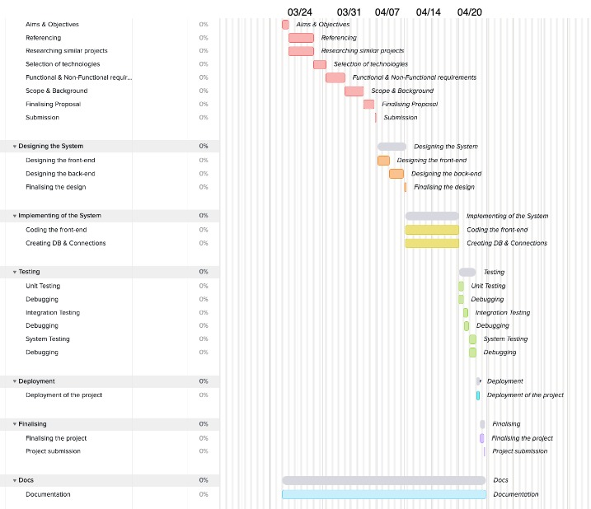

Figure 1 Gnatt Chart

3. Design

3.1 Introduction

Usage of appropriate design techniques: Such as, process model / flow chart / activity sequence diagrams; design narrative

## 3.2 Diagrams

### 3.2.1 Class diagrams

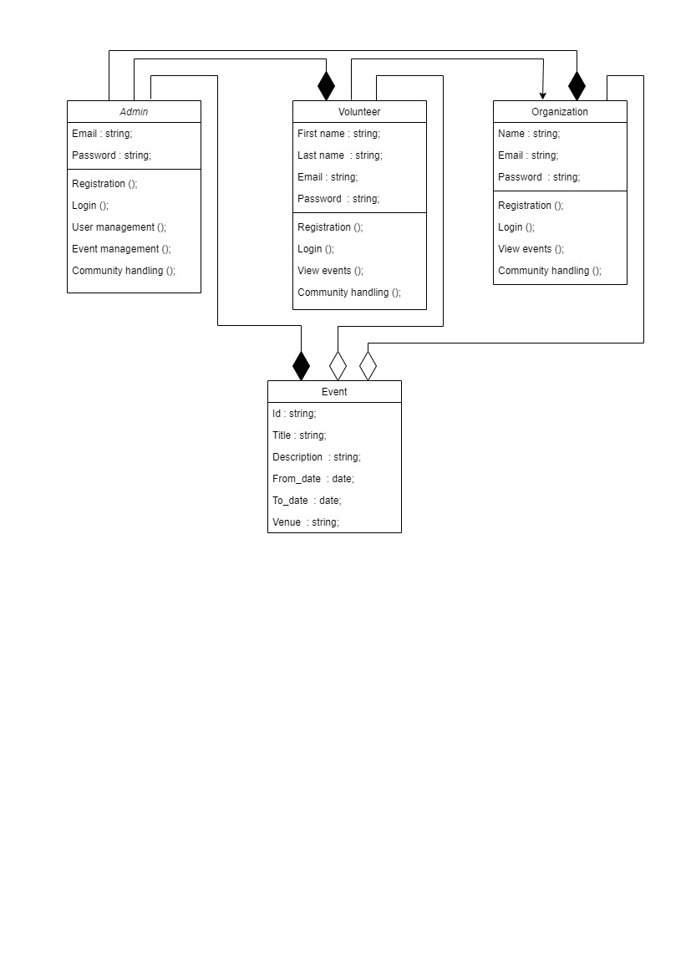

Figure 2 Class Diagram

### 3.2.2 Use case

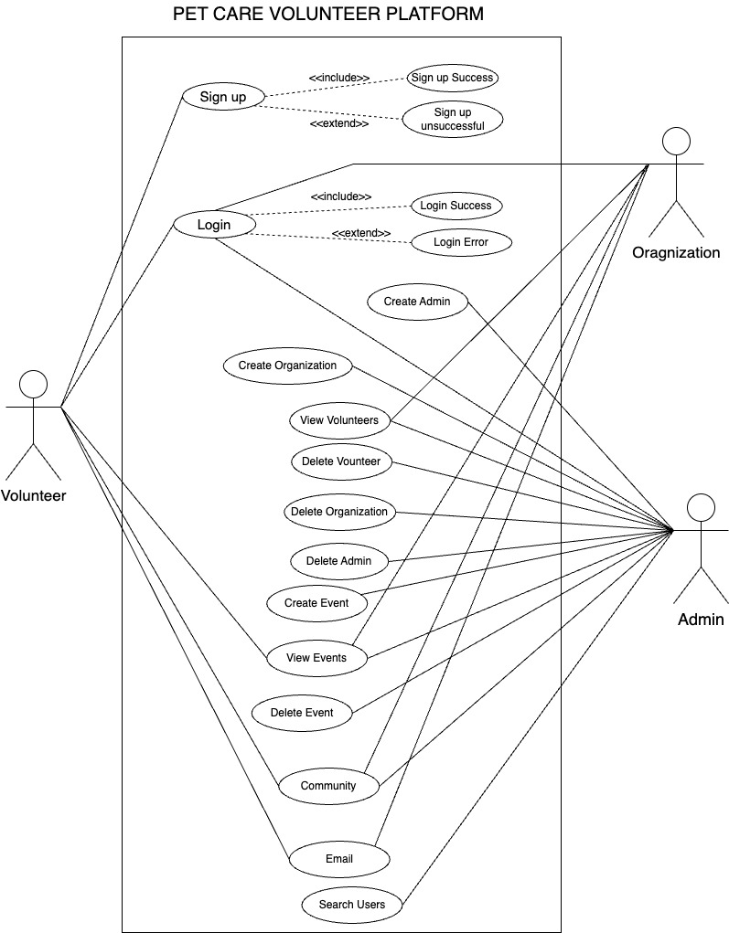

Figure 3 Use Case diagram

### 3.2.3 Activity diagrams

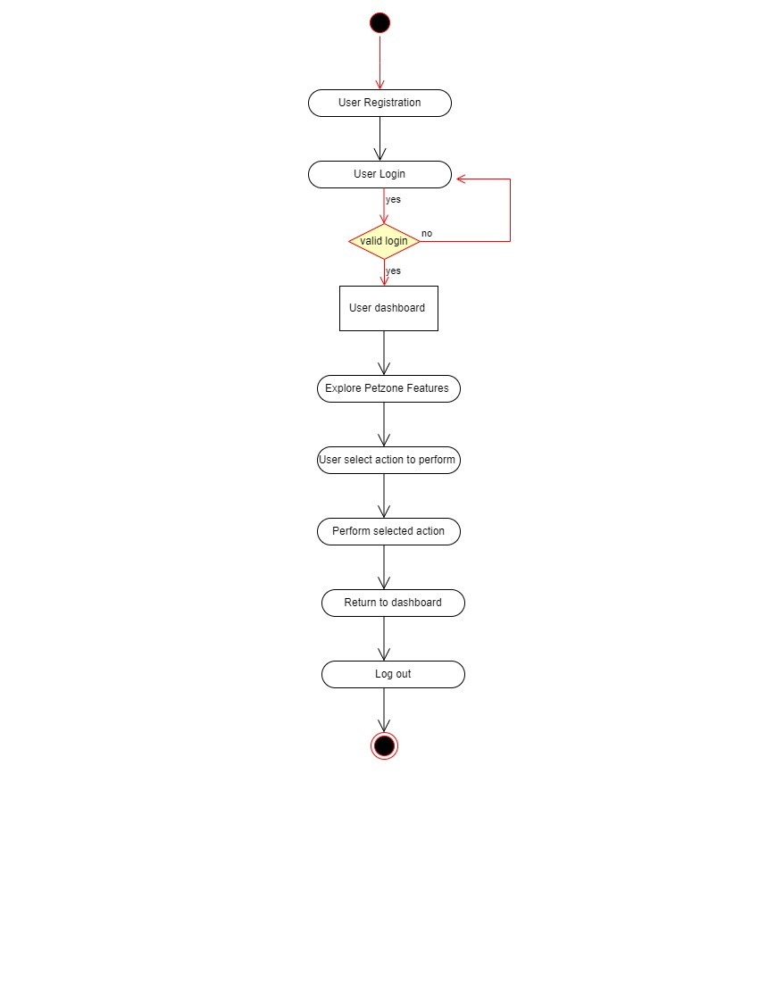

Figure 4 Activity diagrams

### 3.2.4 Sequence diagrams

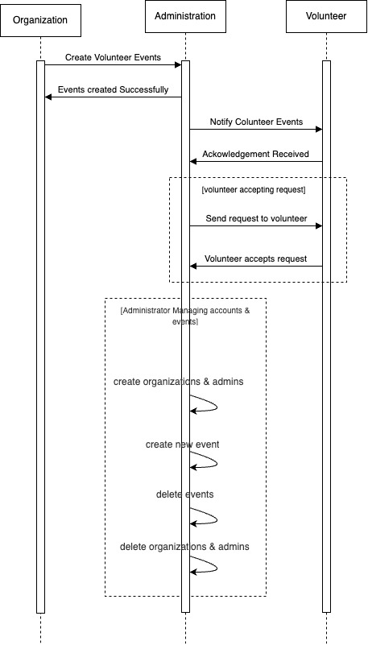

Figure 5 Sequence Diagram

## 3.3 Design Techniques

### 3.3.1 Architectural Design

The following illustrates the overall system architecture at different layers.

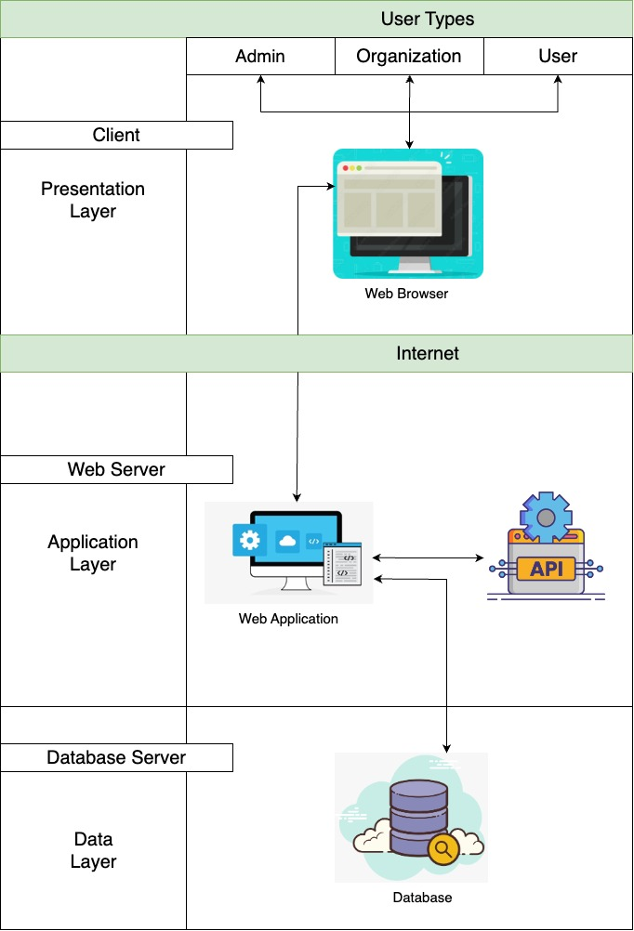

Figure 6 Architecture Design

### 3.3.2 Database Design

**Admin Profiles**

Figure 7 Admin 1-User database document

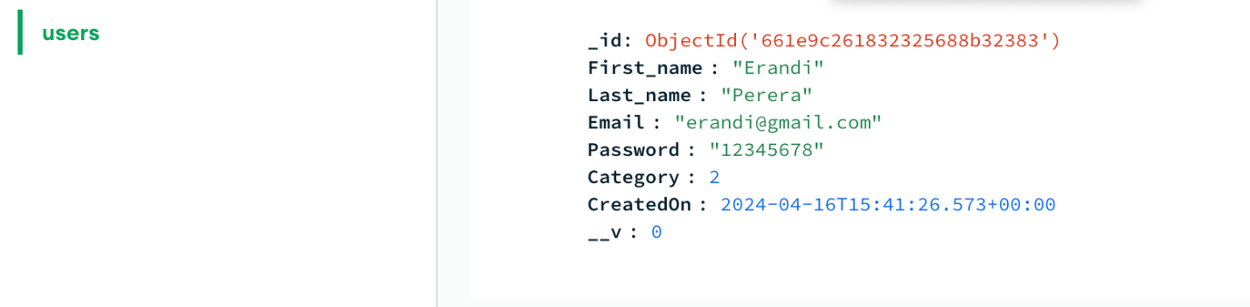

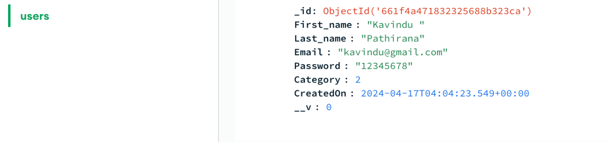

Figure 8 Admin 2-User database documentation

**Organization Profiles**

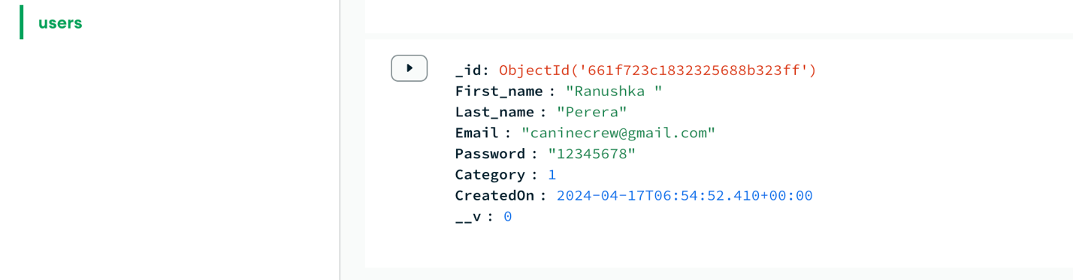

Figure 9 Organization 1-User database documentation

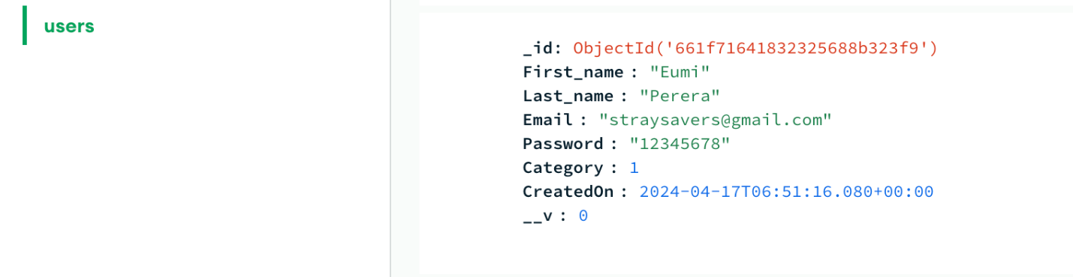

Figure 10 Organization 2-User database documentation

**Volunteer Profiles**

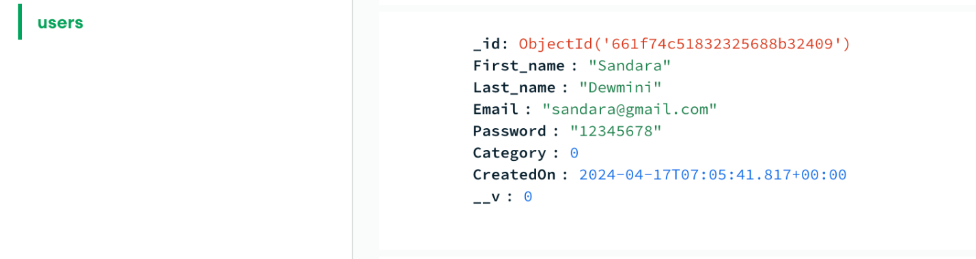

Figure 11 Volunteer 1-User database documentation

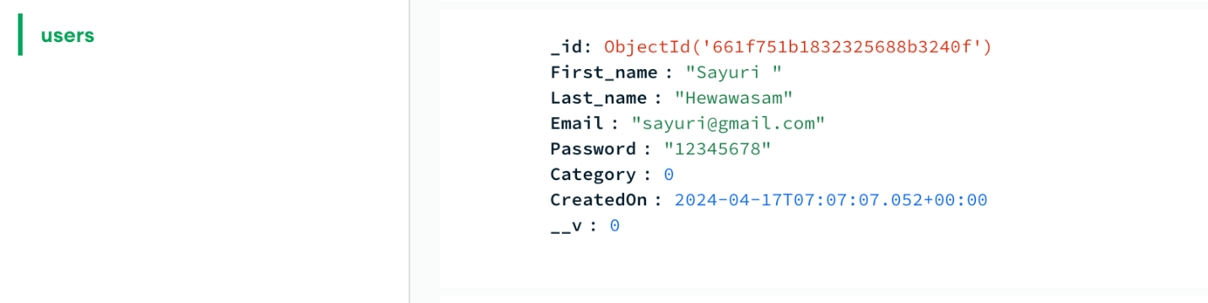

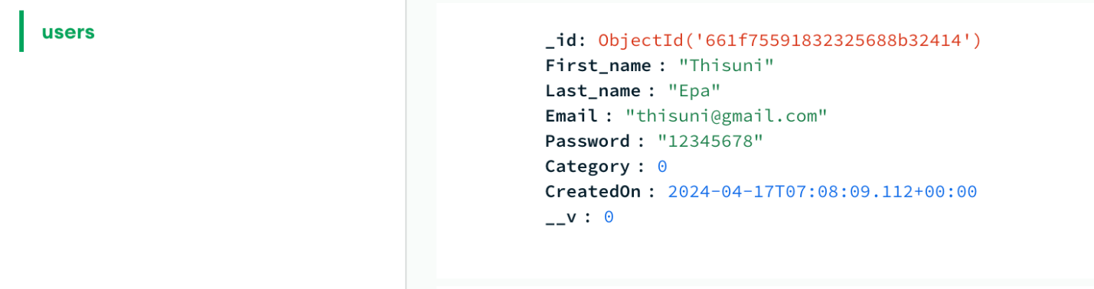Figure 13 Volunteer 2-User database documentation

Figure 12 Volunteer 3-User database documentation

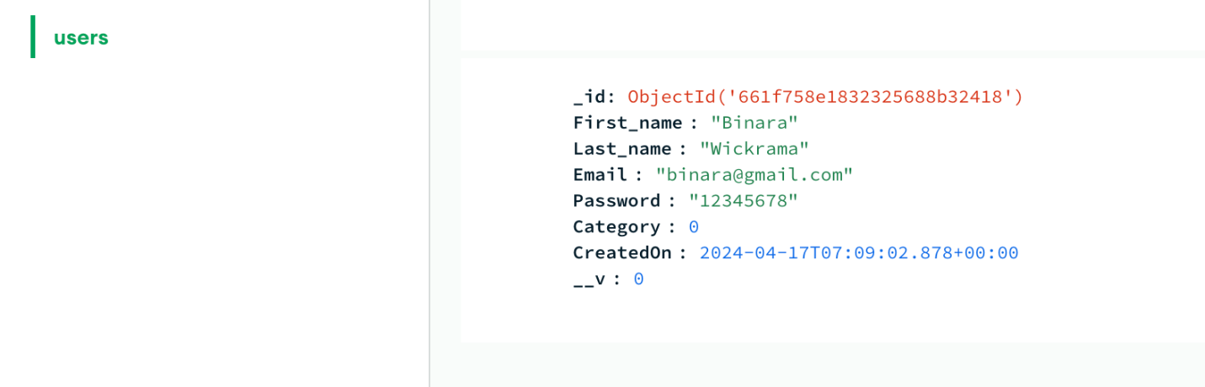

Figure 14 Volunteer 4-User database documentation

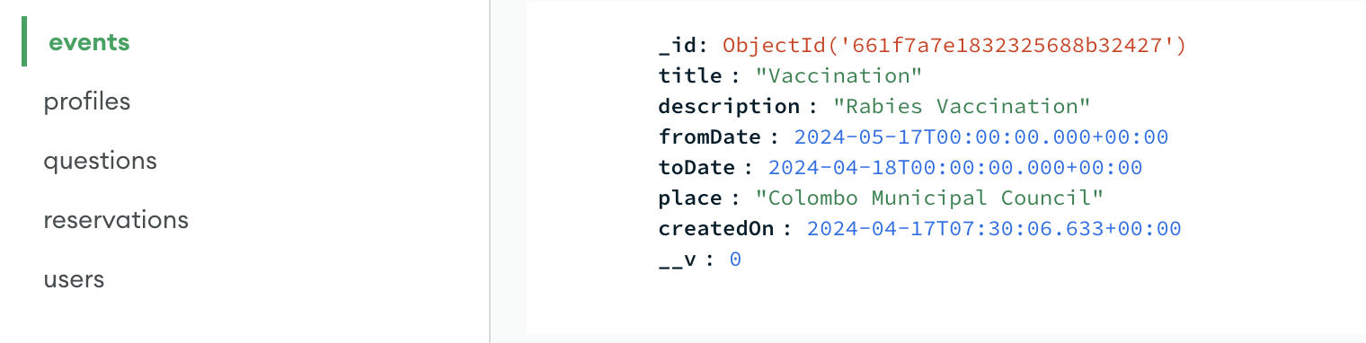**Events**

Figure 15 Event 1-Events database documentation

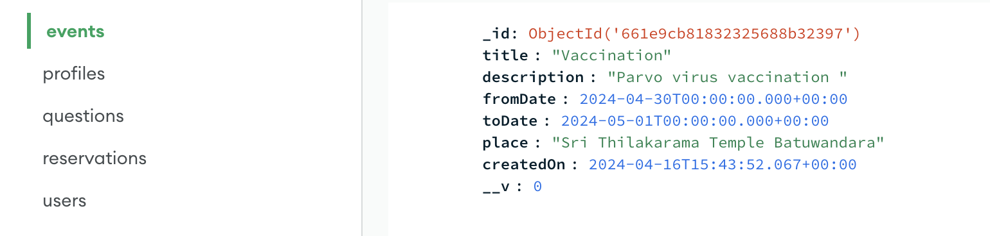

Figure 16 Event 2-Events database documentation

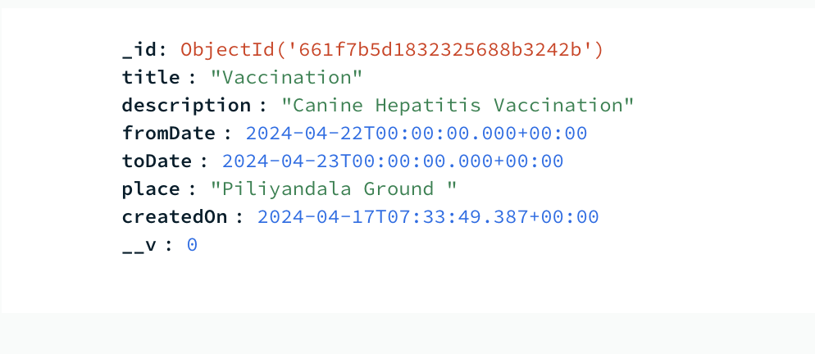

Figure 17 Event 3-Event database documentation

**Questions**

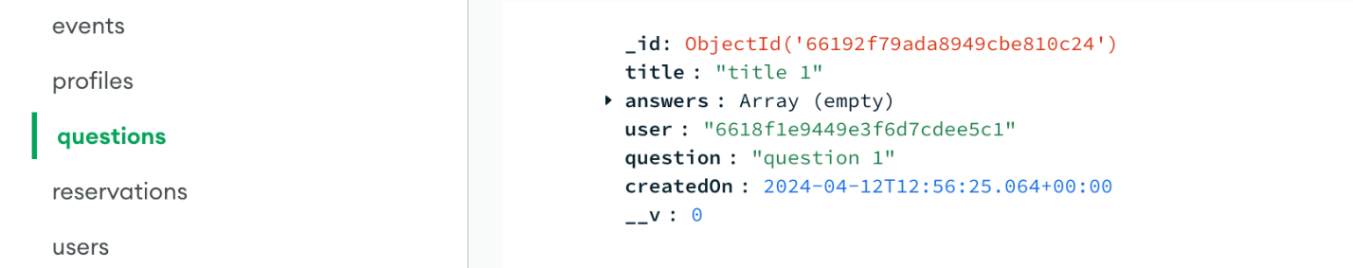

Figure 18 Question 1 - Community database documentation

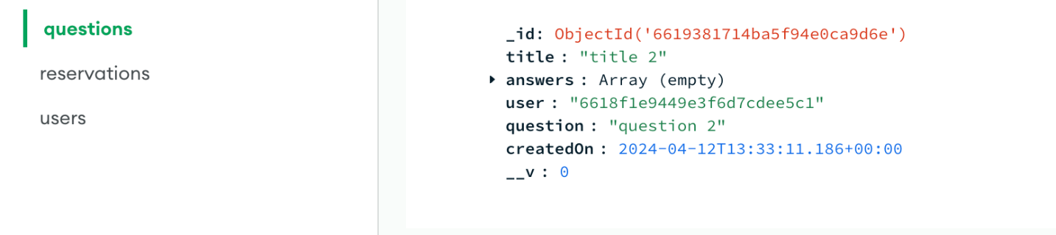

Figure 19 Question 2 - Community database documentation

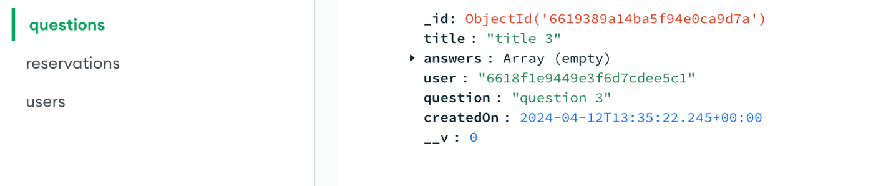

Figure 20 Question 3 - Community database documentation

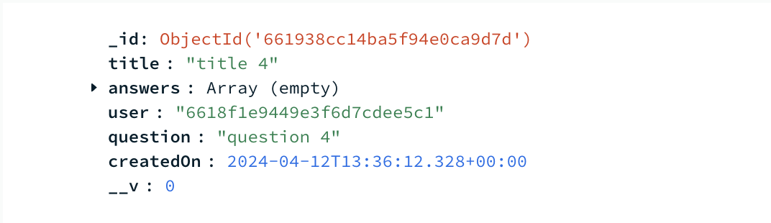

Figure 21 Question 4 - Community database documentation

**Answers**

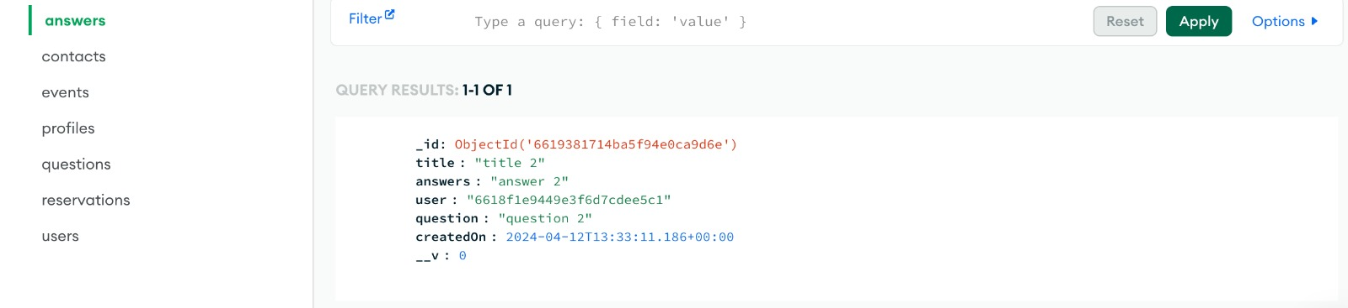

Figure 22 Answers

### 3.3.3 Security Measures

* + Preventing Duplicate Registrations.

The system ensures that the same email address cannot be registered again if it’s already associated with an account. This prevents potential misuse of the system such as creating multiple accounts with the same email address.

* + Database Security

The database used for the system is MongoDB Atlas, a cloud-based database service. Security measures include using a strong password for accessing the database cluster. This helps to protect the database from unauthorized access and ensures that only authorized users can interact with the data.

* + Access Control Levels

The system has three levels of access: Admin, Organization and User. Only the Admin account has the authority to add or remove other admins, organizations and users.

This ensures that administrative tasks are restricted to authorized personnel, reducing the risk of unauthorized modification to the system’s configuration or data.

These security measures collectively help safeguard the system’s data integrity, preventing unauthorized access, and ensuring that administrative privileges are appropriately managed and controlled.

### 3.3.4 Disaster Recovery Mechanism

Disaster recovery mechanisms are essential for ensuring continuity and minimizing downtime in the event of a system failure, data loss or other fatal events.

MongoDB Atlas, our database, is a fully managed cloud database service that provides many disaster recovery features.

* + Automated Backups

MongoDB Atlas offers automated backup features that regularly back up your data to secure cloud storage. These backups capture the entire database, including all collections, indexes etc. In the event of any data loss or corruption, they can be restored to a specific point using these backups to help to recover from disasters quickly and reliably.

* + Cross-Region replication

MongoDB Atlas supports cross-region replication, allowing you to replicate your data across multiple geographic regions. By replicating your data to secondary clusters in different regions. By replicating the data, to secondary clusters in different regions redundancy and resilience against regional disasters such as natural disasters or data center outages.

GitHub

* + Continuous Access

Since the code is stored centrally on GitHub, developers can access it from any location with internet access. In the event of a disaster affecting any developer’s local environment, they can quickly resume their work without any interruptions.

* + Redundancy and Backup

GitHub serves as a redundant backup of the codebase. Even if the developer’s code base is lost due to a disaster, the code remains safe and accessible on GitHub, ensuring that no work is lost.

* + Version Controlling

GitHub’s version control capabilities ensure that changes to the codebase are tracked and documented over time. Developers can easily revert to previous versions of the code if needed.

## 3.5 Interfaces and codes

### 3.5.1 Front End

### 3.5.1.1Volunteer Registration to Petzone

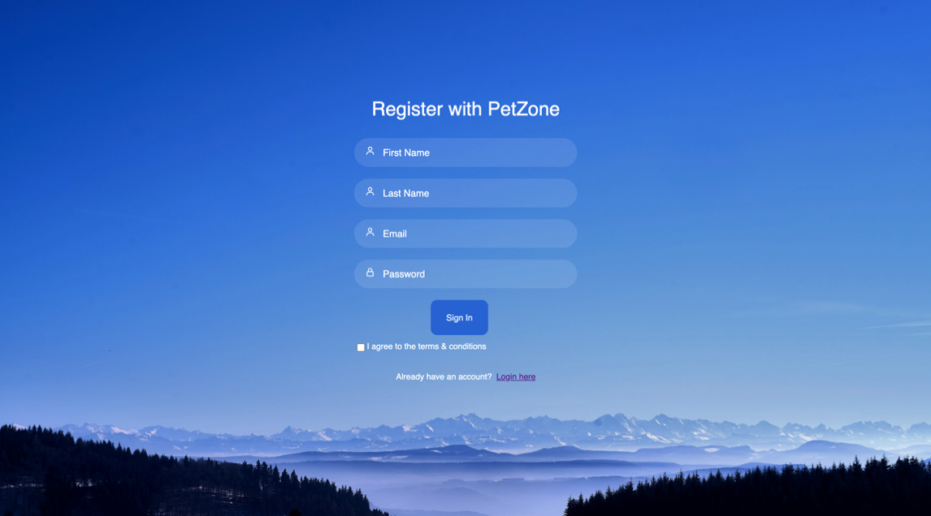

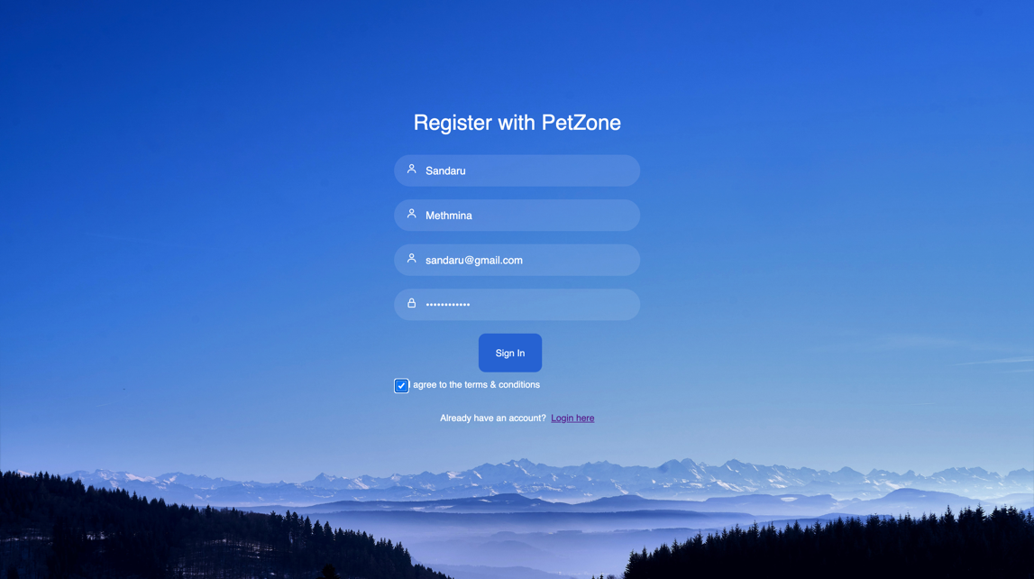

Figure 23 Register UI with details entered

Figure 24 Register UI

When the Sign In button is clicked, a pop-up message is viewed by the user and will be directed to the Login page.

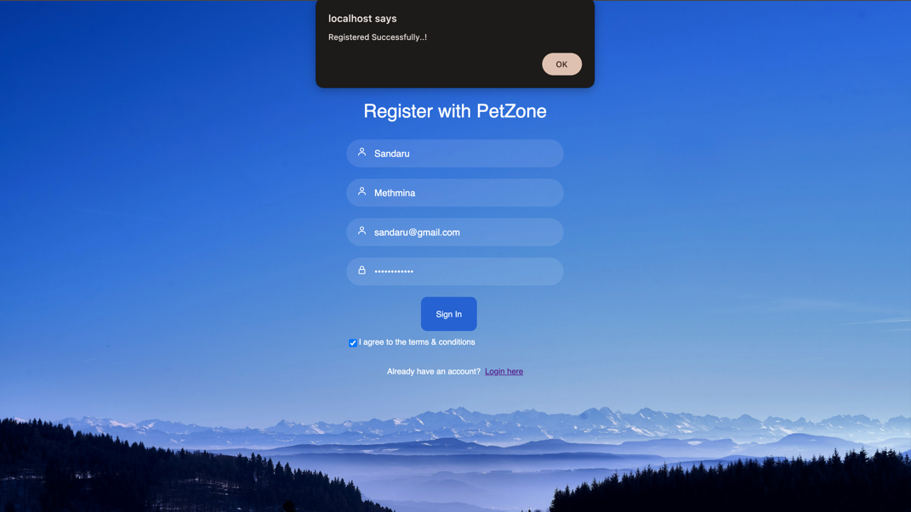

Figure 25 Registration Successful UI

### 3.5.1.2 Login to PetzoneLogin Data entered.

Figure 26 Login UI

### 

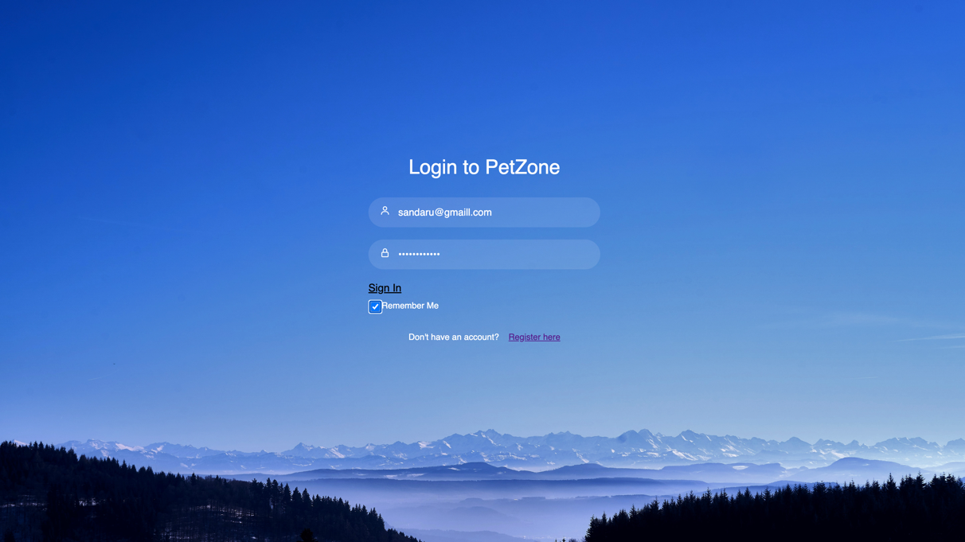

Figure 27 Login details entered Login UI

After the Login details are entered, the Sign In button is clicked and a Login Successful message is popped up and the user is directed to the official Petzone Web application.

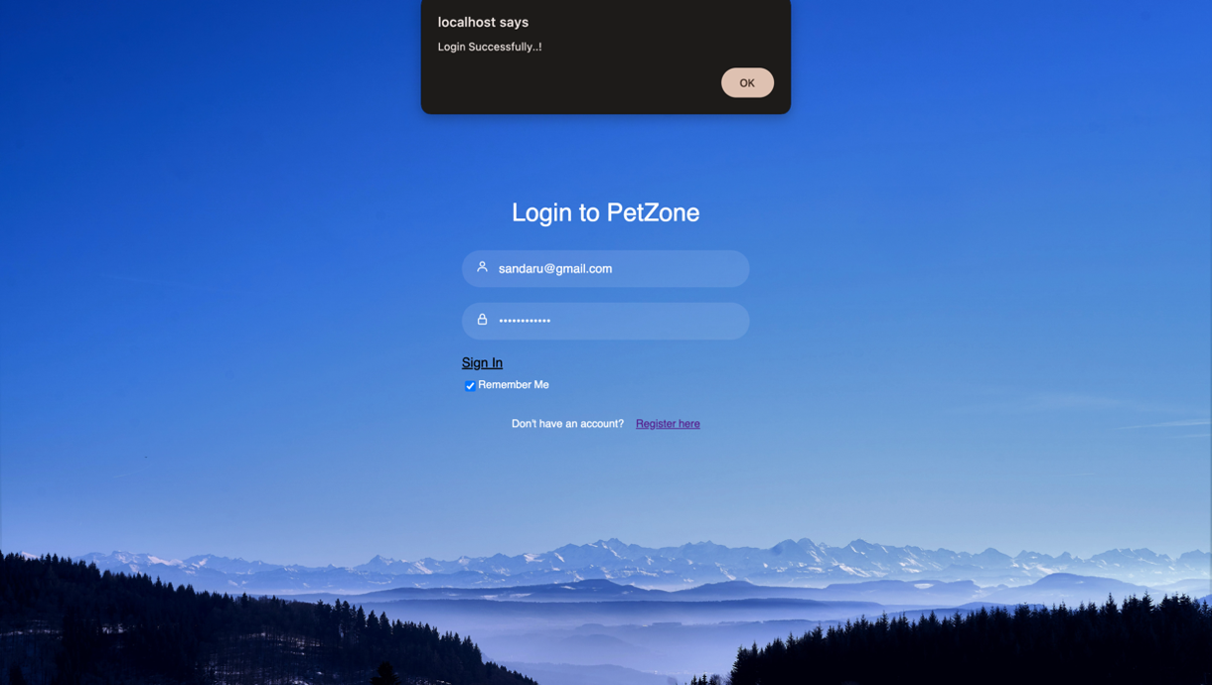

Figure 28 Login Successful UI

### 3.5.1.3 Petzone Home Page

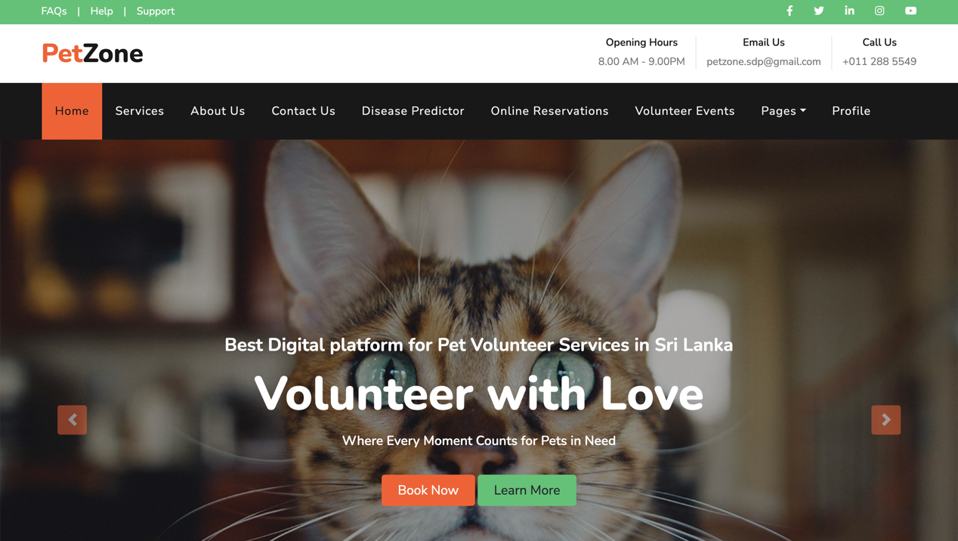

Figure 29 Home UI - 1

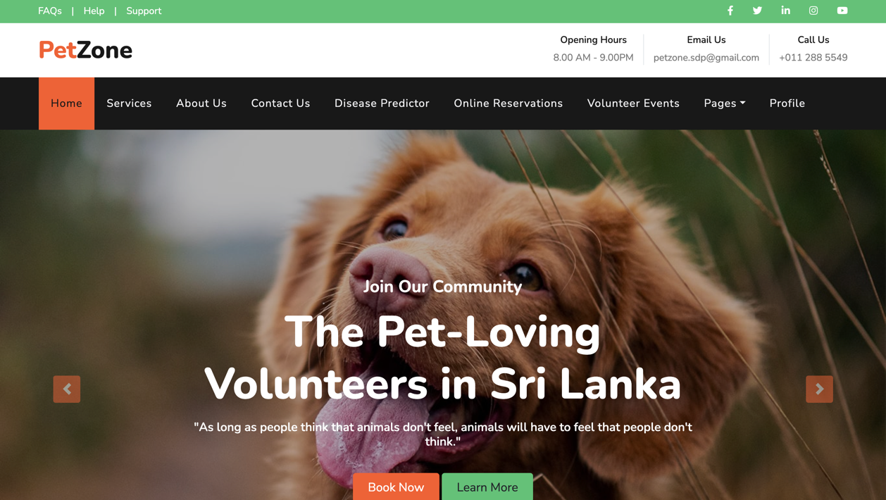

Figure 30 Home UI - 2

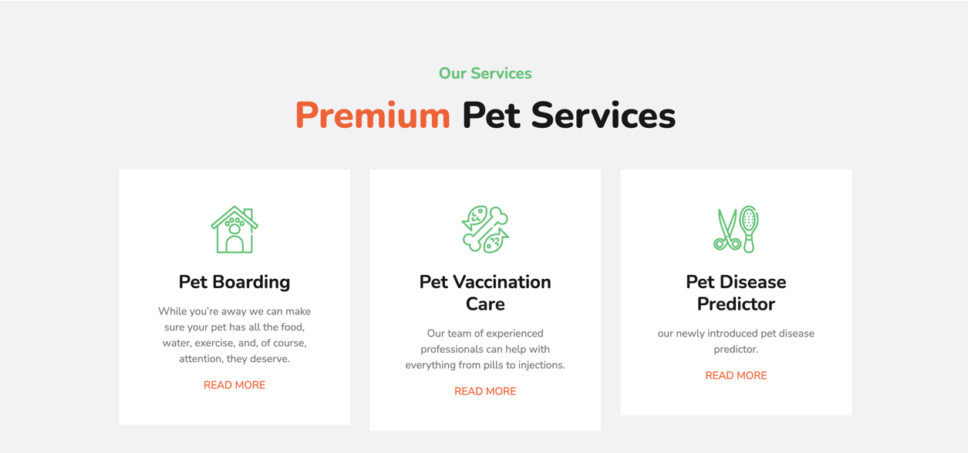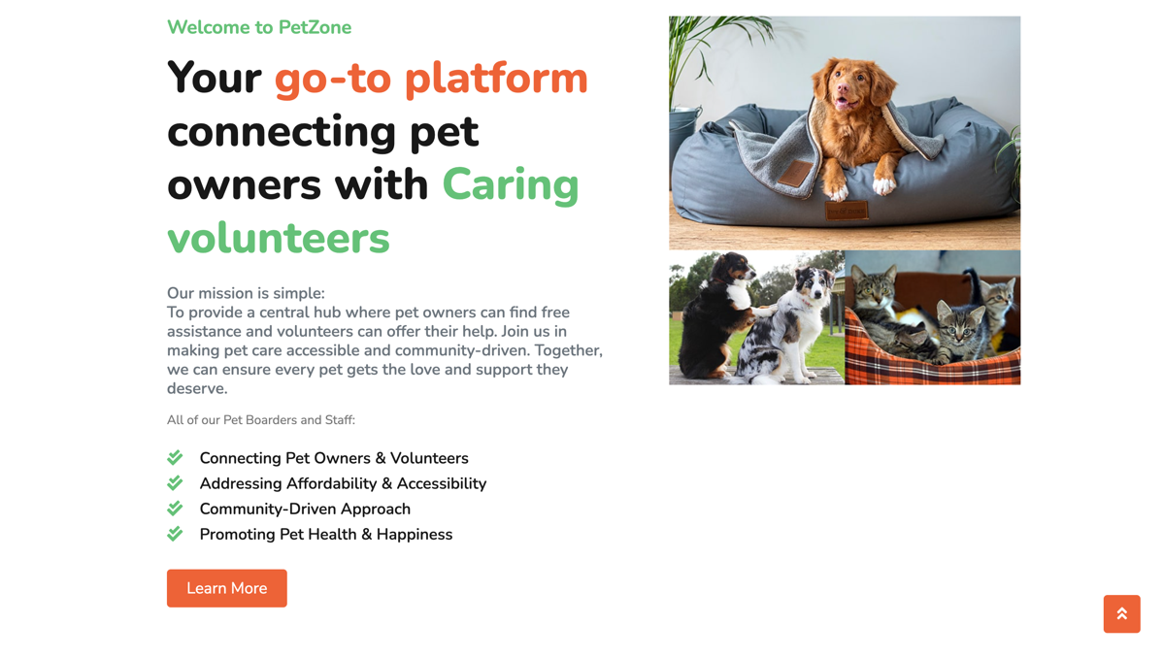

Figure 31 Home UI 3

Figure 32 Home UI 4



Figure 33 Home UI 5

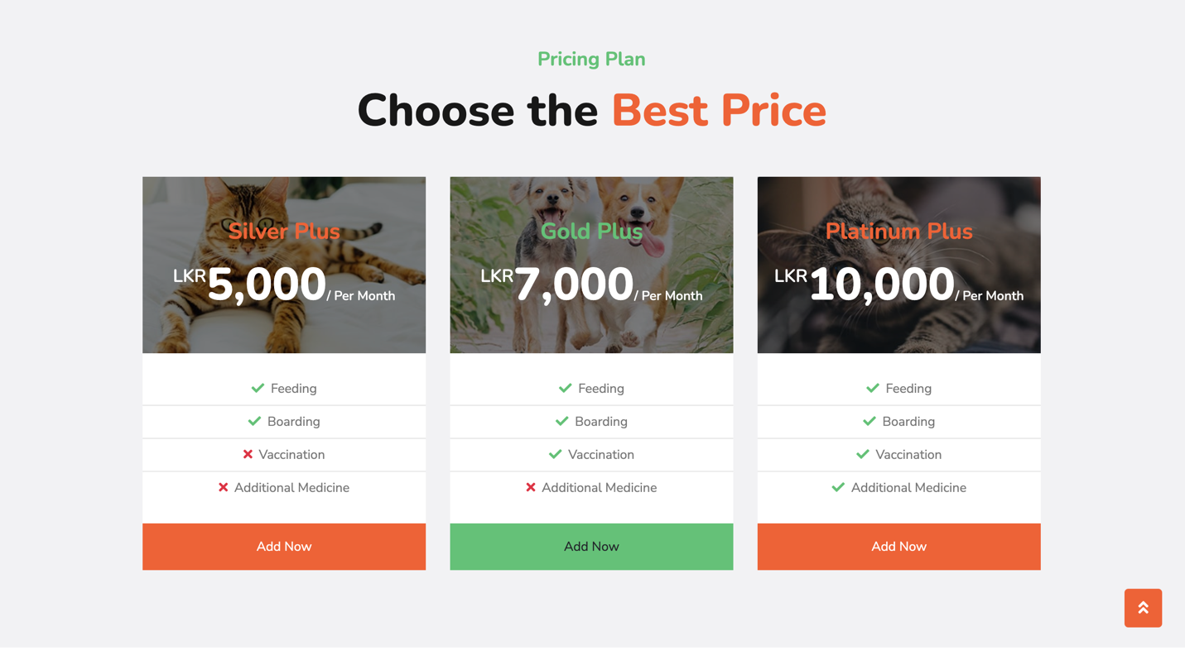

Figure 34 Home UI 6 (Extra Feature)

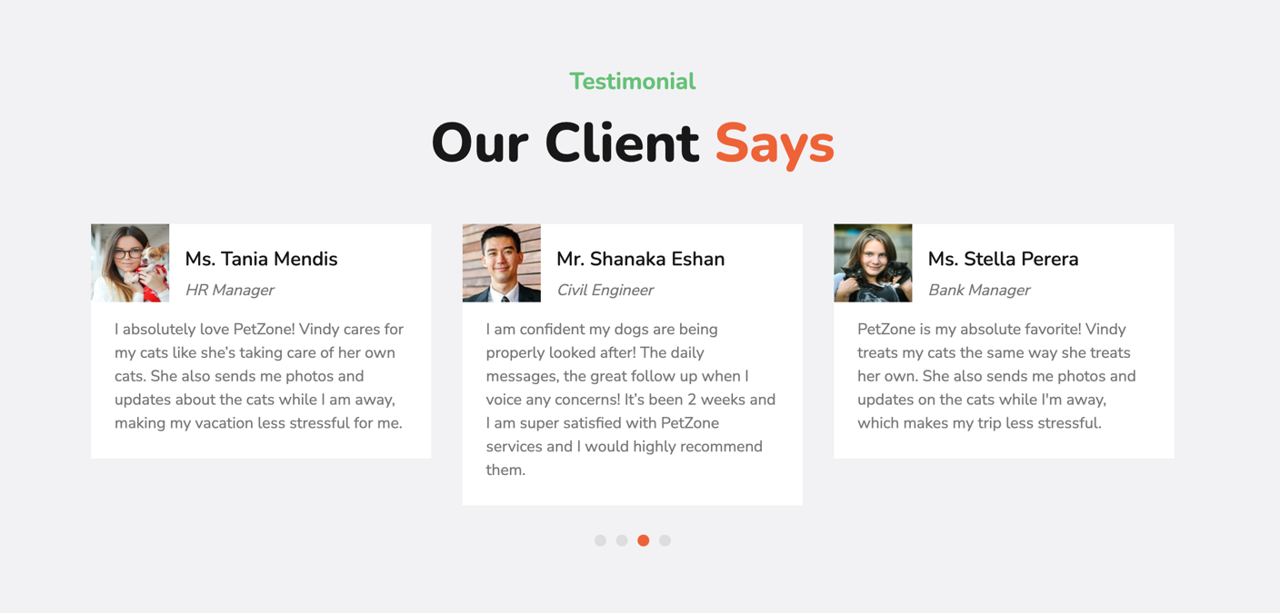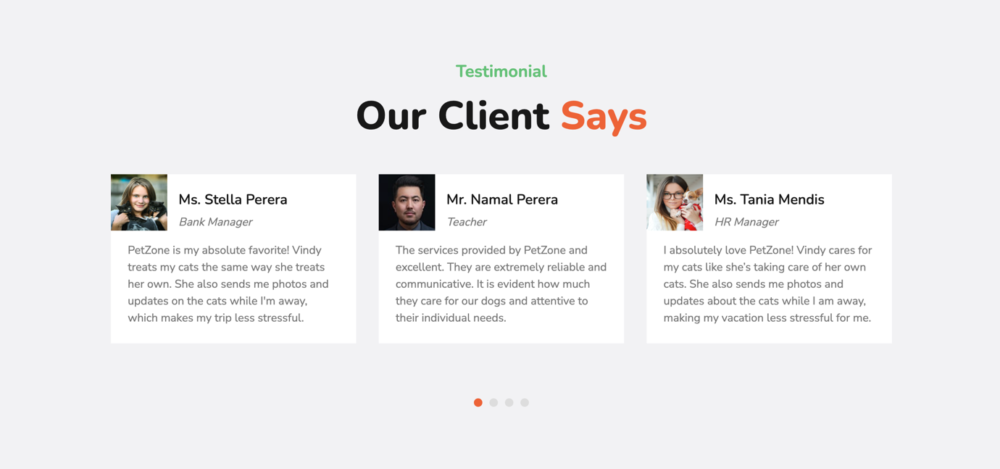

Figure 35 Home UI 8

Figure 36 Home UI 7

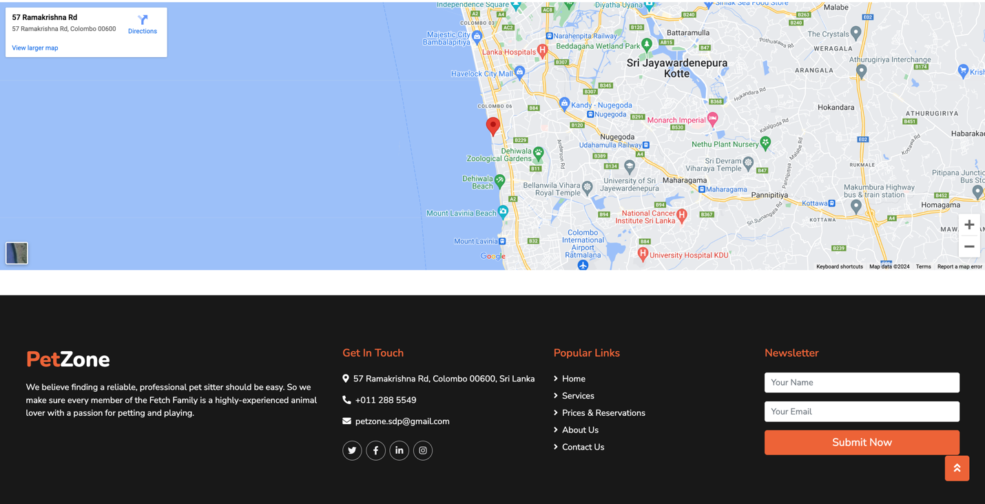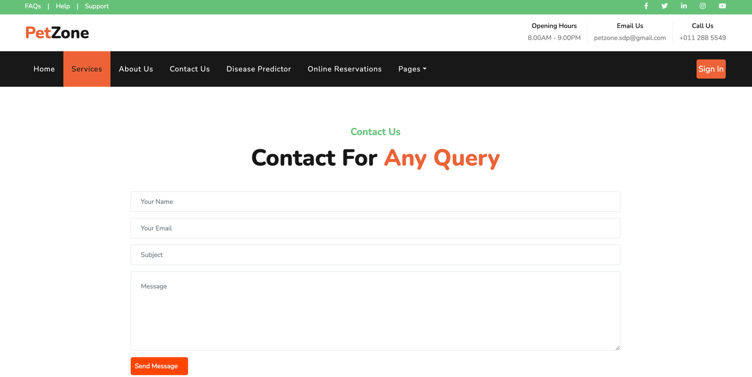

Figure 37 Contact Us UI 2

Figure 38 Contact Us UI 2

Figure 39 Contact Us UI

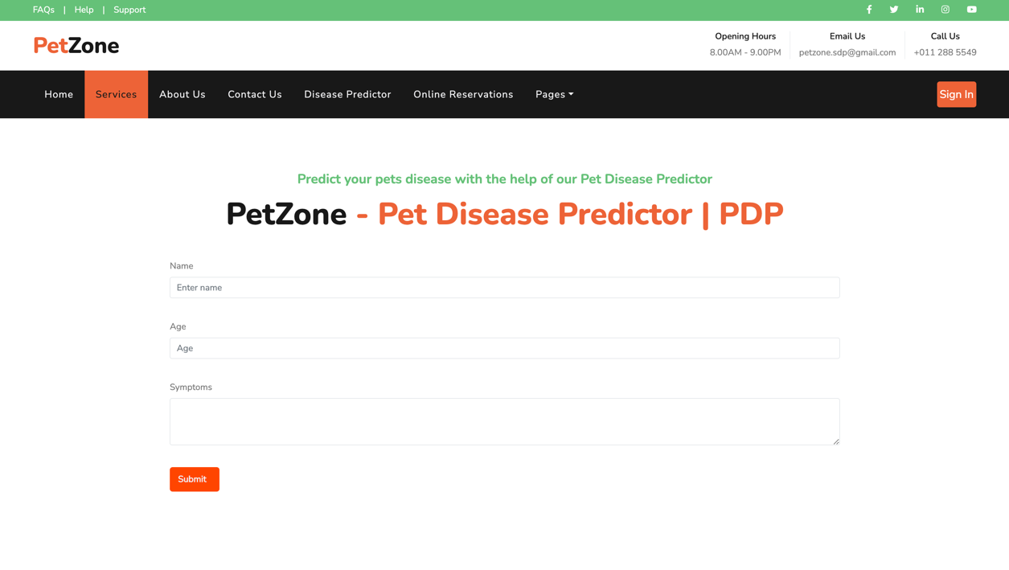

Figure 40 Disease Predictor UI

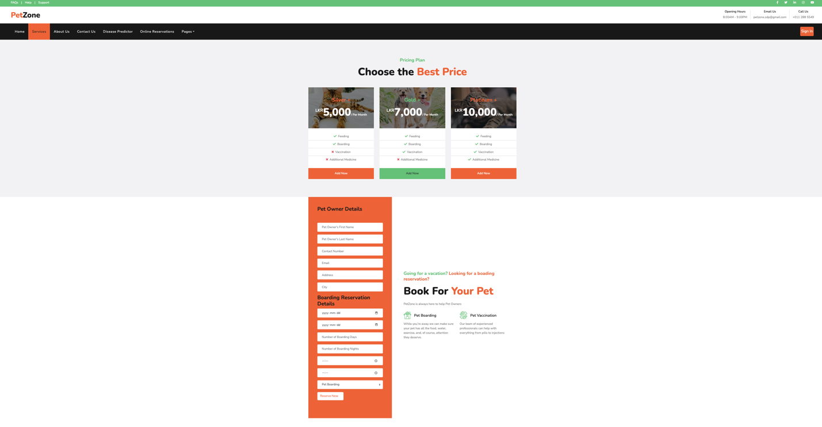

Figure 41Online Reservation for Pet Boarding Booking (extra feature)

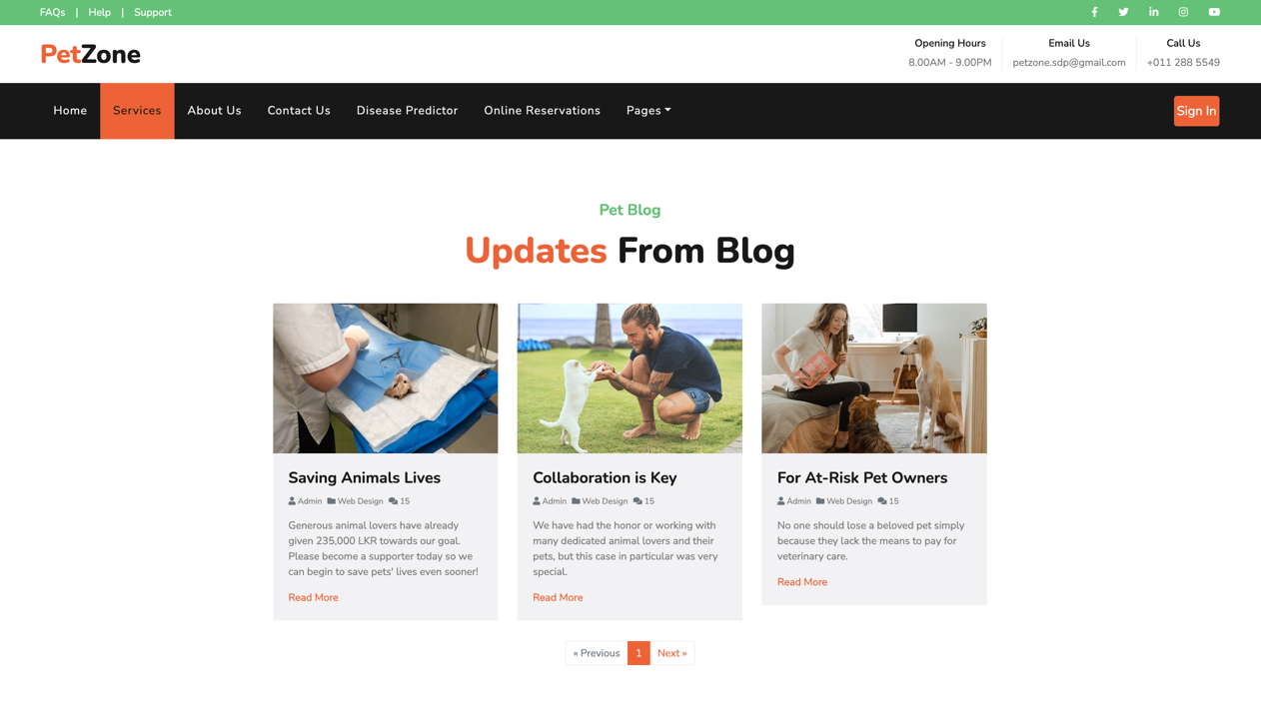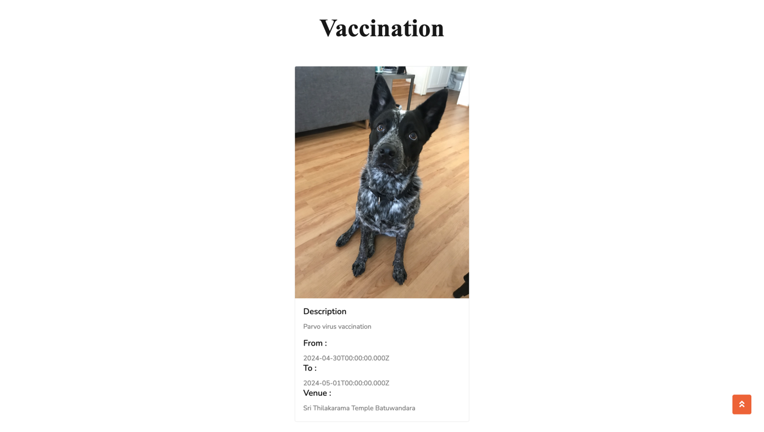

Figure 42 Blog UI (Extra Feature)

Figure 43 Volunteer Events UI -1

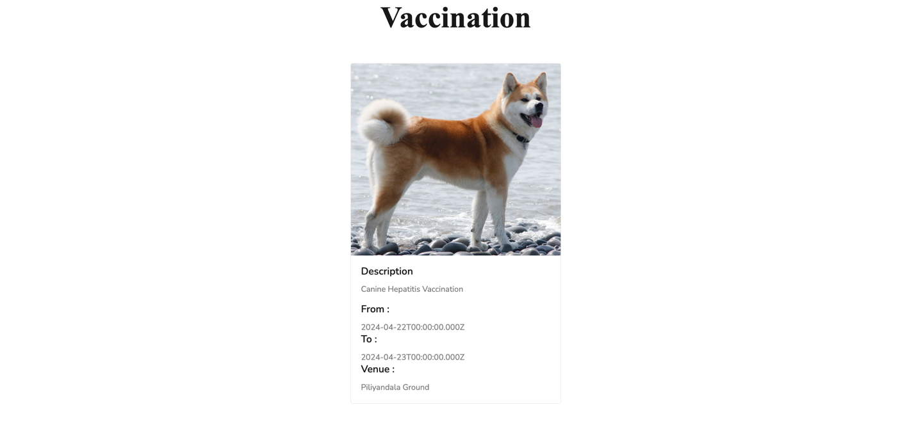

Figure 44 Events Volunteer UI-3

Figure 45 Volunteer Events UI 2

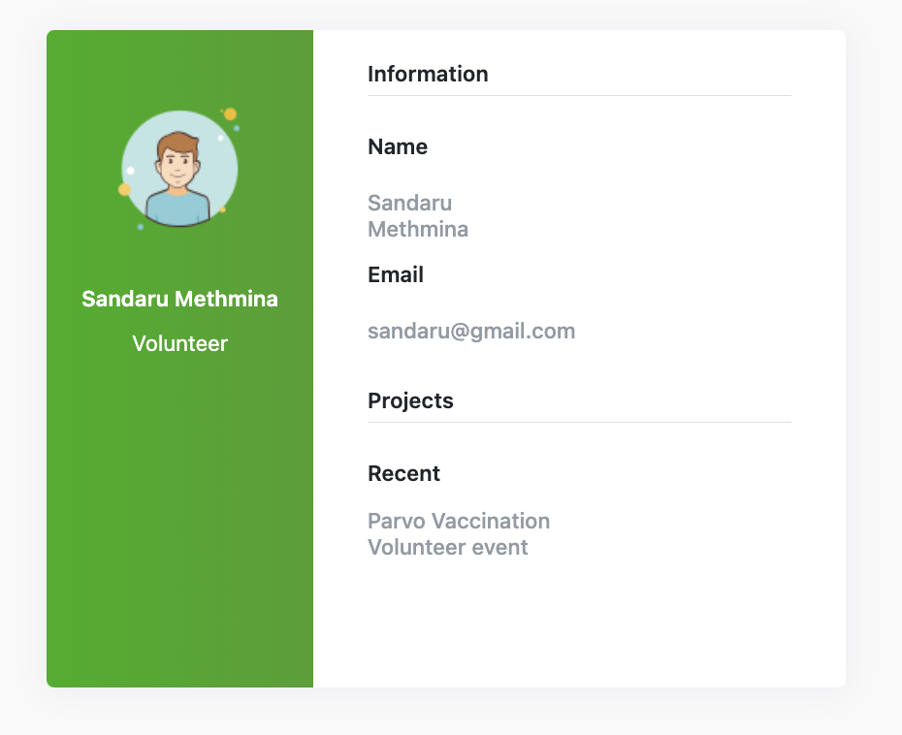

Figure 46 Profile UI

### 3.5.1.4 Management Login

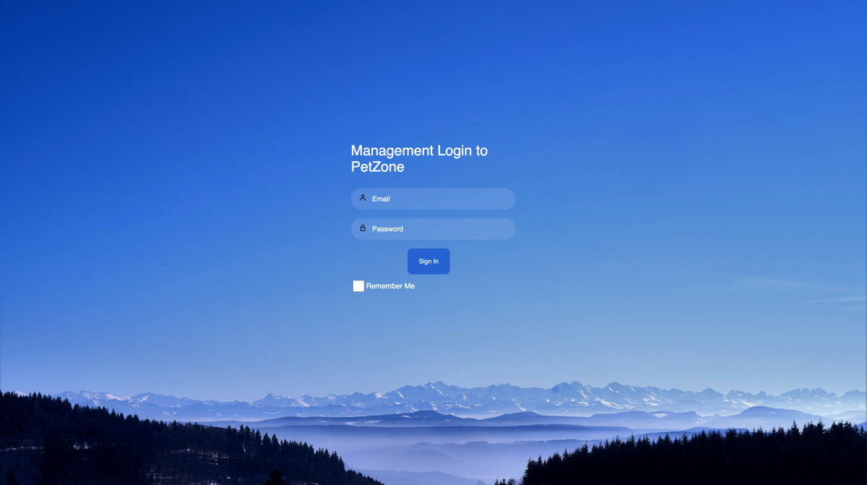

Figure 47 Management Login UI

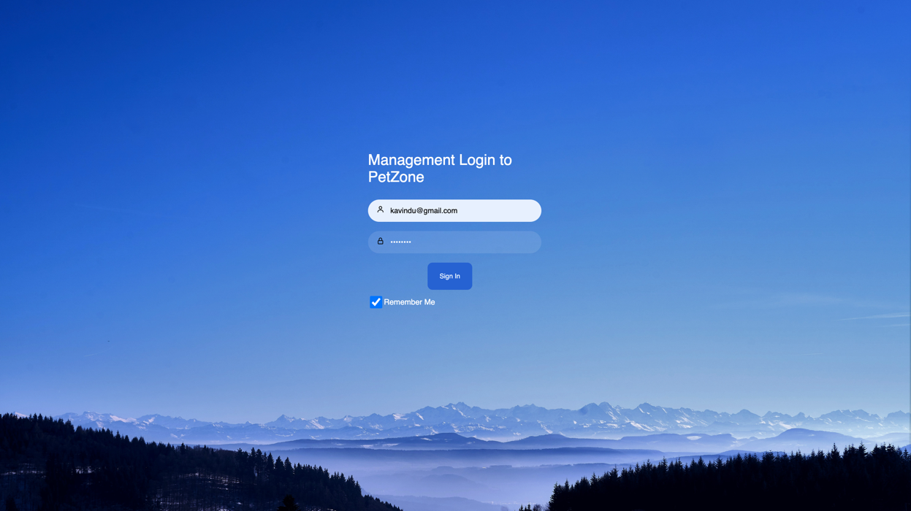

Figure 48 Management Login UI data entered

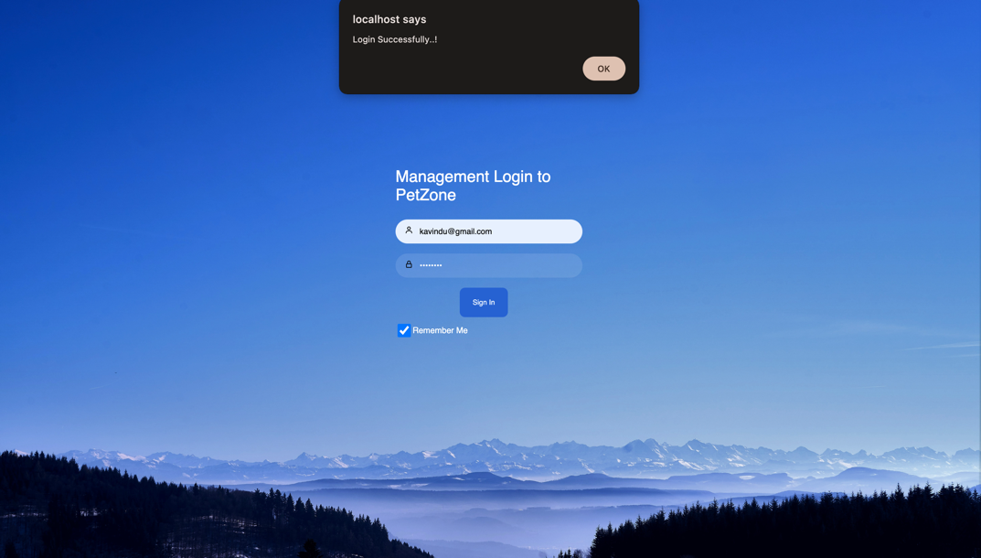When the Sign In button is clicked, Login Successful popup button will be displayed.

Figure 49 Login Successful Popup

### 3.5.1.5 User Management

After the ok button is pressed, the admin is directed to User Management

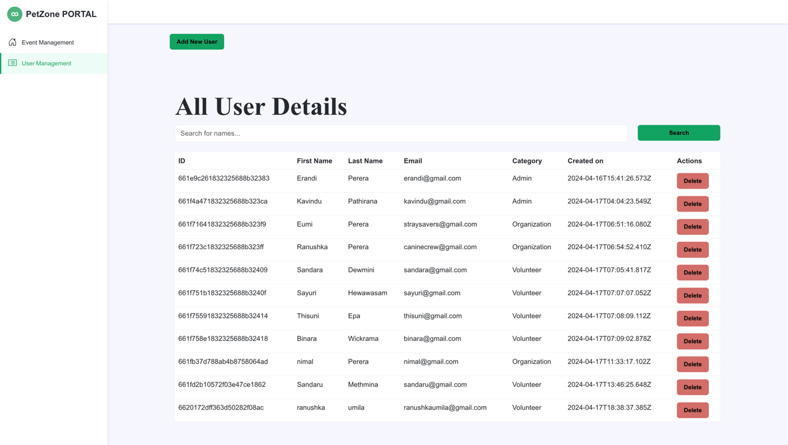

Figure 50 User Management UI

A new Admin or Organizer can be added by clicking the ‘Add new user’ button

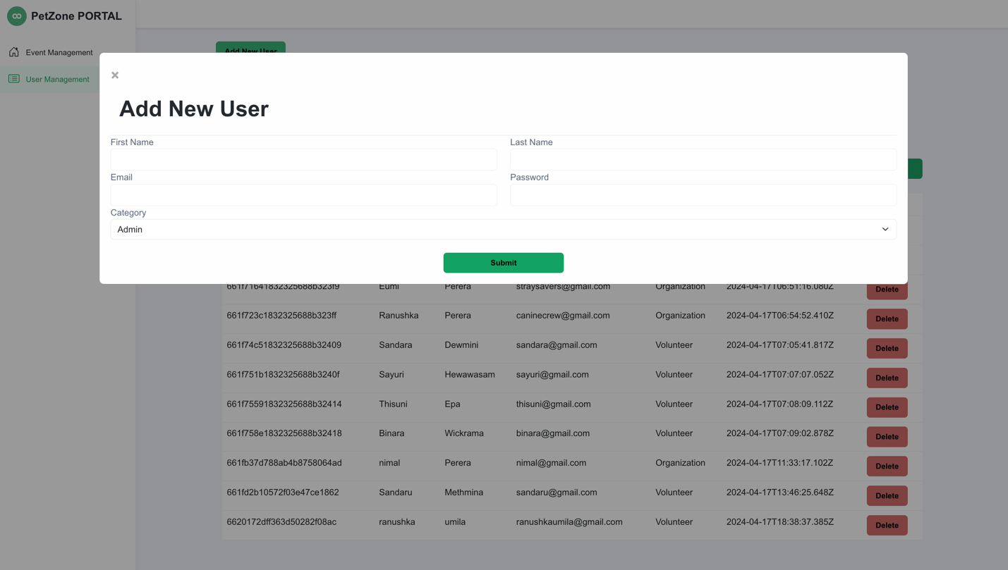

Figure 51 Admin-Add new user

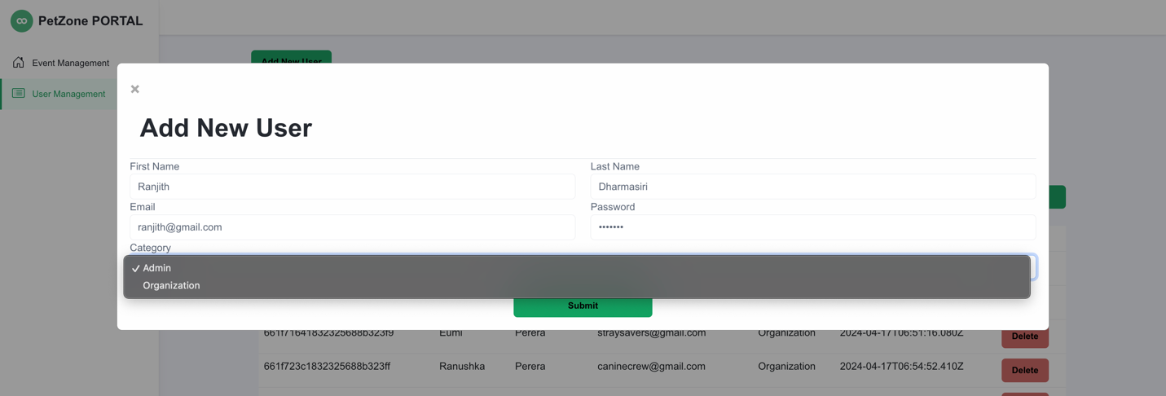

Figure 52 Admin-Add another Admin

When the ‘Submit’ button is clicked, a new admin is created and it can be viewed in the all-users panel

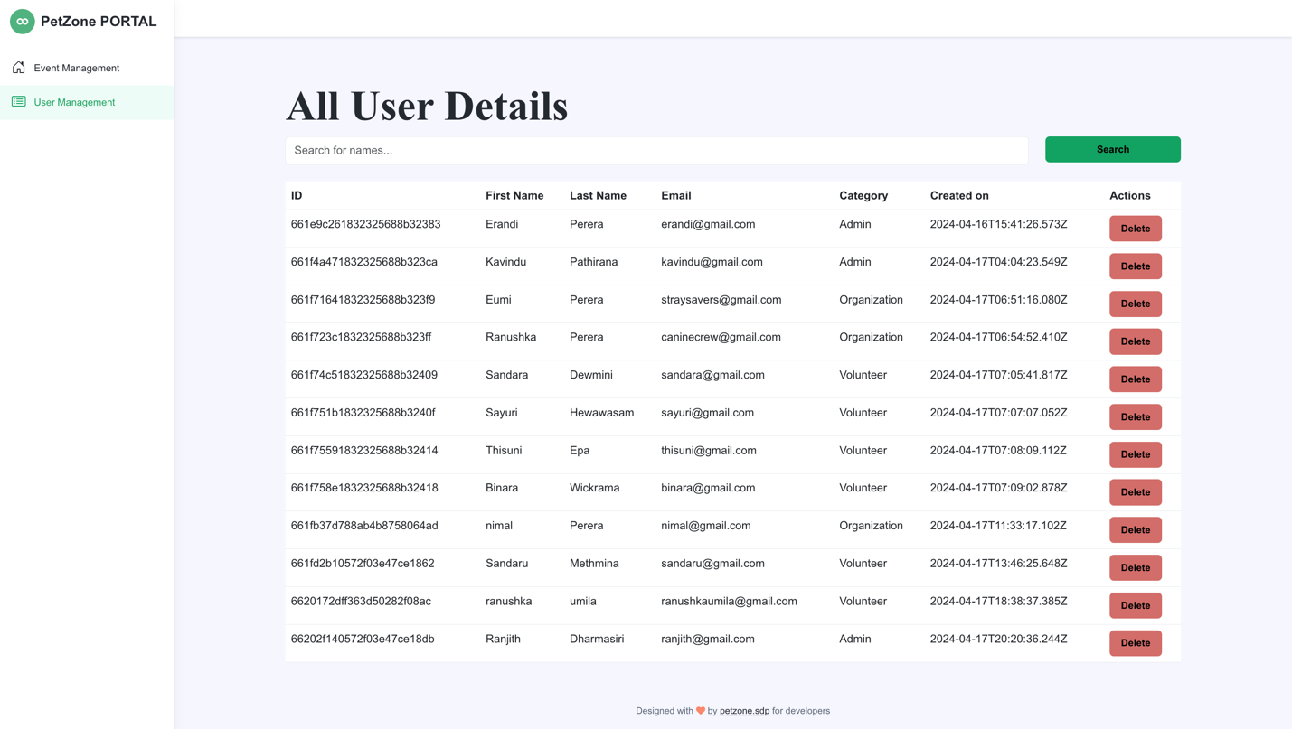

Figure 53 Admin-new Admin added viewed in all users

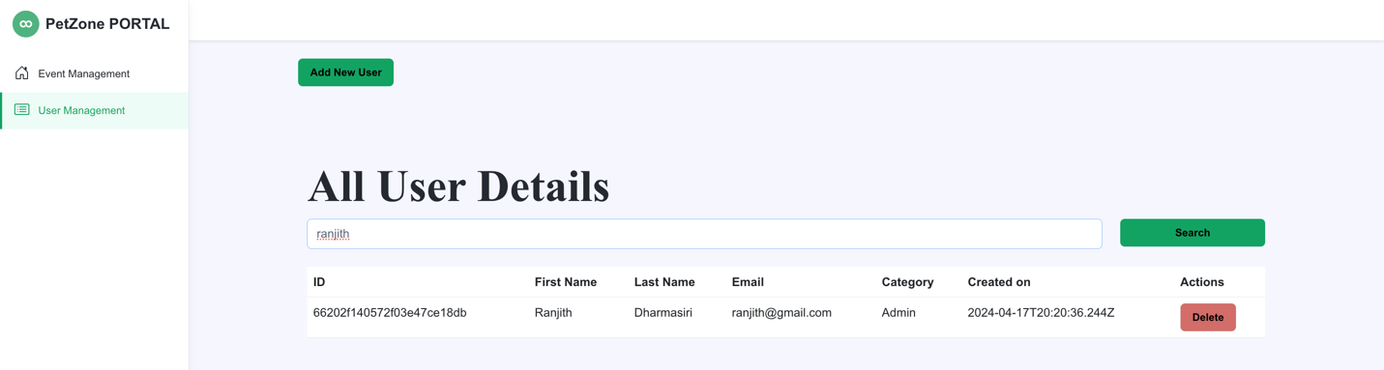

Figure 54 Admin-Search User UI

User can be deleted by using the ‘delete’ button.

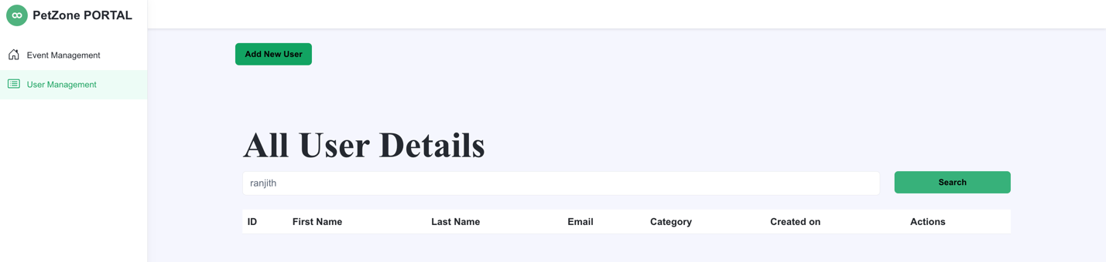

Figure 55 Admin-Admin Deleted

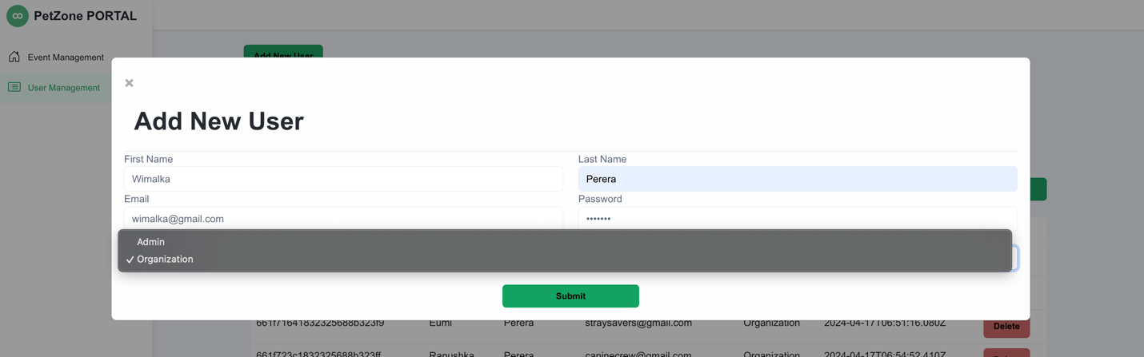

Figure 56 Admin-Create Organization UI

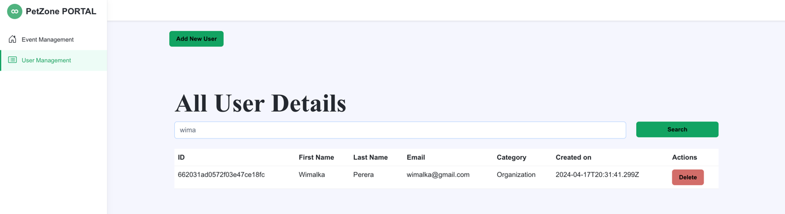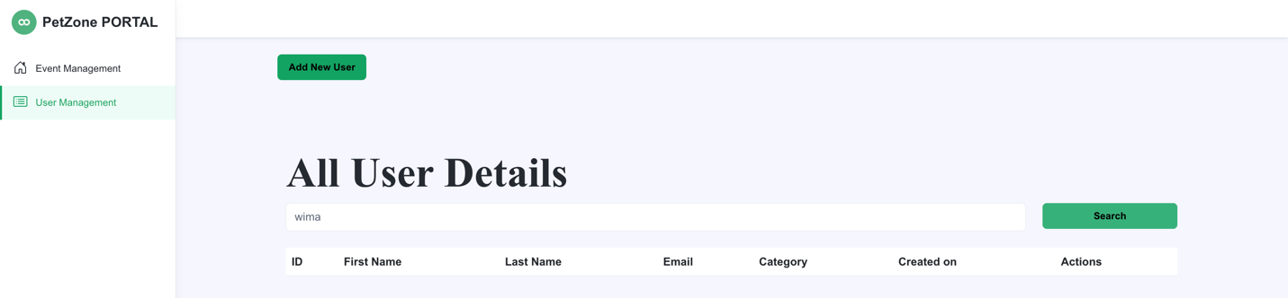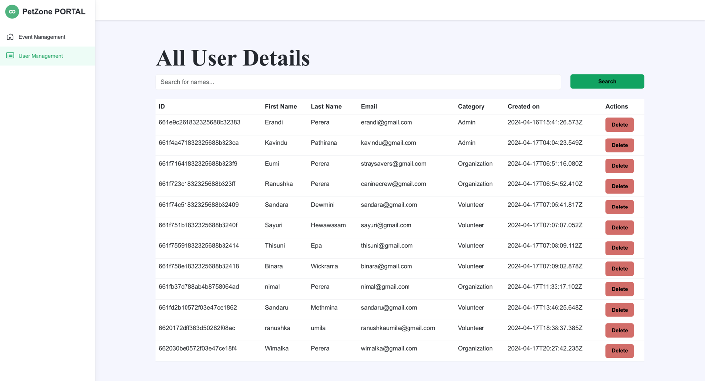

Figure 57 Search User

Figure 58 Admin-Organization Deleted

Figure 59 New Organization

### 3.5.1.6 Event Management

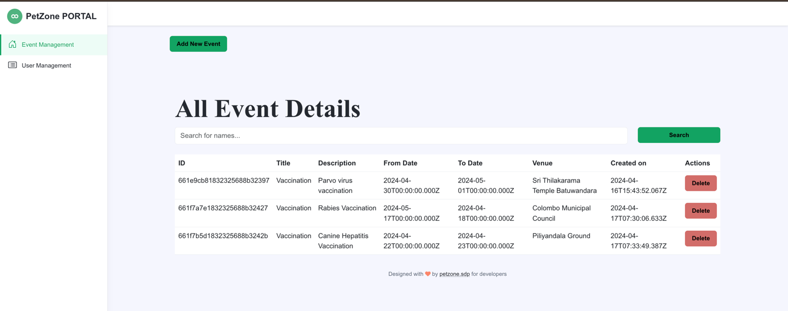

Figure 60 Admin-View All events

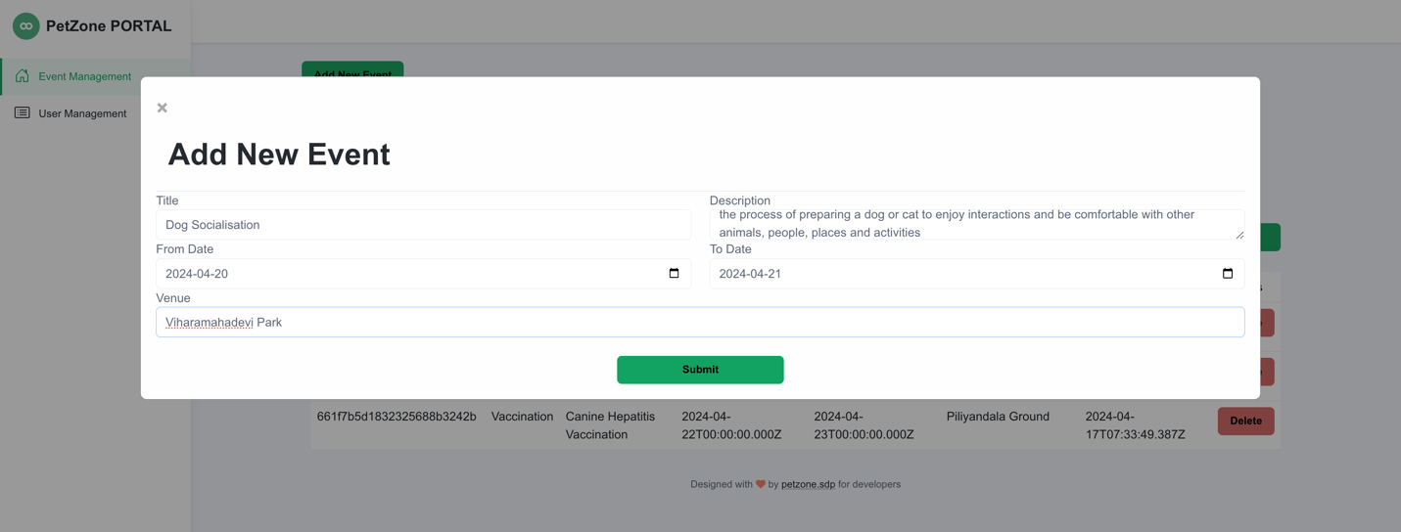

Figure 61 Admin-Add new event UI

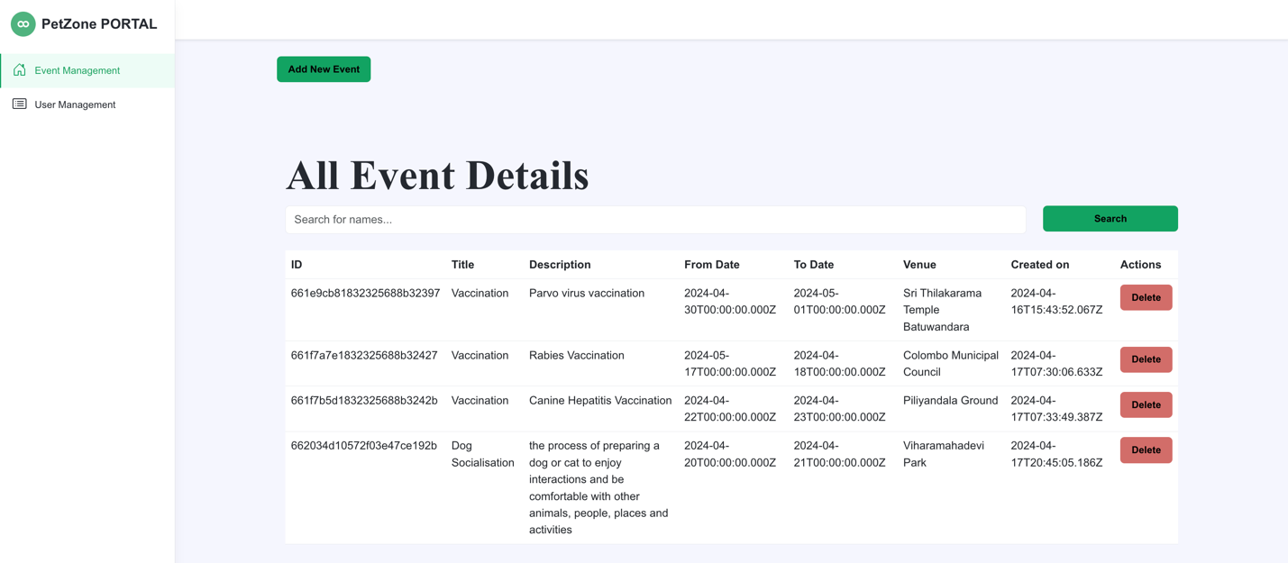When I click the ‘Submit’ button, the event will get recorded.

Figure 62 New Event added-view in all events

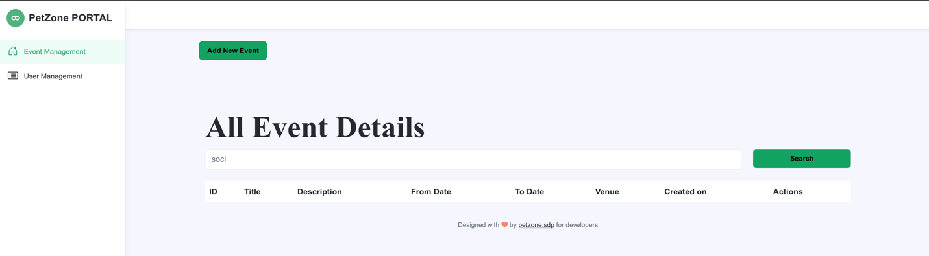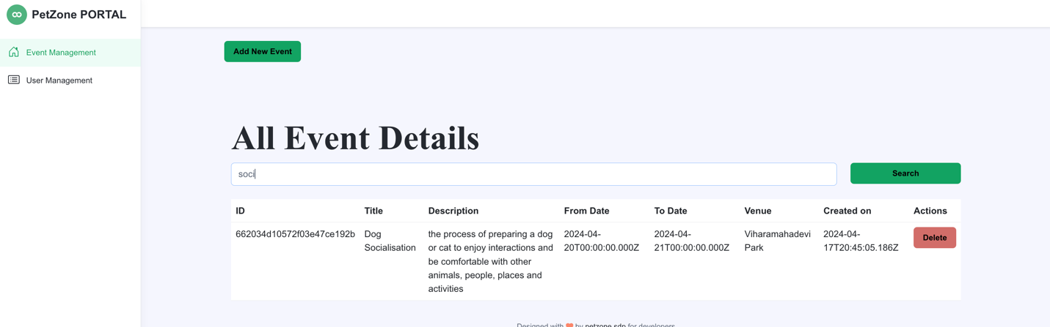

Figure 63 Event Deleted

Figure 64 Search Event

### 3.5.1.6 Community

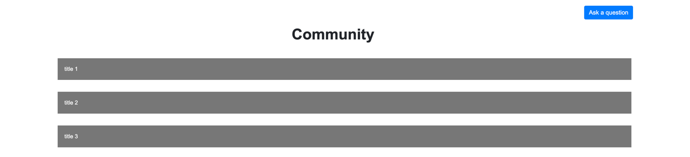A community for the communication of essential details about any event.

Figure 65 Community-Answers section

Figure 66 Community UI

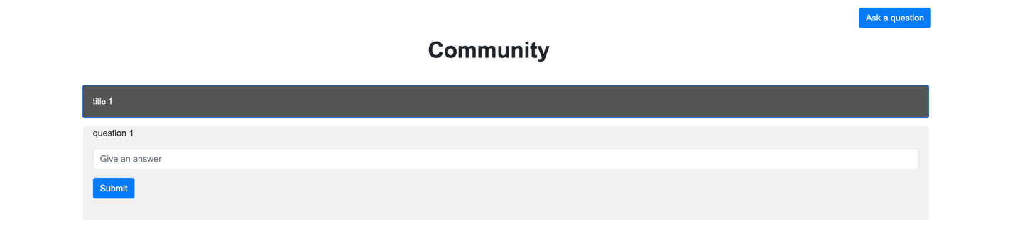

A question can be asked by clicking the ‘Ask a Question’ button

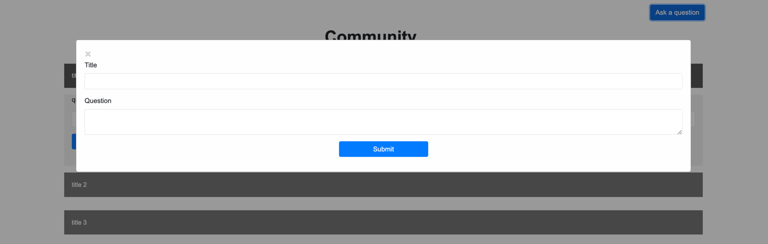

Figure 67 Community-Ask a Question

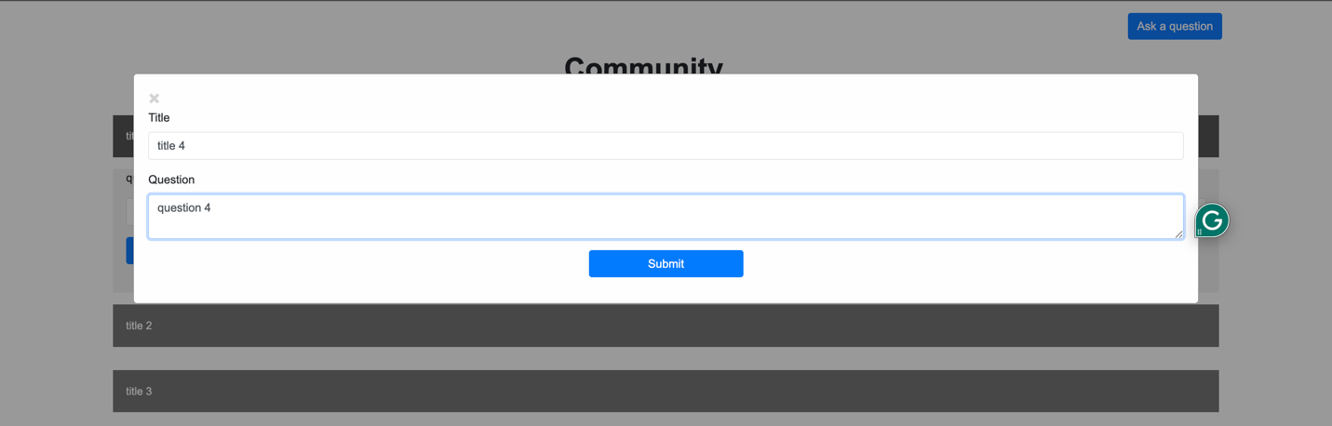

Figure 68 Community-A title and a question typed.

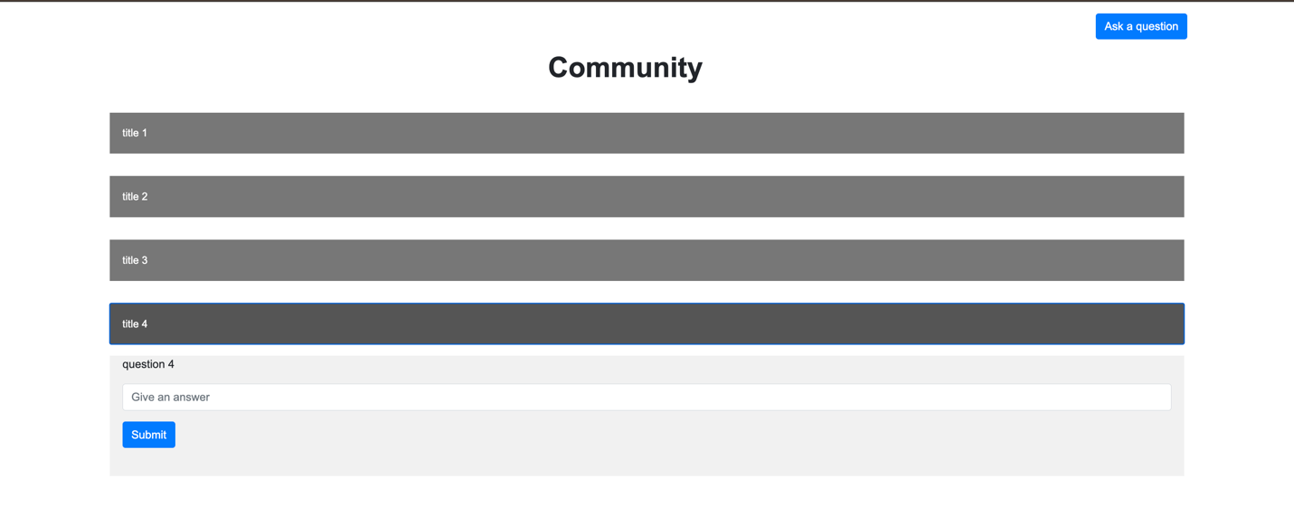

Figure 69 Community-a title and a question added

### 3.5.1.7 Email service

Figure 70 Email Received

Figure 71 Email information typed

### 3.5.2 Back End

### 3.5.2.1 Volunteer Registration to Petzone

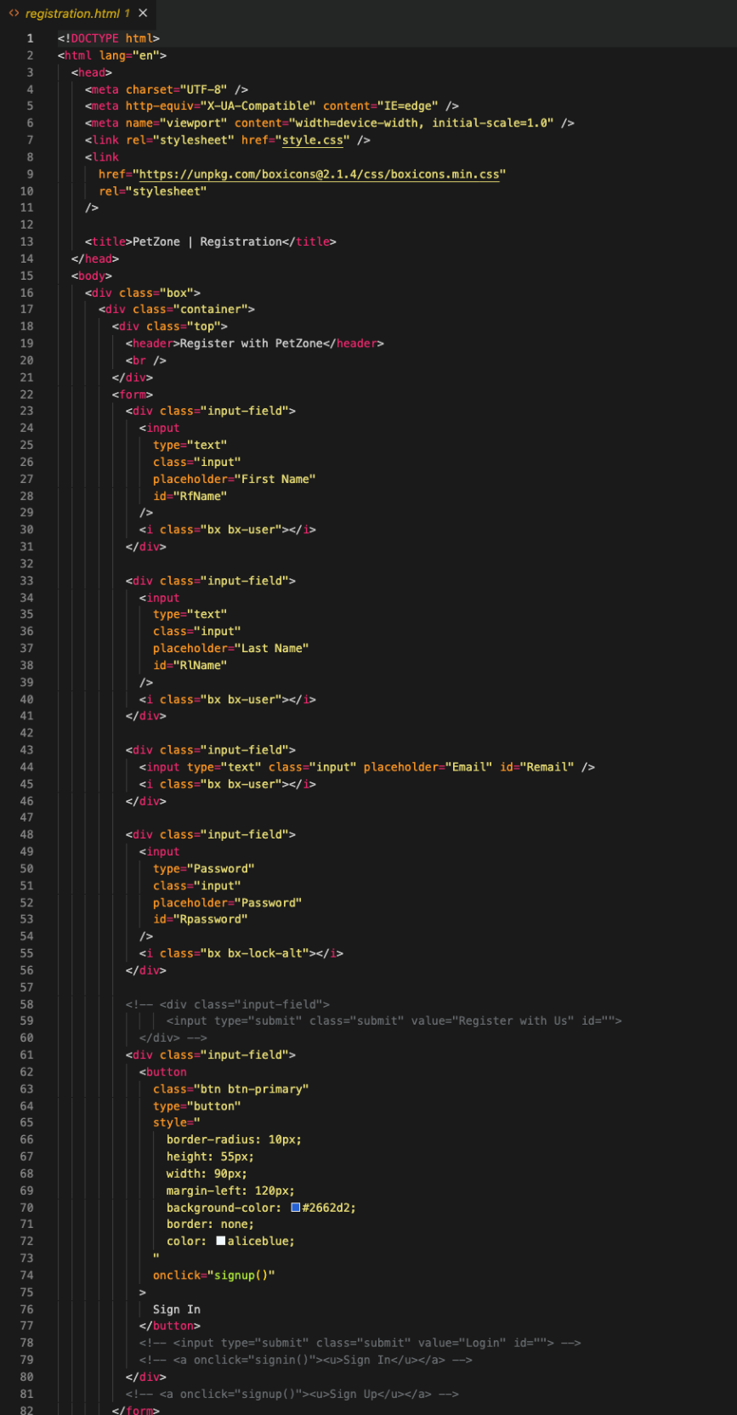

Figure 72 BE-Volunteer Registration pg:1

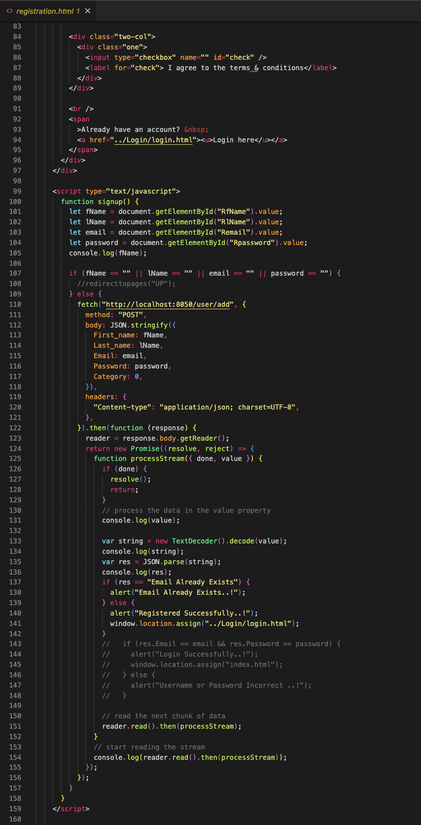

Figure 73 BE-Volunteer Registration pg:2

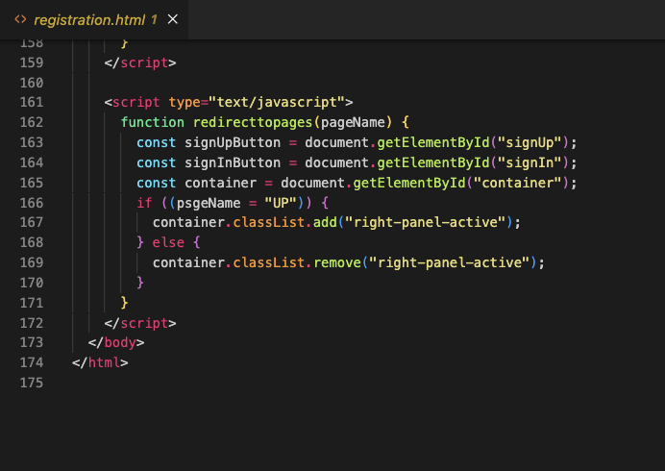

Figure 74 BE-Volunteer Registration pg:3

### 3.5.2.2 Volunteer Login to Petzone

Figure 75 BE-Volunteer Login pg:1

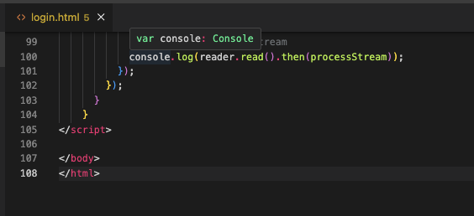

Figure 76 BE-Volunteer Login pg:2

### 3.5.2.3 Petzone Home Page

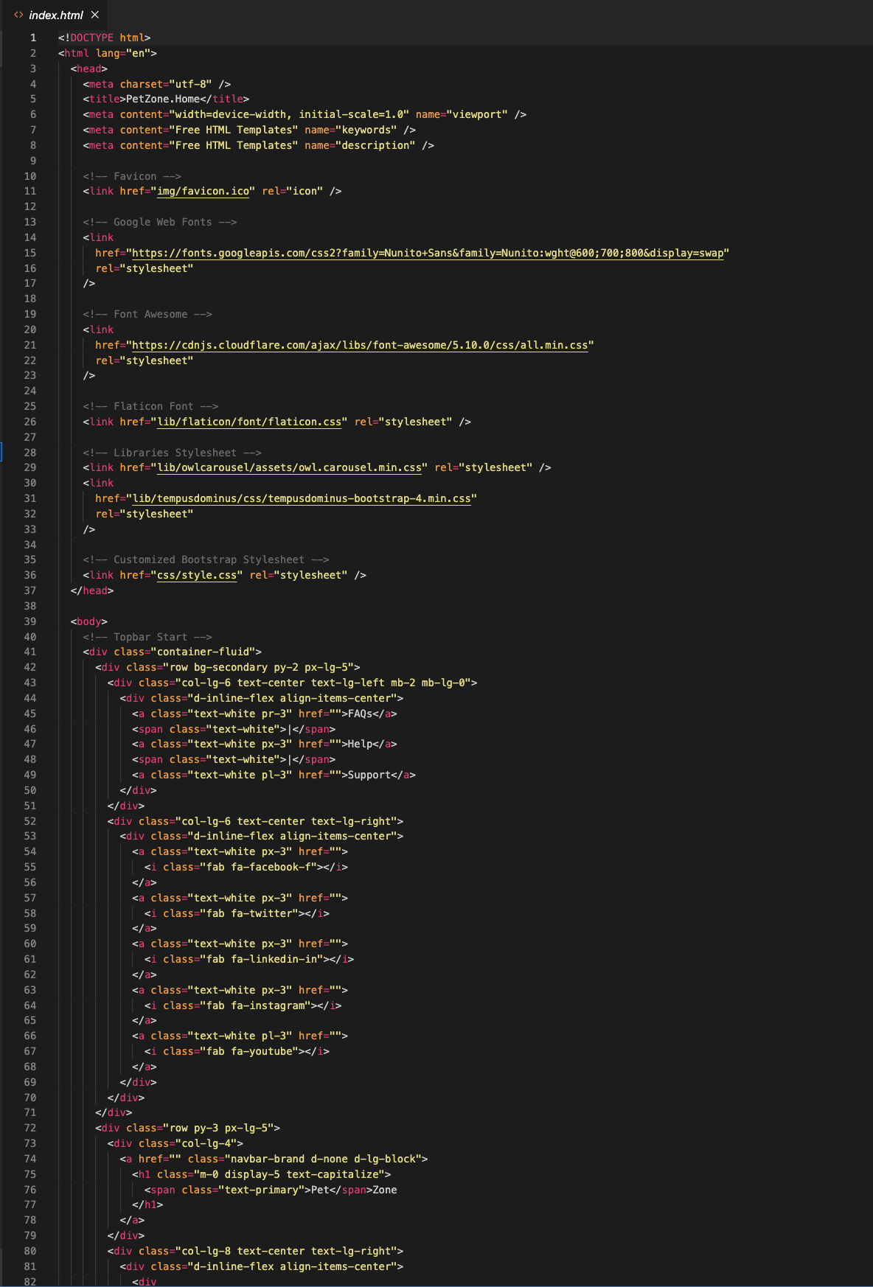

Figure 77 BE-Home pg:1

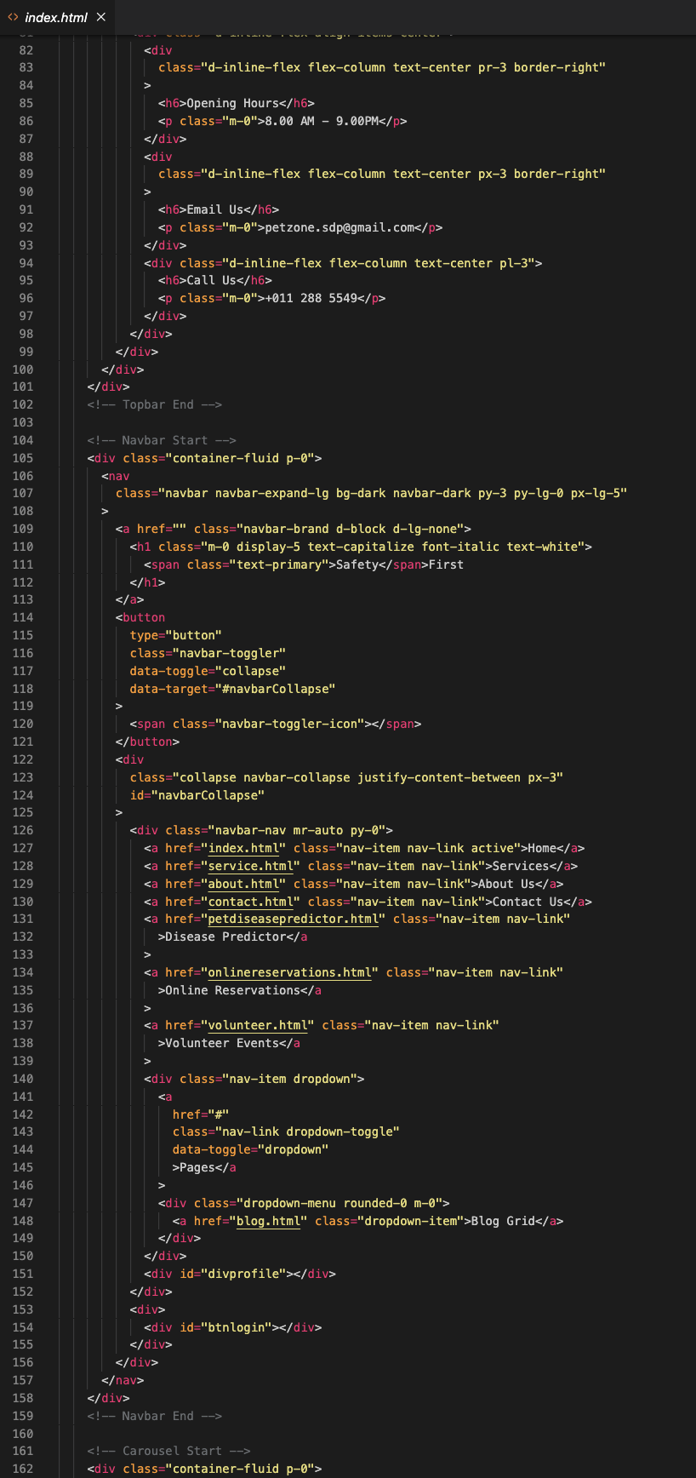

Figure 78 BE-Home pg:2

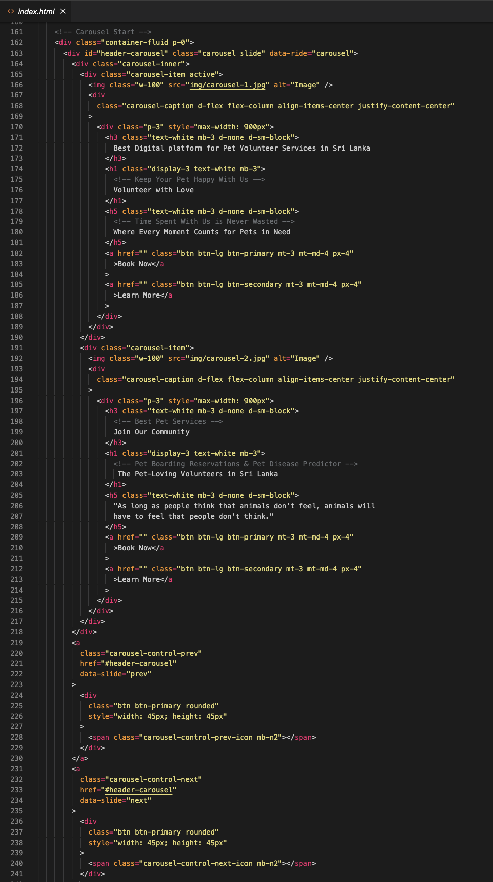

Figure 79 BE-Home pg:3

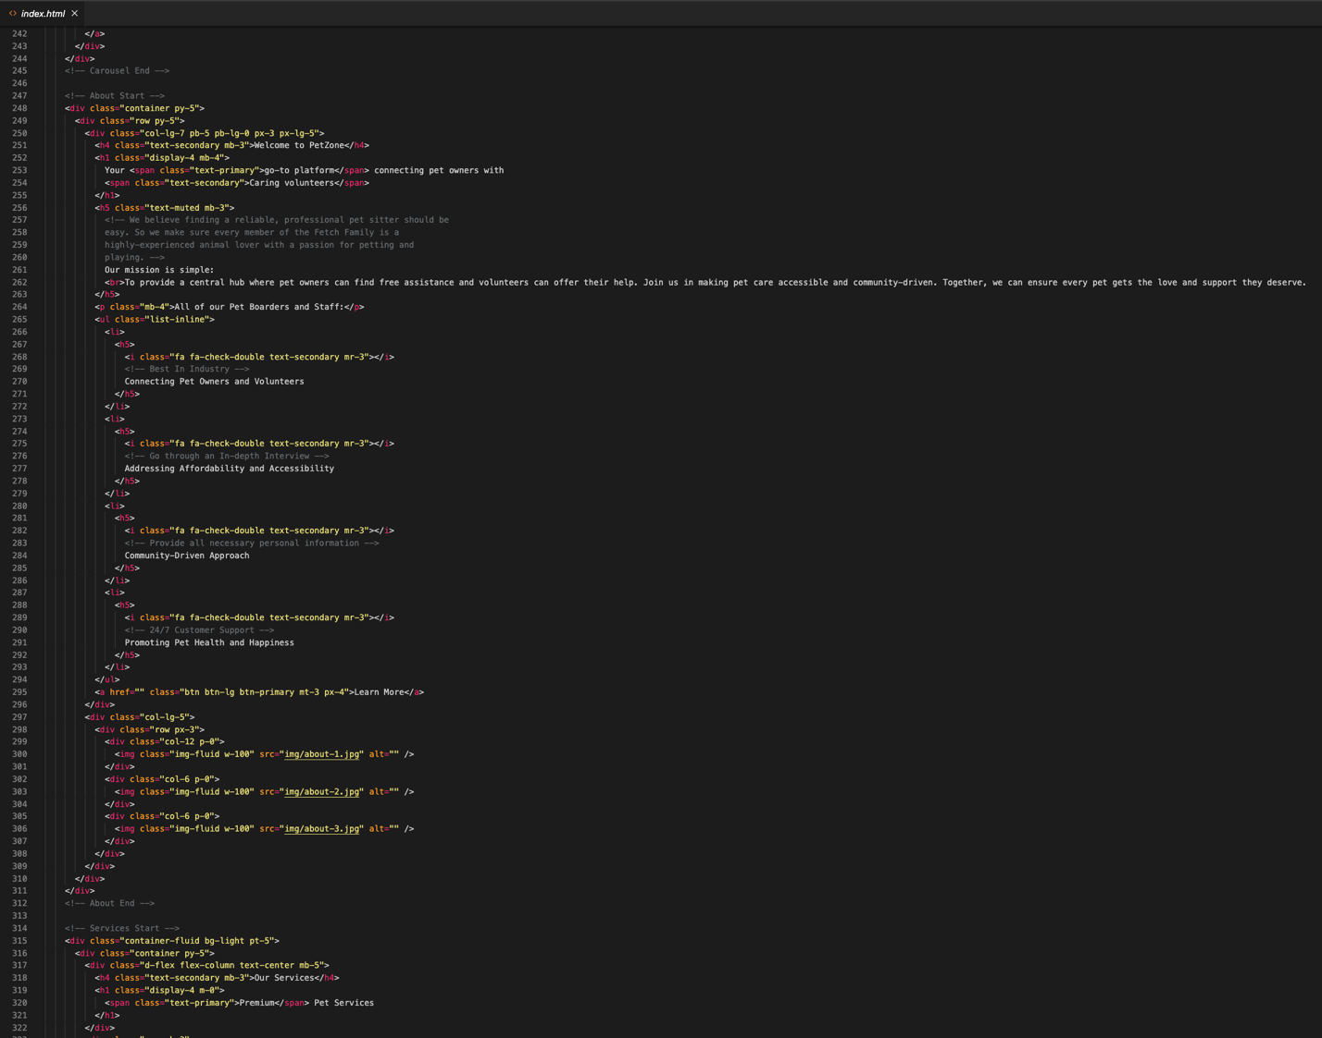

Figure 80 BE-Home pg:4

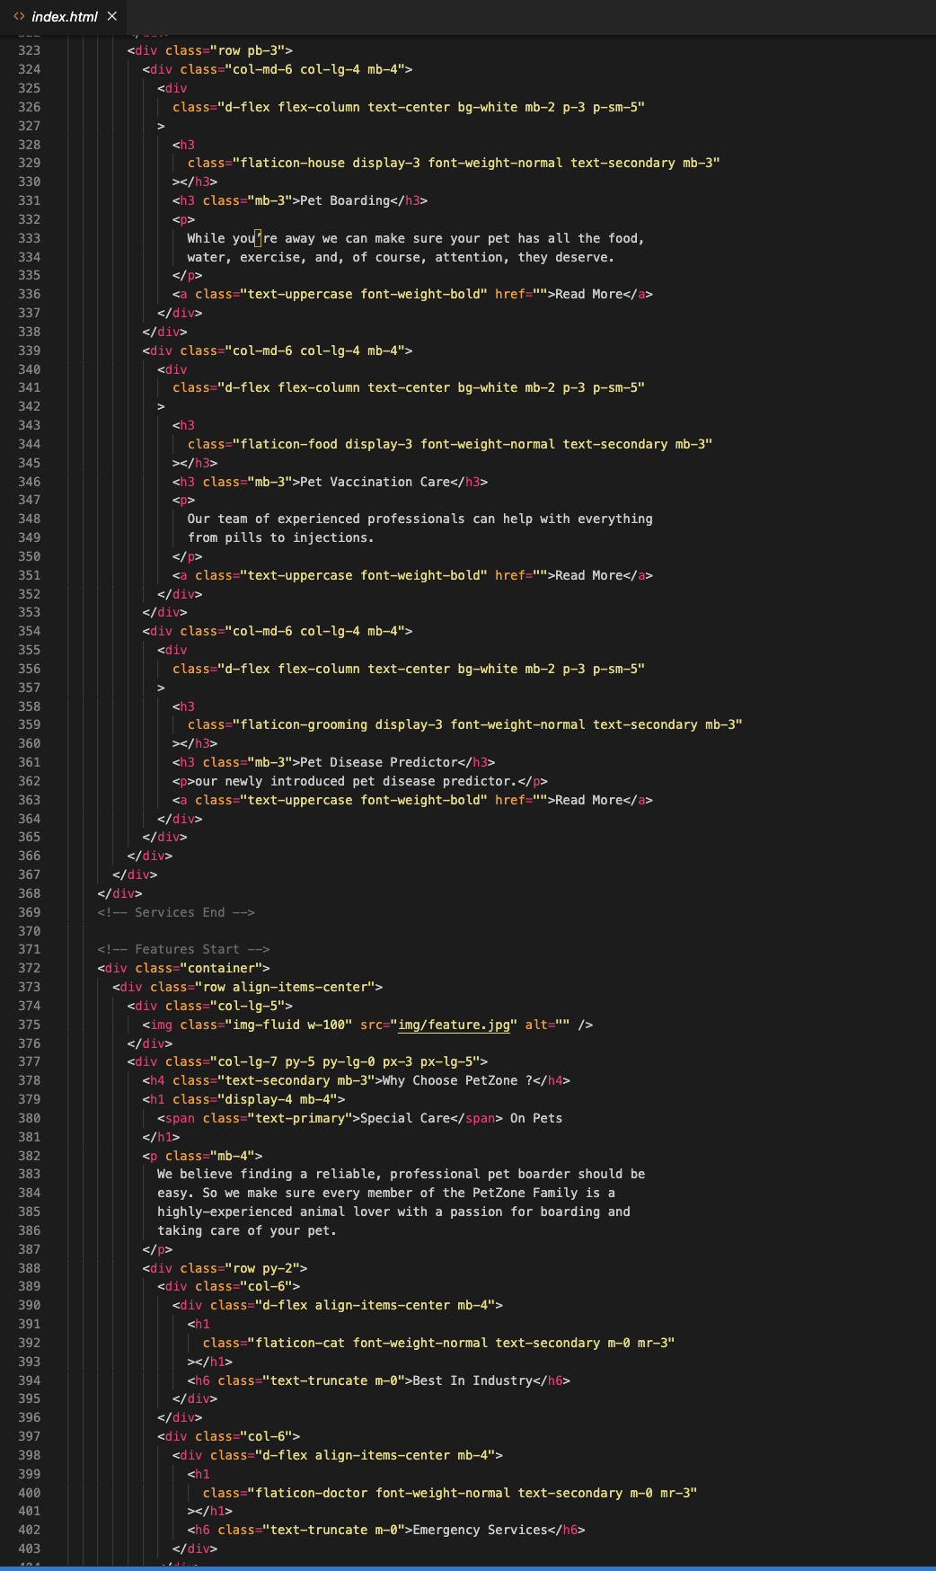

Figure 81 BE-Home pg:5

### 3.5.2.4 Management Login

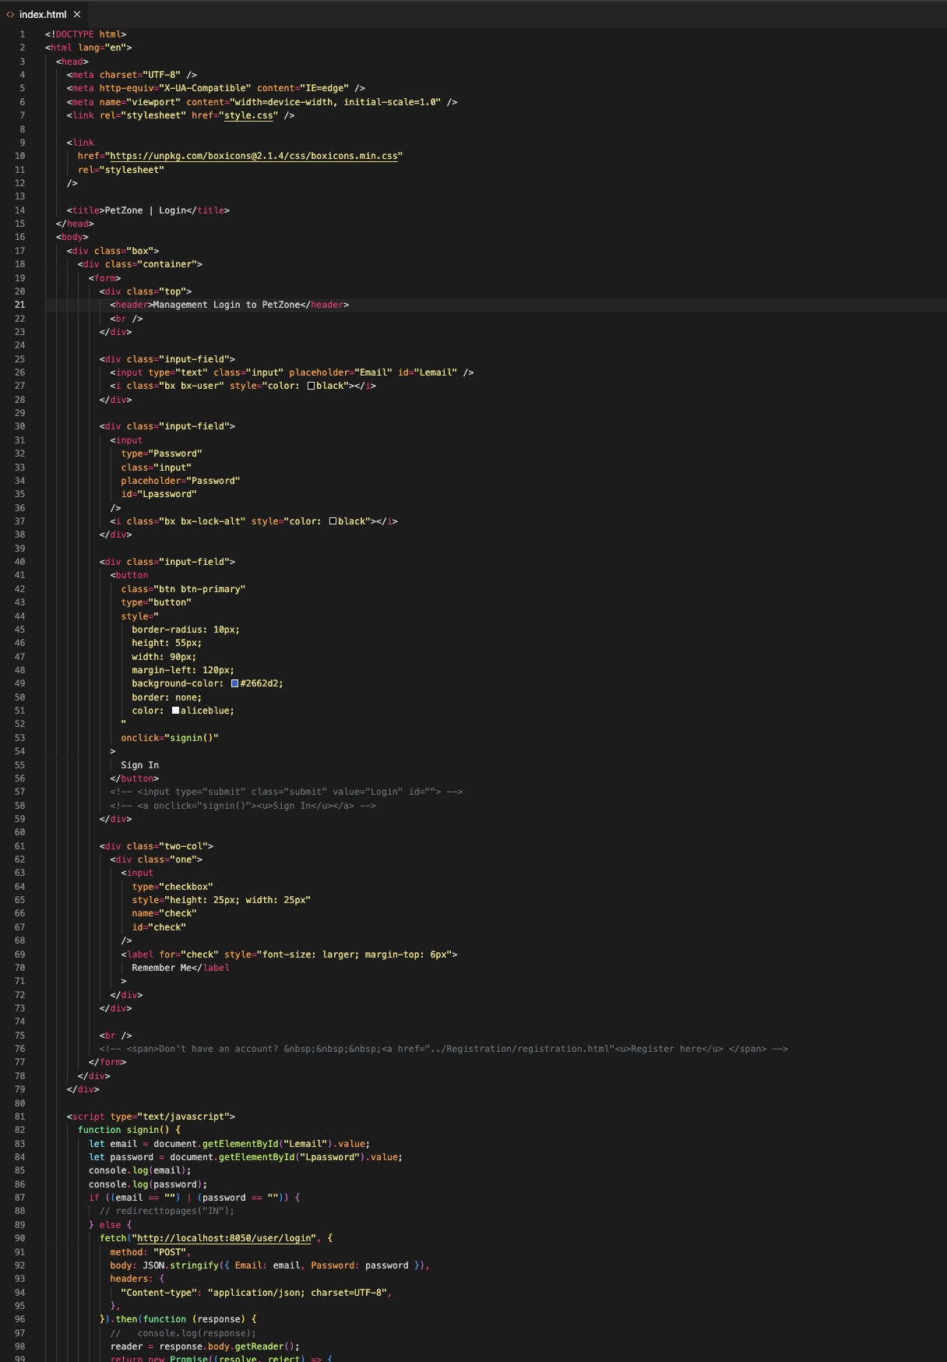

Figure 82 BE-Management Login pg:1

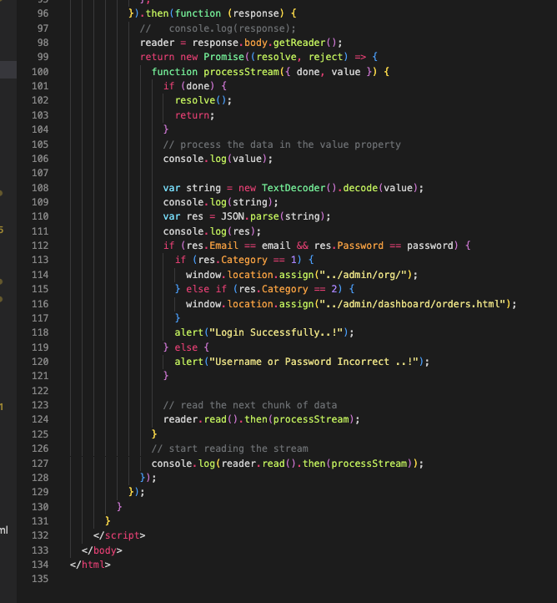

Figure 83 BE-Management Login pg:2

### 3.5.2.5 User Management

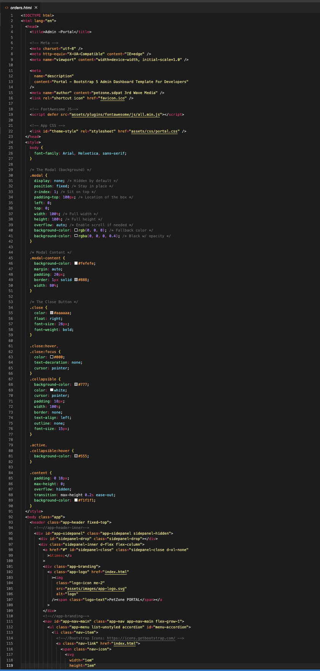

Figure 84 BE-User Management pg:1

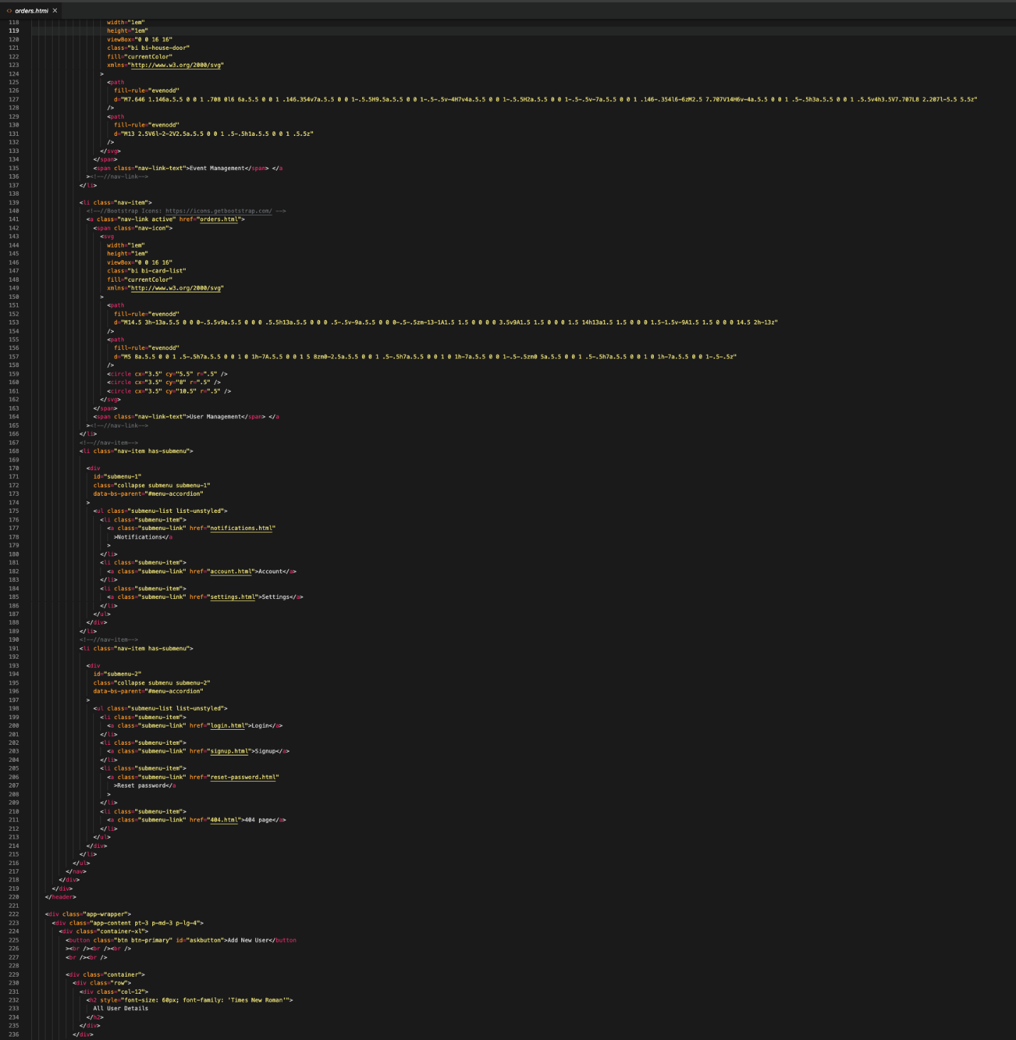

Figure 85 BE-User Management pg:2

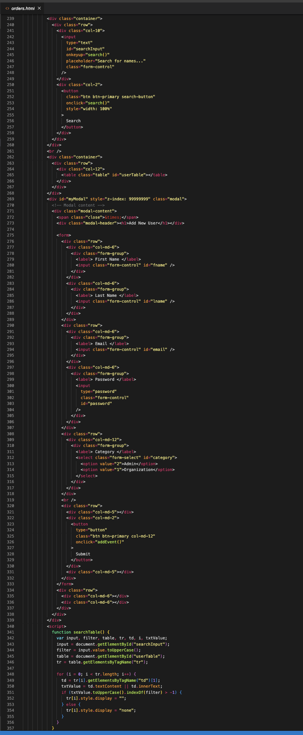

Figure 86 BE-User Management pg:3

3

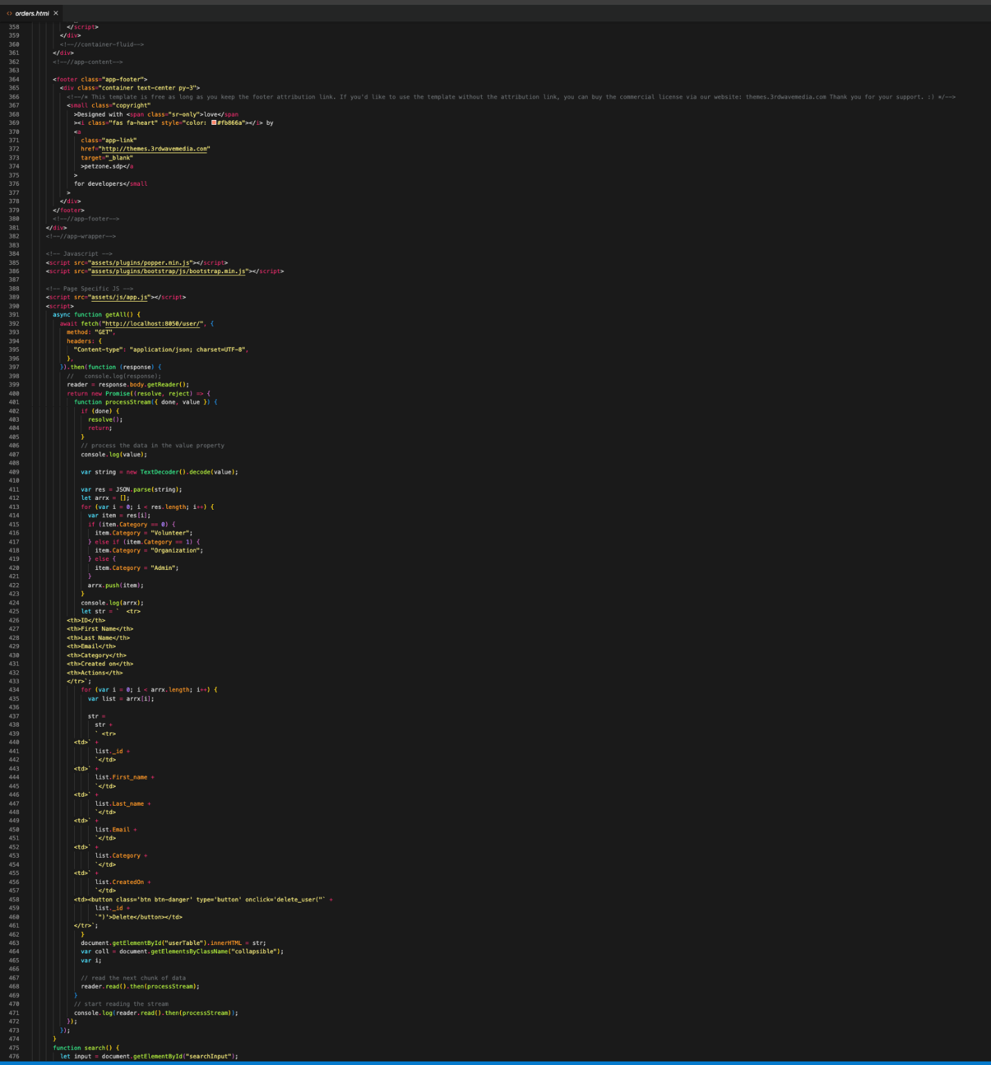

Figure 87 BE-User Management pg:4

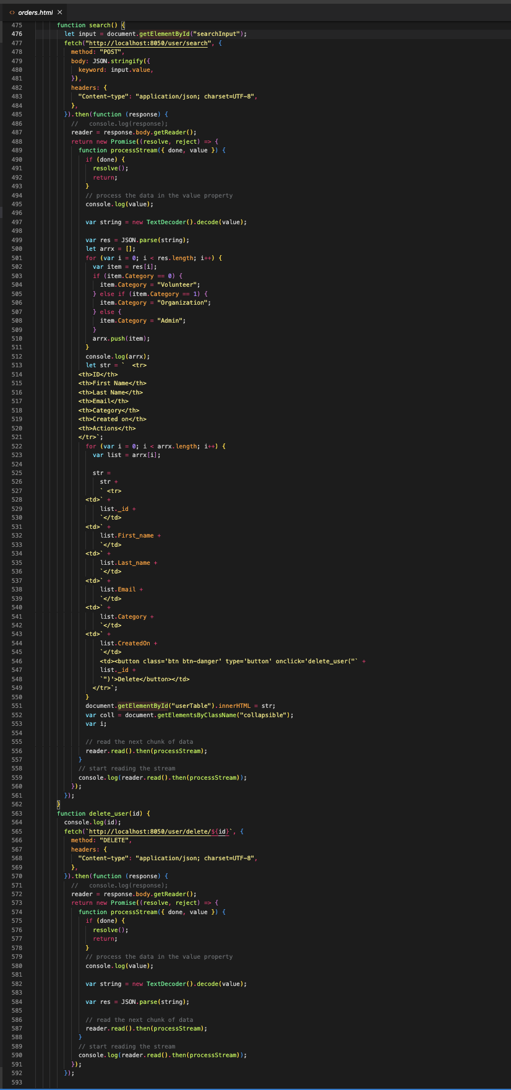

Figure 88 BE-User Management pg:5

### 3.5.2.6 Event Management

Figure 89 BE-Event Management pg:1

### 

Figure 90 BE-Event Management pg:2

### 

Figure 91 BE-Event Management pg:3

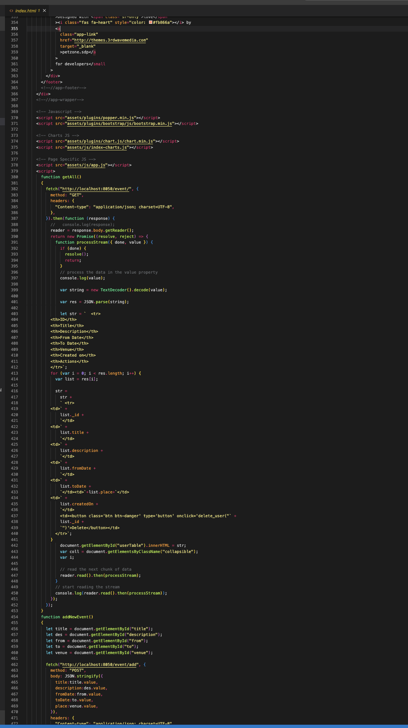

Figure 92 BE-Event Management pg:4

### 3.5.2.6 Community

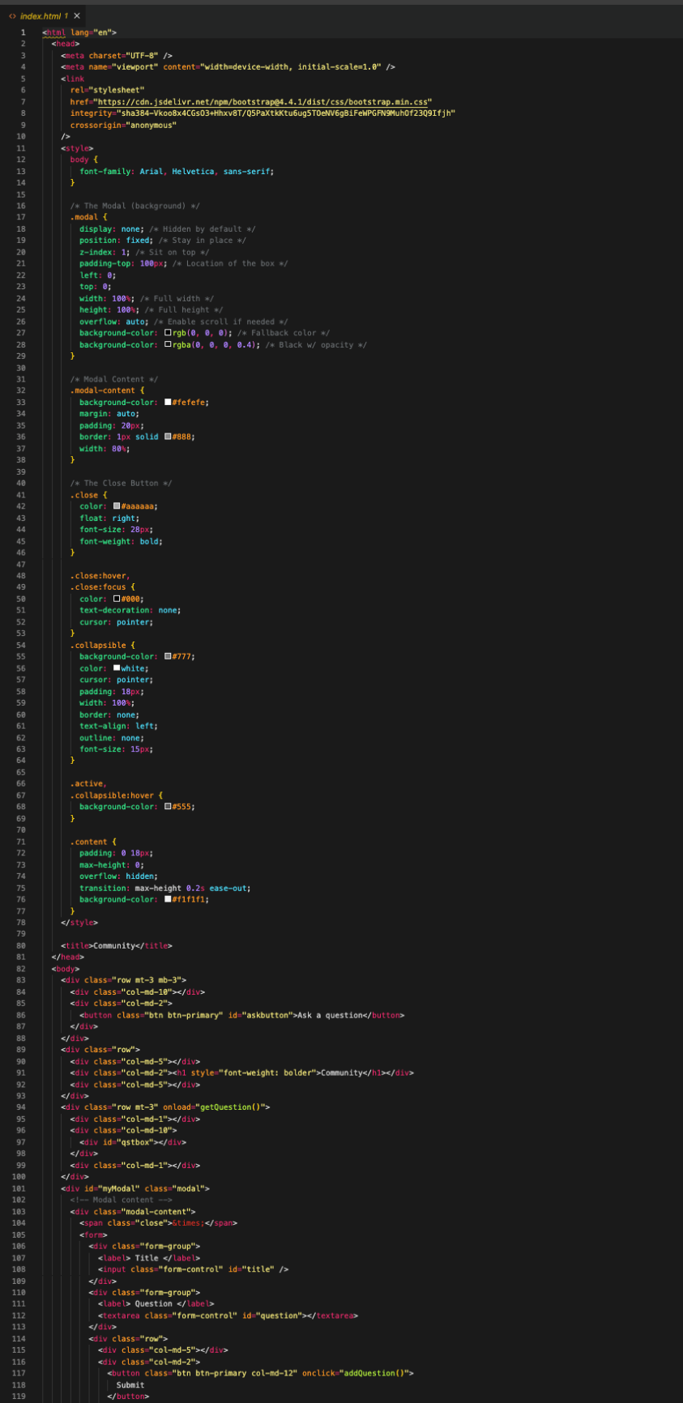

Figure 93 BE-Community pg:1

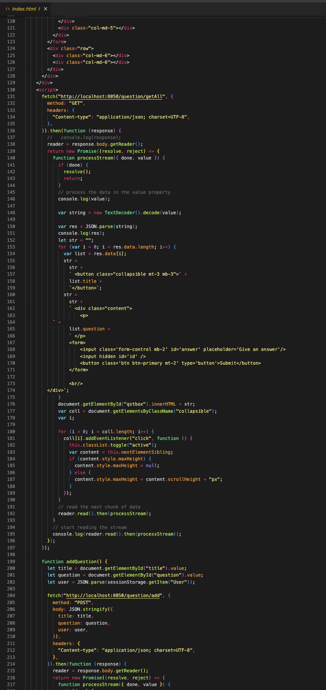

Figure 94 BE-Community pg:2

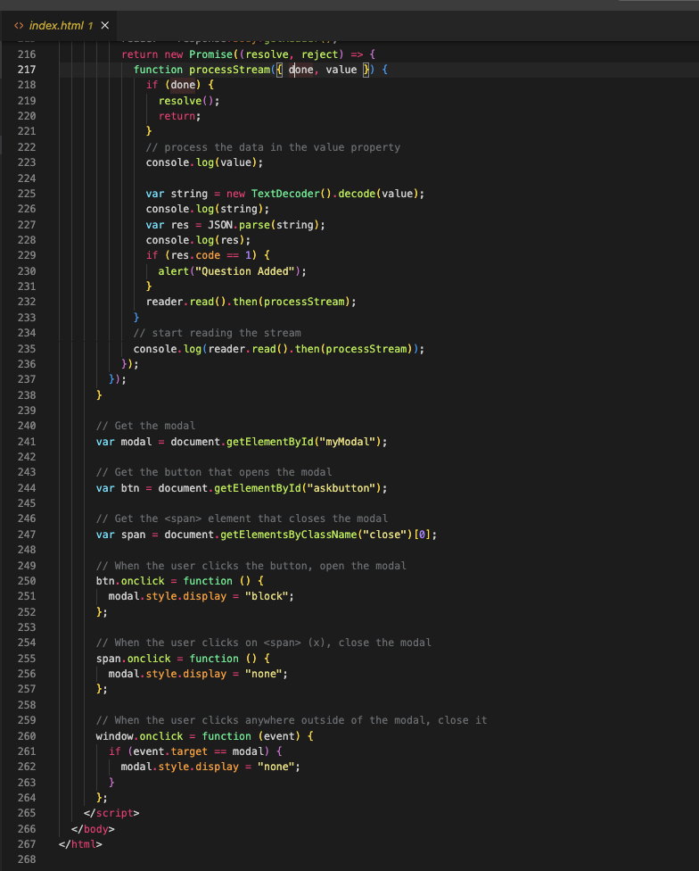

Figure 95 BE-Community pg:3

### 3.5.2.7 Email service

### 

Figure 96 BE-Email Service pg:1

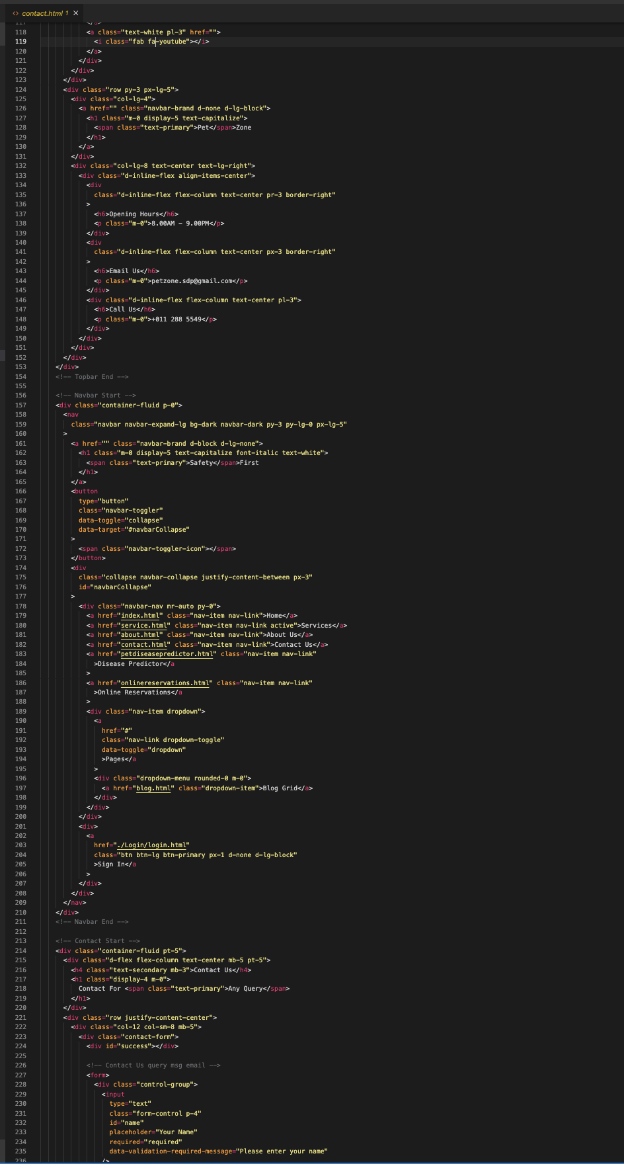

Figure 97 BE-Email Service pg-2

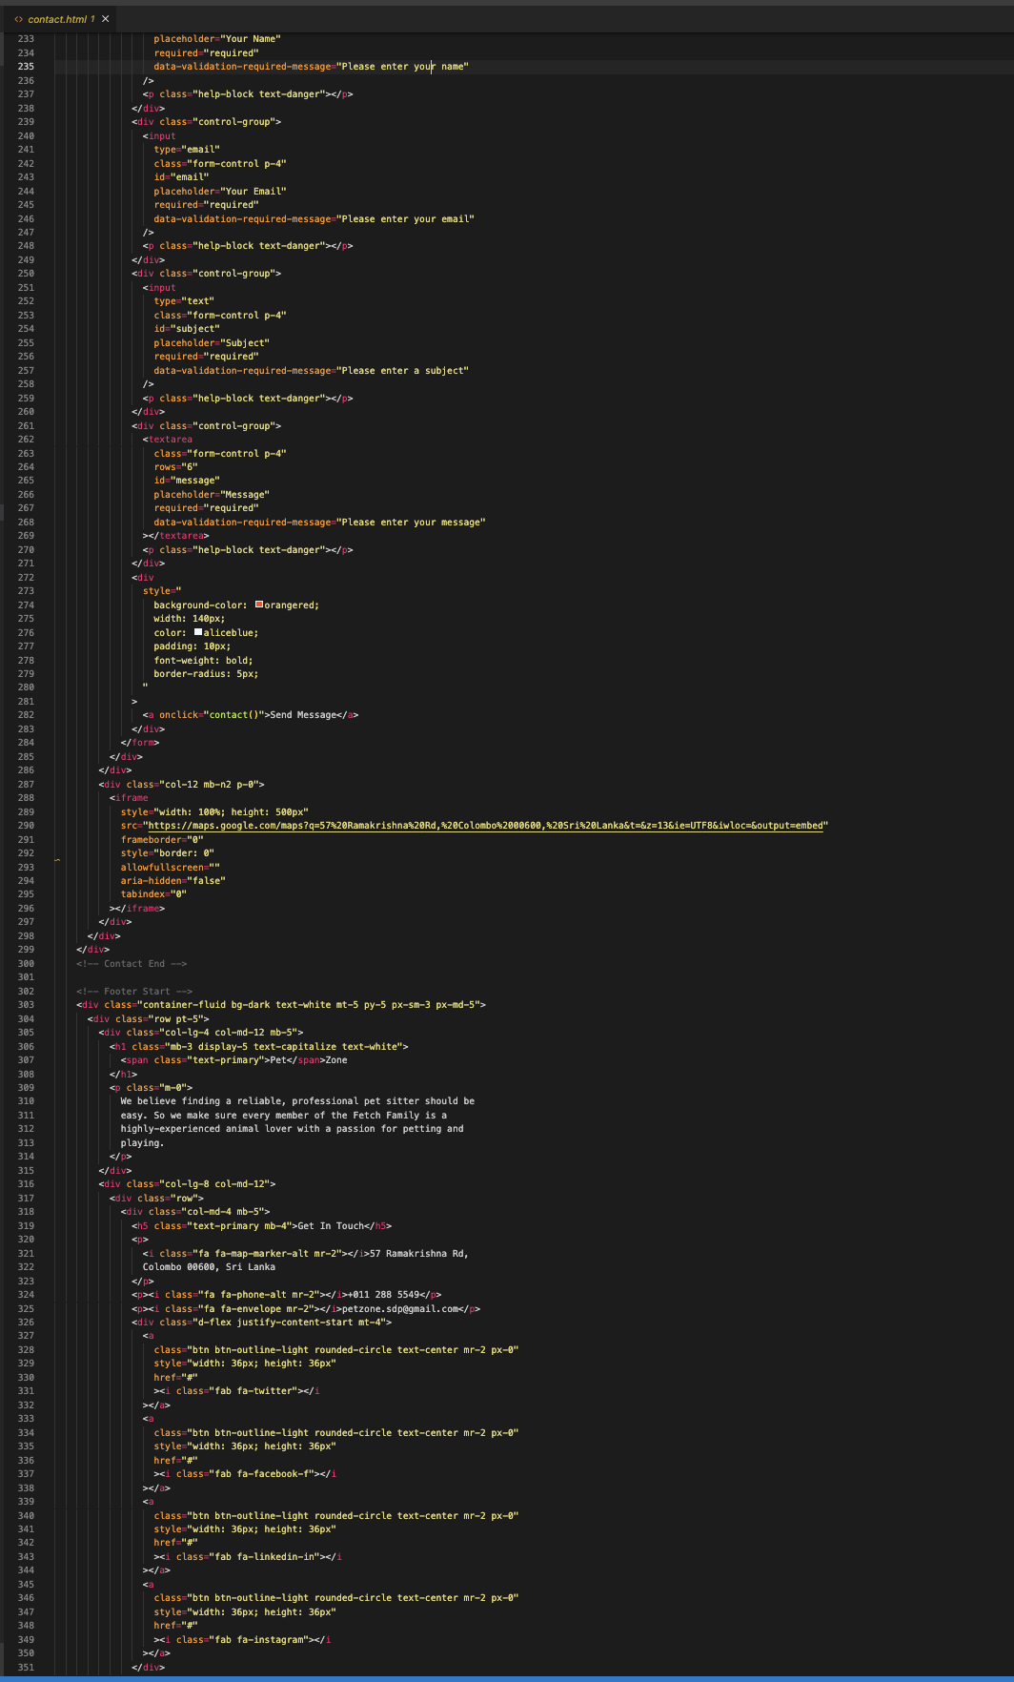

Figure 98 BE-Email Service pg:3

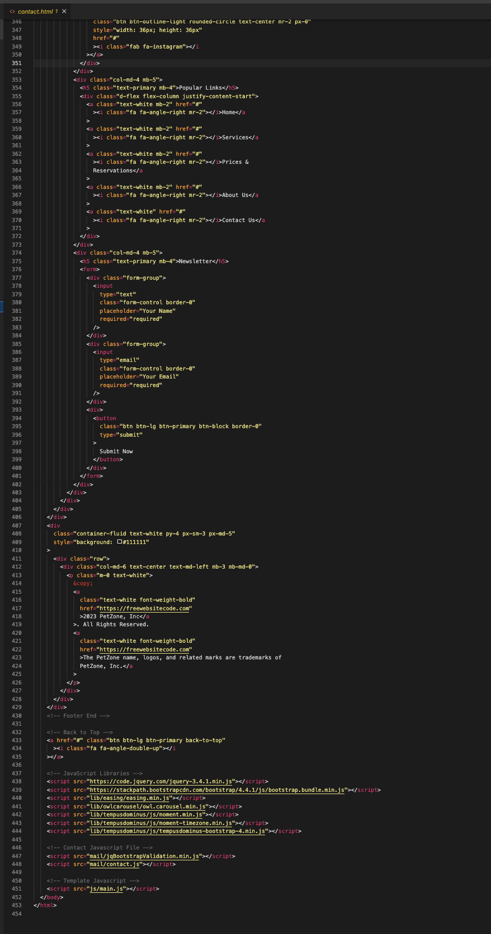

Figure 99 BE-Email Service pg:4

4. Implementation

## 4.1 Chosen Methodology

### 4.1.1 Introduction

Many popular software process models can be used to complete a project successfully. Nowadays developers are facing various problems when following up on some models.

As an example, is the **Waterfall model.**

It’s a linear sequential model where each phase should be completed before proceeding to the next step, one step at a time which is why it’s named the ‘waterfall model’. This makes it difficult to make the changes as it’s challenging to go back to previous stages to make any changes. This model is not recommended for projects where the customer requirements are likely to change. The stakeholders may not see the system until the later stages of development, making it difficult to address any issues and may lead to misunderstandings and or dissatisfactions if their expectations aren’t met.

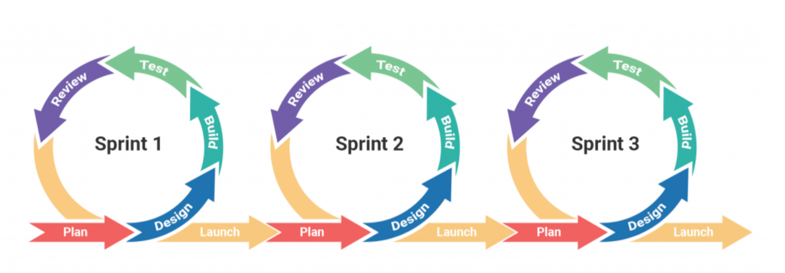Therefore, we chose the **Agile Methodology**.

Figure 100 Agile Methodology

The agile process model prioritizes adaptability to change and collaboration. It allows for iterative Development, where features are developed incrementally and can be adjusted based on user feedback and changing requirements at each sprint. It breaks projects into smaller increments, delivering completed features regularly. Customer feedback and involvement are prioritized throughout the process. It aims for early delivery and frequent delivery. Quality is enhanced through continuous testing, integration and feedback loops.

### 4.1.2 Key characteristics

* + Iterative and Incremental Development

Agile Projects are broken down into small, manageable sprints, each producing a usable feature in the software system. This iterative approach allows for rapid feedback and continuous improvement.

1. Customer Collaboration

This methodology prioritizes close collaboration with stakeholders, including customers and end-users throughout the development process. This ensures that the product meets user needs and delivers the maximum value.

1. Adaptability to change

Agile methodology encourages changes allowing requirements and priorities to evolve throughout the development process. Changes can be made easily and efficiently during sprints, reducing the risk of delivering outdated features.

1. Continuous Improvement

Agile promotes continuous improvement through regular feedback loops. Teams continuously review and refine their processes to improve quality of the product and customer satisfaction.

### 4.1.3 Implementation process

1. Use of Libraries and Interfaces.
   * **HTML, CSS, JavaScript, Bootstrap**: Utilized bootstrap as a front-end framework for responsive design and pre-styled components. Use of JavaScript libraries such as jQuery for DOM manipulation and event handling. Interface with external API for data retrieval.
2. Functions used
   * **Node.js, MongoDB**: Implement Node.js functions for server-side logic, including route handling, request processing, and Database interactions using MongoDB and Node.js.
   * Use functions like ‘find’, ‘insertOne’, ‘updateOne’, ‘deleteOne’ to perform CRUD operations on the MongoDB database.
3. Application of Coding Principles
   * **All technologies**: Apply coding principles such as DRY by reusing code snippets, and components, Keeping the code simple and readable, , and SOLID principles by designing modular and loosely coupled components
4. Critical discussion of coding issues
   * **All technologies**: Addressing issues such as browser compatibility for CSS and JavaScript features, performance optimization for large datasets in MongoDB queries, error handling in Node.js routes.
5. Sophisticated Code
   * **JavaScript, Node.js**: Implement Advanced JavaScript functions like asynchronous programming using async/ await for handling asynchronous operations in Node.js.
6. Code Structure
   * **All Technologies**: Organize codes into separate directories or modules based on the functionality (Eg : routes, controllers, models) to improve readability and maintainability.
7. Choice of Methodologies

* **All Technologies**: Using Agile Methodology for iterative and incremental development. Use tools like Trello for project management, planning and tracking. Hold weekly meeting to discuss the progress.

1. Modularity

* Design codebase with modularity by breaking down functionality into reusable components or modules.

### 4.1.4 Advantages and Benefits

1. Faster Time to market

By delivering working features of the software product regularly at the end of each sprint, Agile methodologies enable faster time to market, allowing organizations to respond to changing market demands and trends quickly and gain a competitive edge.

1. Improve Customer Satisfaction

Agile methodology involves customers and end-users throughout the Development process ensuring that the final product meets their needs and expectations. This leads to higher customer satisfaction.

1. Higher Quality

Agile Methodologies emphasize continuous testing, integration and feedback resulting a higher-quality software with fewer defects and issues. This reduces rework and ultimately saves time and resources.

1. Reduced Risk

Agile projects reduce risk by delivering system features incrementally and getting feedback at each sprint addressing issues rapidly. This reduces the possibility of project failures and guarantees that the final product meets user needs and expectations.

1. Enhanced flexibility

This methodology provides the flexibility to adapt to changing requirements, priorities and market conditions quickly. This enables organizations to respond to customer feedback and market trends more effectively.

### 4.1.5 Chosen Technologies

This topic describes the technologies which is used to implement all the required features of the following system.

All the features of the system is implemented with below mentioned technologies.

|  |  |  |
| --- | --- | --- |
|  | **Technologies** | **Purpose** |
| **Web Application** | **HTML5** | To structure content and design responsive layouts with interactive features and embed multimedia. |
| **CSS** | To style and format the visual appearance and provide an attractive, high-speed user interface. |
| **JavaScript** | To add functionality, manipulate HTML and CSS, handle user interactions, and communicate with servers asynchronously. |
| **Bootstrap** | To build responsive and mobile-first and web application |
| **Node.js** | To build scalable, high-performance backend application. |
| **Database** | **Mongo DB** | To store large volume of data in a secured and flexible way |

### 4.1.6 Software Tools

**Visual Studio Code (VS Code)**

Visual Studio Code (VS Code) is a versatile and feature-rich code editor that caters to the needs of developer across all the languages which are used to implement the system. The customized interface, extensive extension ecosystem and the integrated development features of VS Code have highly increased the productivity of the development process. As a powerful tool, VS Code offers many **integrated Development Environment (IDE) Features such as** IntelliSense, debugging, and integrated Git support, which have enabled developers to implement the system very efficiently. Generally, VS Code has become the major development tool of the project by creating a customized and comfortable coding environment.

**MongoDB**

MongoDB is a fully managed and scalable cloud database that enables developers to confidently build, deploy, and scale MongoDB cloud databases. The most robust set of features, security controls, and global deployment features of MongoDB make it a choice to use MongoDB in the cloud to leverage the preferred size of the system. It’s automated backup and point-in-time recovery capabilities, allowing developers to easily restore data to a specific point in time in the event of data loss or corruption, are another key characteristic that has made MongoDB the cloud database of the system.

**Node.JS**

Node.js has chosen and worked as the backbone for project development due to its ability to leverage JavaScript for both client-side and server-side development of the system, its asynchronous and non-blocking I/O model, vibrant ecosystem of modules and packages, scalability, strong community and support, high performance, fitting to micro services abased architecture and support for modern development practices like server less computing and containerization.

### 4.1.7 Hardware Tools

The overall system is implemented by using below mentioned hardware tools.

**Computer (Laptop):**

Laptops with modern CPUs, ample RAM (4GB), and SSD storage have been used to implement the system to run development environments, compile code, and execute tests efficiently.

**Monitor:**

Large, high-resolution monitors have been used to implement the system which can enhance productivity by providing additional screen real estate for viewing code, documentation, and other development tools simultaneously.

**Keyboard and Mouse:**

Comfortable and ergonomic keyboards and mice are used for implementations which are essential for developers who spend long hours typing and navigating code.

**Networking Equipment:**

Reliable networking equipment, including routers, and network cables, is necessary for connecting development workstations to local networks, the internet, and cloud services. High-speed internet connectivity has been used, which is crucial for downloading dependencies, accessing remote repositories, and collaborating with team members.

### 4.1.8 Development Framework

**Bootstrap**

Bootstrap is another valuable tool which has used for the project development which has provided a responsive and consistent design system, cross-browser compatibility, customization options, accessibility features, strong community support, and seamless integration with JavaScript plugins. Overall Bootstrap has ultimately helped create a high-quality web application more efficiently.

### 4.1.9 Languages

**HTML5**

HTML5 is the latest version of Hypertext Markup Language which has been used for structuring and presenting the content on the PetZone web application. HTML5 offers native support for multimedia elements, and this enables the integration of the multimedia content of the system in the easiest way. The new semantics in HTML5 provide a clearer structure to the web document by improving accessibility and search engine optimization (SEO) of the system. HTML5 aims to improve the performance of web applications through features like Web Workers, which allow scripts to run in background threads. Overall HTML5 is a more powerful and feature-rich platform which has become one of the key languages of the system which provides features to enhance performance across various devices and platforms.

**CSS**

CSS allows to separate the content (HTML) from the presentation (styles) by enhancing the maintainability, to update the design of the PetZone web application without altering its content. This has enabled consistent styling across multiple pages of the web application. CSS is more efficient which can be applied styles to multiple elements simultaneously, reducing the need for repetitive HTML code. Additionally, with the features offering flexibility in design, enhancing accessibility, indirectly impacting SEO and facilitating easier maintenance have enabled to save valuable time and effort of the system development process.

**JavaScript**

JavaScript is an indispensable scripting language which has allowed us to create interactive elements on the PetZone web application, such as dynamic forms, image sliders, and pop-up dialogs, enhancing user engagement and experience. With the feature of DOM manipulation, can be able to dynamically change the content, style, and structure of the web application. In summary, JavaScript has become another key language of the system implementation which can communicate with the server, access to a rich ecosystem of libraries and frameworks which has been used for implementations.

### 4.1.10 Developed Components

**Registration/Signup (User, Organization, Admin)**

The registration functionality enables all new users, organizations and the admin to sign up with the PetZone web application. It generally contains a sign-up form where the registrants can enter their details such as first name, last name, email and password. The system validates the input email address to ensure that registrants provide a valid email address. After successful validation, the new registrant record is entered to the database and logs into PetZone system automatically by creating a separate user profile.

**Login (User, Organization, Admin)**

The login functionality allows all the users who successfully complete registration with the PetZone web application, to log into the application. The web application consists of a login form where the users can enter their email address or username and password. During the submission, the system validates the credentials with the database and authenticates the user if they are valid. If the credentials are incorrect, the user gets error messages and user is not allowed to login.

**User Management Module**

With this functionality, the admin of the system can handle the CRUD (Create, Read, Update, and Delete) operations related to users. This includes operations such as adding new users, editing existing users, viewing user details, deleting users from the system and searching the records upon to entered details.

**Event Management Module**

Event management module enables the admin to handle the CRUD (Create, Read, Update, and Delete) operations related to events. Adding new events, viewing event details, deleting events from the system and searching the event records upon to entered details are the functionalities which admin can handle with event management module.

**Search Module for Volunteer Opportunities**

This search module allows the users to search for new and existing Volunteer Opportunities of the PetZone system. The search functionality presents volunteer opportunity details upon to entered details bu the user.

**User sign-up module for volunteer roles**

All the users are added to the system as volunteers from the registration. After successfully adding a user, the user is enabled for all the volunteer functionalities.

**User profile module**

The user profile feature in PETZONE allows volunteers and pet owners to create and maintain personalized profiles that present their individual needs and engaged projects. These profiles enable users to highlight personal details, their skills, availability, and interests, making it easier to connect and collaborate with others in the pet care community. Additionally, this functionality makes it simpler for pet owners to find caring volunteers.

**Community management module**

The community questions and answers functionality in PETZONE is a valuable resource for pet owners, volunteers, and organizations to seek advice, share knowledge, and address concerns related to pet healthcare. Users can ask questions, seek guidance, and provide answers based on their expertise and experiences within the pet care community. By encouraging open communication and collaboration, PETZONE empowers users to support each other, enhancing their knowledge of pet healthcare.

**Email inquiry module**

Within PETZONE, the email inquiry module allows for smooth communication among volunteers, organizations, and platform administrators. Users can access the email inquiry module from the contact us. Users can easily reach out with questions, feedback, or support needs regarding registration, profile management, or platform usage.

5. Software Quality Assurance

## 5.1 Validation & Verification

According to below mentioned structured approach, the Quality Assurance (QA) validation and verification have been done for PETZONE focuses on ensuring that the web application covers up the needs of pet owners and volunteers and maintains the highest standards of usability, reliability, safety and performance.

**Functional Testing**

* Ensure all the key functionalities worked as expected, such as user registration, User management, connecting pet owners with volunteers, and event management.
* Ensure users can easily navigate the platform and handle tasks simply.
* Test compatibility on different devices and networks to ensure a seamless experience for the user.

**Database Integrity**

* Validate the validity and stability of data stored in the system database
* Verify that the database can handle multiple concurrent users without data corruption or performance degradation.

**Security Assessment**

* Present vulnerability scans and penetration testing to recognize and address any potential security threats.
* Ensure compliance with relevant data protection regulations.

**User Acceptance Testing (UAT)**

* Gather feedback by conducting UAT from pet owners, volunteers, and organizations to validate and ensure that the PetZone application meets their expectations and needs.

**Performance Testing**

* Monitor application performance and speed under different load conditions to ensure optimal performance.
* Identify and address any challenges or performance issues that may arise during peak usage.
* Optimize code and database queries to increase overall system performance and scalability**.**

### 5.1.1 Roles and Responsibilities

**Quality Assurance Roles and Responsibilities for PETZONE Project:**

|  |  |
| --- | --- |
| **Role** | **Responsibilities** |
| **QA Lead** | * Understanding the project objectives and requirements by conducting regular discussions with project managers and developers. * Develop the appropriate QA strategy, including testing methodologies, tools, and timelines. * Oversee the progress, issues and improvements for PetZone application by conducting regular meetings with developers and managers. * Make sure the PETZONE web application is delivered on time and with quality. |
| **QA Analysts** | * Design appropriate test plans and test cases by considering project requirements and objectives. * Perform hands-on testing of the PETZONE website, which includes checking for functionality, regression issues, integration challenges, and ensuring user acceptance of the system. * Identify and prioritize the issues of the web application and collaborate with developers to resolve issues. |
| **Test Automation Engineer** | * Design and develop automated scripts using automation tools such as selenium and cypress. * Run automated tests to check if the PETZONE application works well and is reliable and integrate tests into CI/CD pipeline. * Oversee and maintain the stability of automated testing processes. |
| **User Acceptance Testing (UAT) Coordinator** | * Conducting meetings with UAT activities for stakeholders of Petzone such as pet owners, volunteers, and organizations. * Design UAT test plan and provide testing guidelines and conducting sessions to gather feedback from stakeholders. * Identify and prioritize issues during the UAT and communicate results and recommendation with the team |
| **Security Testing Specialist** | * Perform security checks and penetration testing to recognize any vulnerabilities in the PETZONE application. * Recommend and develop security measures to protect sensitive information and stop unauthorized entries. |

### 5.1.2 Environment Requirement

**Development Environment:**

* Operating System: Windows
* Integrated Development Environment (IDE): Visual Studio Code
* Web Development Tools: Node.js (Node Package Manager), Git for version control
* Database: MongoDB

**Testing Environment:**

* Operating System: Windows
* Web Browsers: Google Chrome, Microsoft Edge for cross-browser testing
* Testing Tools: Selenium WebDriver for automated testing, Postman for API testing, Jest or Mocha for unit testing
* Test Data: Sample data for simulating various scenarios, including pet profiles, volunteer profiles, and event management
* Test Environment Setup: Different environments are used for integration testing, such as staging and QA environments that closely resemble the production environment.

**Production Environment:**

* Operating System: Ubuntu
* Application Server: Node.js for running the PETZONE web application
* Database Server: MongoDB
* Security Measures: SSL/TLS certificate for secure communication
* Scalability: Load balancer configuration for distributing incoming traffic, horizontal scaling of application servers to handle increased load during peak times

### 5.1.3 Testing tools and frameworks

### 5.1.4 Test Plan/ Schedule

**Quality Assurance (QA) Test Plan and Schedule for the PETZONE project:**

**Objective**

* This QA Test Plan is to make sure that the PETZONE web application meets the specified requirements and standards in terms of functionality, usability, security, and performance.

**Testing scope**

* The system QA has been executed in four test phases such as functional testing, usability testing, security testing, and performance testing to cover all features and functionalities of PetZone web application.

**Test Phases**

* Functional Testing
* Usability Testing
* Security Testing
* Performance Testing

**Functional Testing**

* Verify and validate the user registration process. Test the profile management features for both individual volunteers and organizations. Ensure that the functionality to link pet owners with volunteers is working properly. Validate the event management functionalities. Confirm the functionality of the opportunity database.

**Usability Testing**

* Assess the user interface to ensure it is easy to navigate and has an intuitive design. Test the responsiveness on various devices and screen sizes. Check if all accessibility features are in place for users with disabilities. Confirm that user workflows are efficient and clear.

**Security Testing**

* Conduct penetration testing in order to find any vulnerabilities in the application. Verify the data encryption methods to safeguard any sensitive information. Test the authentication and authorization procedures. Check to ensure compliance with the appropriate security standards has been met.

**Performance Testing**

* Evaluate response times for actions like user registration, managing profiles, and database queries. Ensure caching methods are working properly and efficiently use resources. Identify any performance issues and areas that could be optimized.

**Test Schedule:**

* Day1-4: Functional Testing
* Day 4-6: Bility Testing
* Day 6-8: Security Testing
* Day 8-10: Performance Testing
* Day10-13: Bug Fixing and Retesting
* Day 13-15: Final QA Review and Sign-off

### 5.1.5 Test Cases and Results for Selected Components.

**Test Case 1**

|  |  |  |  |
| --- | --- | --- | --- |
| **Project Name** | PetZone Volunteer system - Registration | **Test Engineer** | Erandi Perera |
| **Test date** | 05.04.2024 | | |
| **Test case ID** | 1 | | |
| **Product module** | User Registration | **Status** | Pass |
| **Purpose** | To Register with the PetZone web application | | |
| **Pre- condition** | Enter the particular details such as first name, last name, email and password | | |
| **Steps** | Load the PetZone web application. Click the sign-in button and click for “Register here” then enter the first name, last name, email and password and click sign-in. | | |
| **Expected Outcome** | To get a separate user profile according to entered details and log into the system successfully. | | |
| **Actual Outcome** | Successfully get login form to log into system and a separate user profile has been created by the system. | | |
| **Post Condition** | Redirect to the login form. | | |

**Test case 2**

|  |  |  |  |
| --- | --- | --- | --- |
| **Project Name** | PetZone Volunteer system - Login | **Test Engineer** | Sandara Dewmini |
| **Test date** | 05.04.2024 | | |
| **Test case ID** | 2 | | |
| **Product module** | User Login | **Status** | Pass |
| **Purpose** | To Log Into PetZone system | | |
| **Pre- condition** | Registration or enter the particular details such as email and password | | |
| **Steps** | First login to the system by entering username and the password then click login button then and then the relevant user login form will display | | |
| **Expected Outcome** | To get the relevant user log form according to the entered username and the password. | | |
| **Actual Outcome** | Successfully logged in to the system and redirected to home page | | |
| **Post Condition** | Redirected to home page | | |

Test Case 3

|  |  |  |  |
| --- | --- | --- | --- |
| **Project Name** | PetZone Volunteer system – Add new user | **Test Engineer** | Eumi Perera |
| **Test date** | 05.04.2024 | | |
| **Test case ID** | 3 | | |
| **Product module** | Add new user | **Status** | Pass |
| **Purpose** | To create new user profile by adding user details | | |
| **Pre- condition** | The admin must log in to the system | | |
| **Steps** | First login to the system by entering username and the password then after getting the admin dashboard, click user management and click add new user. Then enter the relevant details such as first name, last name, email, password and the category and click submit option. | | |
| **Expected Outcome** | To create user profile successfully and add the user details to the database successfully. | | |
| **Actual Outcome** | All the inserted data successfully added to the user table and created user profile. | | |
| **Post Condition** | Redirect to the user management portal. | | |

Test case 4

|  |  |  |  |
| --- | --- | --- | --- |
| **Project Name** | PetZone Volunteer system – Delete user | **Test Engineer** | Kavindu Pathirana |
| **Test date** | 05.04.2024 | | |
| **Test case ID** | 4 | | |
| **Product module** | Delete user | **Status** | Pass |
| **Purpose** | To delete user profile by deleting user details | | |
| **Pre- condition** | The admin must log in to the system | | |
| **Steps** | First login to the system by entering username and the password then after getting the admin dashboard, click user management and choose the record which is wanted to delete from the user table. Then click the delete button according to chosen record. | | |
| **Expected Outcome** | To delete user profile successfully and delete the relevant user details from the database successfully. | | |
| **Actual Outcome** | The chosen record is deleted successfully. | | |
| **Post Condition** | Redirect to the user management portal. | | |

Test case 5

|  |  |  |  |
| --- | --- | --- | --- |
| **Project Name** | PetZone Volunteer system – View all user | **Test Engineer** | Ranushka Perera |
| **Test date** | 05.04.2024 | | |
| **Test case ID** | 5 | | |
| **Product module** | View all user | **Status** | Pass |
| **Purpose** | To view all user profiles | | |
| **Pre- condition** | The admin must log in to the system | | |
| **Steps** | First login to the system by entering username and the password then after getting the admin dashboard, admin can view all the user details from the user table. | | |
| **Expected Outcome** | To successfully view all user details. | | |
| **Actual Outcome** | All user details have been viewed successfully. | | |
| **Post Condition** | - | | |

Test case 6

|  |  |  |  |
| --- | --- | --- | --- |
| **Project Name** | PetZone Volunteer system – View all events | **Test Engineer** | Erandi Perera |
| **Test date** | 05.04.2024 | | |
| **Test case ID** | 6 | | |
| **Product module** | View all events | **Status** | Pass |
| **Purpose** | To view all event details | | |
| **Pre- condition** | The admin must log in to the system | | |
| **Steps** | First login to the system by entering username and the password then after getting the admin dashboard, admin can view all the event details from the user table. | | |
| **Expected Outcome** | To successfully view all user details. | | |
| **Actual Outcome** | All user details have viewed successfully. | | |
| **Post Condition** | - | | |

Test case 7

|  |  |  |  |
| --- | --- | --- | --- |
| **Project Name** | PetZone Volunteer system – Delete event | **Test Engineer** | Erandi Perara |
| **Test date** | 05.04.2024 | | |
| **Test case ID** | 7 | | |
| **Product module** | Delete events | **Status** | Pass |
| **Purpose** | To delete event details | | |
| **Pre- condition** | The admin must log in to the system | | |
| **Steps** | First login to the system by entering username and the password then after getting the admin dashboard, click event and choose the record which is wanted to delete from the delete table. Then click the delete button according to chosen record. | | |
| **Expected Outcome** | To delete event successfully and delete the relevant event details from the database successfully. | | |
| **Actual Outcome** | The chosen record is deleted successfully. | | |
| **Post Condition** | Redirect to the user management portal. | | |

Test case 8

|  |  |  |  |
| --- | --- | --- | --- |
| **Project Name** | PetZone Volunteer system – Add new event | **Test Engineer** | Eumi Perera |
| **Test date** | 05.04.2024 | | |
| **Test case ID** | 8 | | |
| **Product module** | Add new events | **Status** | Pass |
| **Purpose** | To create new events | | |
| **Pre- condition** | The admin must log in to the system | | |
| **Steps** | First login to the system by entering username and the password then after getting the admin dashboard, click events and click add new event. Then enter the relevant details such as title, description, date and the venue and click submit option. | | |
| **Expected Outcome** | To add the event details to the database successfully. | | |
| **Actual Outcome** | All the inserted data successfully added to the user table and created user profile. | | |
| **Post Condition** | Redirect to the user management portal. | | |

Test case 9

|  |  |  |  |
| --- | --- | --- | --- |
| **Project Name** | PetZone Volunteer system – Search user | **Test Engineer** | Kavindu Pathirana |
| **Test date** | 05.04.2024 | | |
| **Test case ID** | 9 | | |
| **Product module** | Search user | **Status** | Pass |
| **Purpose** | To view all user details by entering the user first name | | |
| **Pre- condition** | The admin must log in to the system and connect with user management and enter the first name of the user in search bar | | |
| **Steps** | First login to the system by entering username and the password then after getting the admin dashboard, click user management. Then enter the relevant user’s first name in the search bar. | | |
| **Expected Outcome** | To successfully view relevant user details. | | |
| **Actual Outcome** | Relevant user details have been viewed successfully according to the user’s first name entered. | | |
| **Post Condition** | - | | |

Test case 10

|  |  |  |  |
| --- | --- | --- | --- |
| **Project Name** | PetZone Volunteer system – Search event | **Test Engineer** | Kavindu Pathirana |
| **Test date** | 05.04.2024 | | |
| **Test case ID** | 10 | | |
| **Product module** | Search event | **Status** | Pass |
| **Purpose** | To view event details by entering the title of the event | | |
| **Pre- condition** | The admin has to log in to the system and connect with event management and enter the title of the event in search bar. | | |
| **Steps** | First login to the system by entering username and the password then after getting the admin dashboard, click events. Then enter the relevant enter the title of the event in search bar. | | |
| **Expected Outcome** | To successfully view relevant event details. | | |
| **Actual Outcome** | Relevant event details have viewed successfully according to title of the event entered. | | |
| **Post Condition** | - | | |

Test case 11

|  |  |  |  |
| --- | --- | --- | --- |
| **Project Name** | PetZone Volunteer system – Community | **Test Engineer** | Eumi Perera |
| **Test date** | 05.04.2024 | | |
| **Test case ID** | 11 | | |
| **Product module** | Community Q&A | **Status** | Pass |
| **Purpose** | To ask question and answer for pet healthcare problems | | |
| **Pre- condition** | The admin must log in to the system | | |
| **Steps** | First login to the system by entering username and the password then after getting the admin dashboard, click community and add questions or answer questions which are added already. | | |
| **Expected Outcome** | To add questions and answers successfully. | | |
| **Actual Outcome** | Questions and answers are added successfully | | |
| **Post Condition** | Redirect to the user management portal. | | |

# 6. Use of Collaborative Tool

**1. Version Control System (VCS):**

Tool: Git

Git is a distributed version controlling system widely used in software development. It tracks changes in the source code files, enabling multiple developers to collaborate on a project efficiently. Git allows developers to work in different branches simultaneously, merge changes, and revert to previous code version if needed. It’s flexible and support large projects and is widely used in both commercial and open-source development.

**2. Project Management**

Tool: Trello

Trello is a visual project management to tool based on the concept of boards, lists and cards. It allows teams to organize tasks and projects in a flexible and initiative way. Users can create boards for different projects, create lists to represent workflow stages and can add cards to represent tasks and action items.

**3. Communication and Collaboration**.

Tool: Google Meet

Google meet is a video conferencing and collaboration tool developed by Google. It allows users to host and join online meetings, share screens and collaborate in real time.

**4. Code Review**.

Tool: GitHub Pull Requests, GitHub Merge Request

GitHub Pull Requests (for repositories hosted on GitHub) or Merge requests (for repositories hosted on GitLab) are mechanisms for reviewing and integrating changes into codebase. When a developer completes a feature or fixes a bug on a separate branch, they create a pull request/merge request to propose the changes for review. Other team members can then review the code, leave comments, suggest improvements, and approve or reject the changes before they are merged into the main branch. This process helps maintain code quality, identify bugs, and facilitate collaboration among developers.

1. **Documentation**

Tool: One Drive

OneDrive is a cloud storage service provided by Microsoft that allows users to store, sync, and share files and folder online. While OneDrive is primarily used for file storage and sharing, it can also be used for documentation purposes. Teams can create and collaborate on documents, spreadsheets, presentations, and other types of files using Microsoft Office Online, which is integrated with OneDrive. OneDrive's collaboration features include real-time co-authoring, version history, comments, and access control, making it suitable for creating and managing project documentation.

1. Future Implementation for PetZone:
2. Enhanced Search and Filtering Options:

Implement advanced search and filtering options for events, allowing users to filter by pet type, event type, volunteer skills, and specific date ranges. Introduce natural language processing (NLP) to enable more flexible search queries and better understand user intent.

1. Automated Notifications and Reminders:

Introduce automated email or push notifications to remind volunteers of upcoming events they've signed up for and notify them of new events matching their interests. Enable users to set notification preferences to receive updates about events in their area.

1. Online Event Registration and RSVP:

Allow volunteers to register or RSVP for events directly through the platform, facilitating efficient attendance tracking and resource management. Implement a waitlist feature for events reaching full capacity.

1. Integration with Social Media Platforms:

Integrate PetZone with social media platforms to facilitate easy sharing of event details and posters, enhancing event visibility and attracting more volunteers. Consider incorporating social login options for smoother user authentication and a more seamless user experience.

1. Mobile Application Development:

Develop a mobile application for PetZone, offering users convenient access to event searches, poster viewing, and participation management from their smartphones. Utilize mobile-specific features like push notifications and geolocation services to enhance user engagement.

1. Gamification and Volunteer Engagement:

Introduce gamification elements such as badges, points, and leaderboards to incentivize volunteer participation and foster a sense of community. Recognize and reward volunteers for their contributions, encouraging continued engagement and involvement.

1. Data Analytics and Insights:

Implement data analytics tools to gather insights on event participation, volunteer engagement, and the impact of events on pet care initiatives. Utilize these insights to improve event planning, volunteer management, and resource allocation.

1. Accessibility Improvements:

Ensure PetZone is accessible to all users, including those with disabilities, by implementing features such as screen reader support, high-contrast themes, and keyboard navigation.Conduct regular accessibility testing and gather user feedback to identify areas for improvement and ensure inclusivity.

Conclusion

PETZONE represents an innovative solution in pet healthcare, that changing the way pet owners seek medical help and providing a platform for caring volunteers and organizations to offer essential support. Through the use of technology, PETZONE acts as a unique connector, bringing together individual volunteers and organizations in the pet care community in a way that has never been seen before.

PETZONE makes it easy for users to sign up, create profiles, and connect with pet owners in need with its user-friendly interface and strong features. The extensive database guarantees that opportunities for volunteering and pet care are always available, making community engagement quick and efficient.

Additionally, PETZONE promotes teamwork and involvement to support pets in need. With event listings and volunteer profiles, PETZONE inspires community members to get involved and make a difference, enhancing the connection between pet owners, volunteers, and organizations.

PETZONE simplifies pet healthcare, promoting community involvement and making a positive impact. As PETZONE grows and develops further, it will continue to make strides in the pet healthcare industry.

References / Bibliography

Kumar Pal, S. (2018). *Software Engineering | Agile Development Models - GeeksforGeeks*. [online] GeeksforGeeks. Available at: <https://www.geeksforgeeks.org/software-engineering-agile-development-models/>.<https://www.geeksforgeeks.org/software-engineering-agile-development-models/>.

JavaTpoint (2011). *Agile Model - Javatpoint*. [online] www.javatpoint.com. Available at: <https://www.javatpoint.com/software-engineering-agile-model>.

Wang, F.R. and Z. (2023). *Ergonomics in Design*. [online] *Google Books*. AHFE International. Available at: <https://books.google.lk/books?hl=en&lr=&id=07LQEAAAQBAJ&oi=fnd&pg=PA73&dq=pet+volunteer+platforms&ots=hI3HkWj_Io&sig=XNFJr-qUTO1JviywzExqtf4MfJw&redir_esc=y#v=onepage&q=pet%20volunteer%20platforms&f=false>.

Srivastava, A., Bhardwaj, S. and Saraswat, S. (2017). SCRUM Model for Agile Methodology. *2017 International Conference on Computing, Communication and Automation (ICCCA)*, [online] 1(1). doi:https://doi.org/10.1109/ccaa.2017.8229928.

Johnson, T. and Kumar, R. (2021) Preventive pet healthcare: *Reducing long-term costs and improving animal welfare.*

*Smith, L. (2022) *Technology in volunteer management: Enhancing efficiency and impact in non-profit organizations. \**

Appendix – Team Member’s Contribution

**Each of the six tasks were collectively agreed upon through consent and Each of the group members contributed in an equal manner.**

### BSc (Hons) in Computer Science in Software Engineering

CI6125 Software Development Practices

Course work 2 (Individual Project)

Batch No: - COL/KU-T-BSC-SE/B/2324-JAN/15

KU ID: K2425685

ESOFT ID:E222739

Student Name: H.P.K.G. Pathirana

**Kingston University, BSc (Hons) (top-up)**

**Coursework Cover Sheet**

**Part 2 – Student Feedback**

|  |  |
| --- | --- |
| **Student ID: E222739** | **Student Name: H.P.K.G. Pathirana** |
| **Module Code: EM6125** | **Module Name: Software Development Practices** |
| **Assignment number:** **6830-1710596528305-CI6125** | **ESoft Module Leader: Ms. Lasanthika Jayasekara** |
| **Date set:** | **Date due: 20th of April 2024** |

|  |
| --- |
| Strengths (areas with well-developed answers) |

|  |
| --- |
| Weaknesses (areas with room for improvement) |

|  |
| --- |
| Additional Comments |

|  |  |  |
| --- | --- | --- |
|  |  |  |
| **ESoft Module Lecturer:** | **Provisional mark as %:** |  |
| **ESoft Module Marker:** | **Date marked:** |

Introduction

In the realm of animal welfare, the organization and coordination of volunteer pet care events are essential pillars of compassion and community engagement. Our Volunteer Pet Care Event Management System embodies a commitment to the well-being of animals and the empowerment of volunteers, providing indispensable tools for efficient event management and meaningful participation.

At the core of our system lies an intuitive Admin Panel, meticulously designed to offer administrators essential functionalities such as Search and Add. This central hub serves as the nerve center for event organization, enabling administrators to effortlessly search for and add new pet care events, ensuring that the platform remains up-to-date and responsive to the needs of both animals and volunteers.

Complementing this administrative backbone is the Volunteer User Interface, a user-friendly platform crafted to inspire and engage volunteers in the noble cause of animal welfare. Here, volunteers can browse through a captivating array of event posters, each representing an opportunity for impactful involvement and service. With intuitive navigation and seamless access to event details, volunteers can find events that align with their interests and availability, fostering a sense of connection and purpose in their journey of pet care.

As advocates for compassion and collaboration, our Volunteer Pet Care Event Management System transcends mere functionality to embody a shared commitment to the welfare of animals and the promotion of volunteerism. Through innovative technology and a passion for animal advocacy, we endeavor to create a platform where every interaction fosters empathy, connection, and positive change. Together, let us embark on a journey of caring and service, where every volunteer

Methodology

1. Requirement Analysis:

* Gather detailed requirements for the system, including the specific functionalities needed for the admin panel (Search, Add) and the volunteer user side (View event posters).
* Define the user stories and use cases to understand how different types of users will interact with the system.
* Determine the data model for storing pet care event information in the MongoDB database.

1. Design Phase:

* Design the user interfaces for both the admin panel and the volunteer user side using HTML, CSS, and JavaScript.
* Create wireframes and mockups to visualize the layout and flow of the system.
* Define the API endpoints for communication between the frontend and backend using Express.js.

1. Environment Setup:

* Install and configure VS Code as the Integrated Development Environment (IDE) for coding.
* Set up Wamp Server as the local server for hosting the application during development.

1. Backend Development:

* Set up the backend server using Node.js and Express.js.
* Implement RESTful API endpoints to handle CRUD operations for pet care events (Add, Search) from the admin panel.
* Integrate MongoDB to store and retrieve event data.

1. Frontend Development:

* Develop the admin panel frontend using HTML, CSS, and JavaScript.
* Implement user interfaces for adding new events and searching existing events.
* Utilize AJAX or Fetch API to communicate with the backend API endpoints.

1. Volunteer User Side Development:

* Design and develop the volunteer user interface for viewing event posters using HTML, CSS, and JavaScript.
* Display event posters dynamically fetched from the backend server.
* Ensure a responsive and intuitive user experience for volunteers browsing event posters.

1. Integration and Testing:

* Integrate the frontend and backend components to ensure seamless communication and functionality.
* Conduct unit tests to verify the correctness of individual components.
* Perform integration testing to validate the system, including admin panel functionalities and volunteer user interactions.

1. Deployment and Launch:

* Deploy the application to Wamp Server for local testing.
* Optionally, deploy to a cloud platform like Render free hosting for remote access and testing.
* Configure the server environment and database connection settings as necessary.

1. Maintenance and Iteration:

* Monitor system performance and address any issues or bugs that arise post-launch.
* Gather feedback from users and stakeholders to identify areas for improvement.
* Iterate on the system by adding new features or refining existing ones based on user needs and market trends.

Understanding Components

1. Frontend Components

* Admin Panel Interface (HTML/CSS/JavaScript):

This component provides the user interface for administrators to interact with the system. It includes forms and search functionalities for adding and searching pet care events. HTML provides the structure, CSS styles the elements, and JavaScript handles dynamic interactions such as form submissions and search requests.

* Volunteer User Interface (HTML/CSS/JavaScript):

This component presents event posters to volunteer users. It comprises HTML for structure, CSS for styling, and JavaScript for fetching event data from the backend and dynamically generating event posters. It ensures a visually appealing and user-friendly experience for volunteers browsing through available pet care events.

**User Interface:**

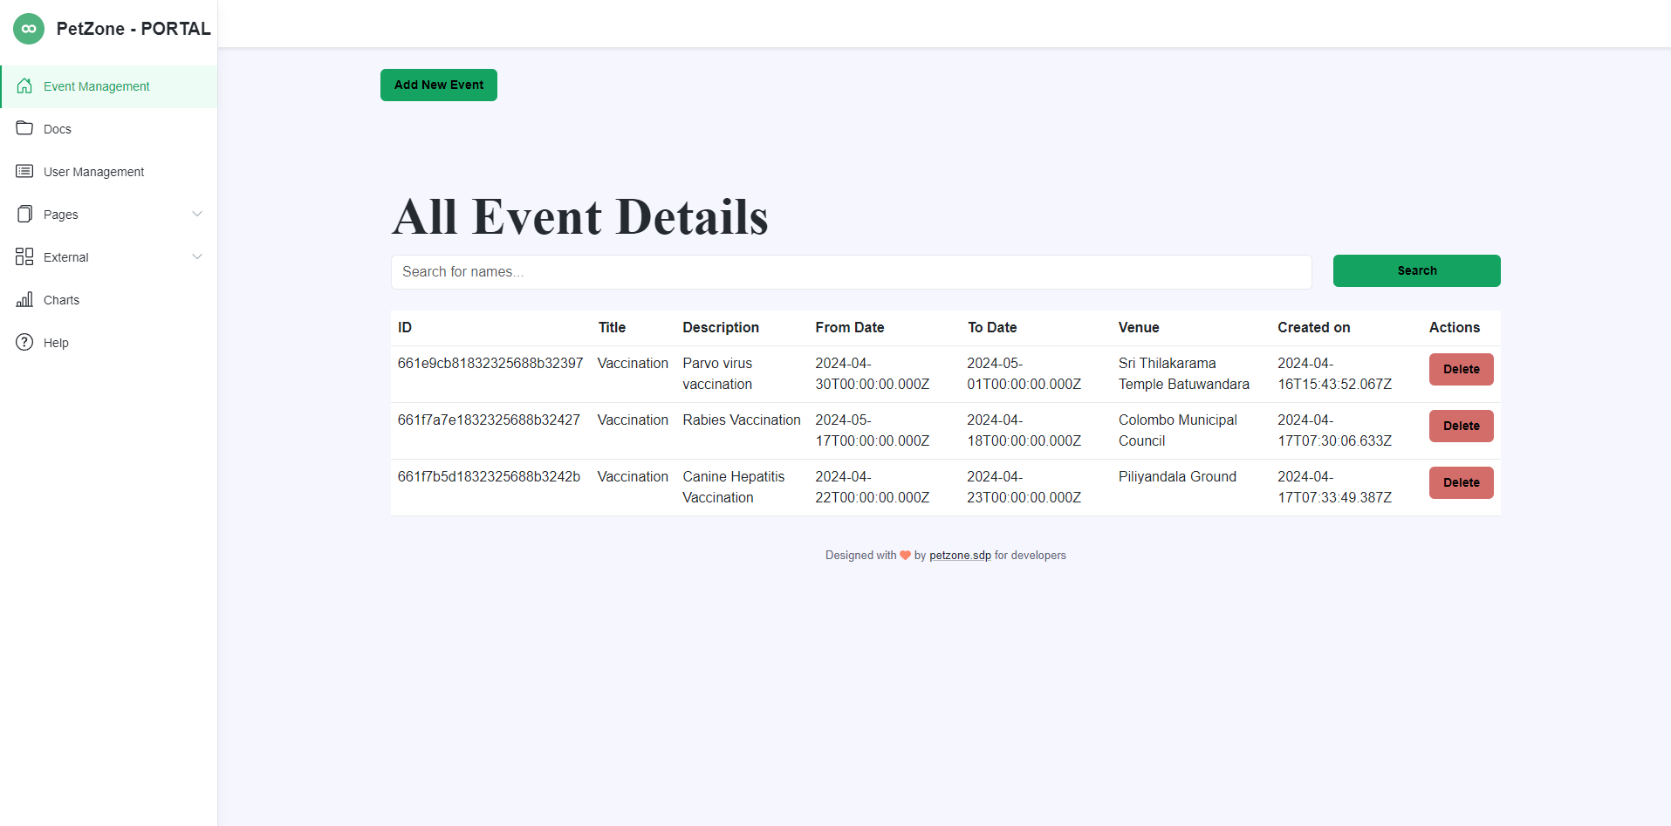

* No results were found from the search.

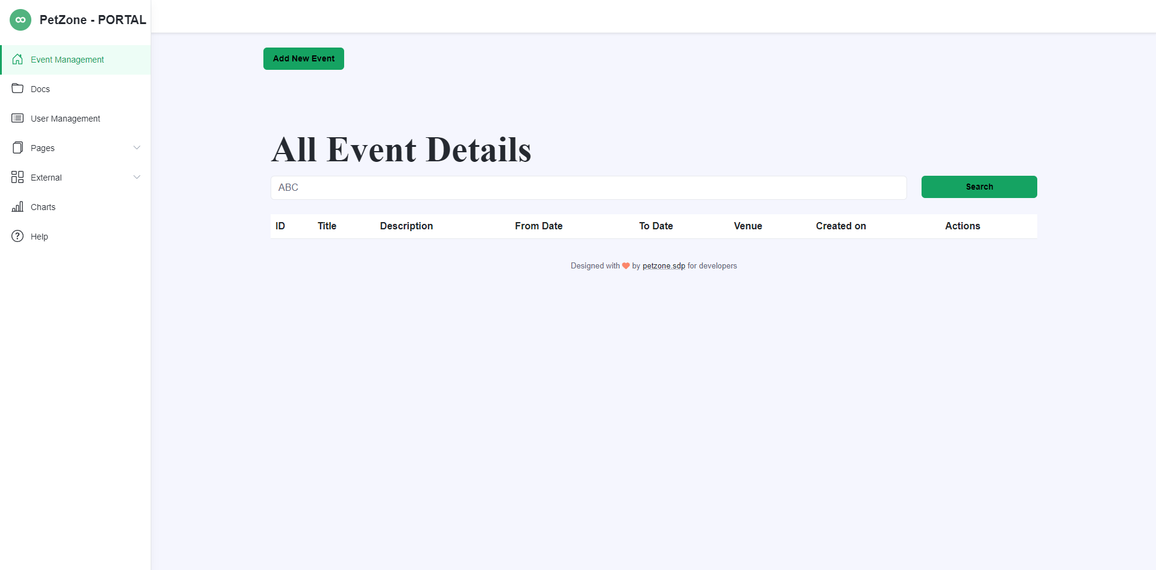

* Search results found for ‘%Vacc%’

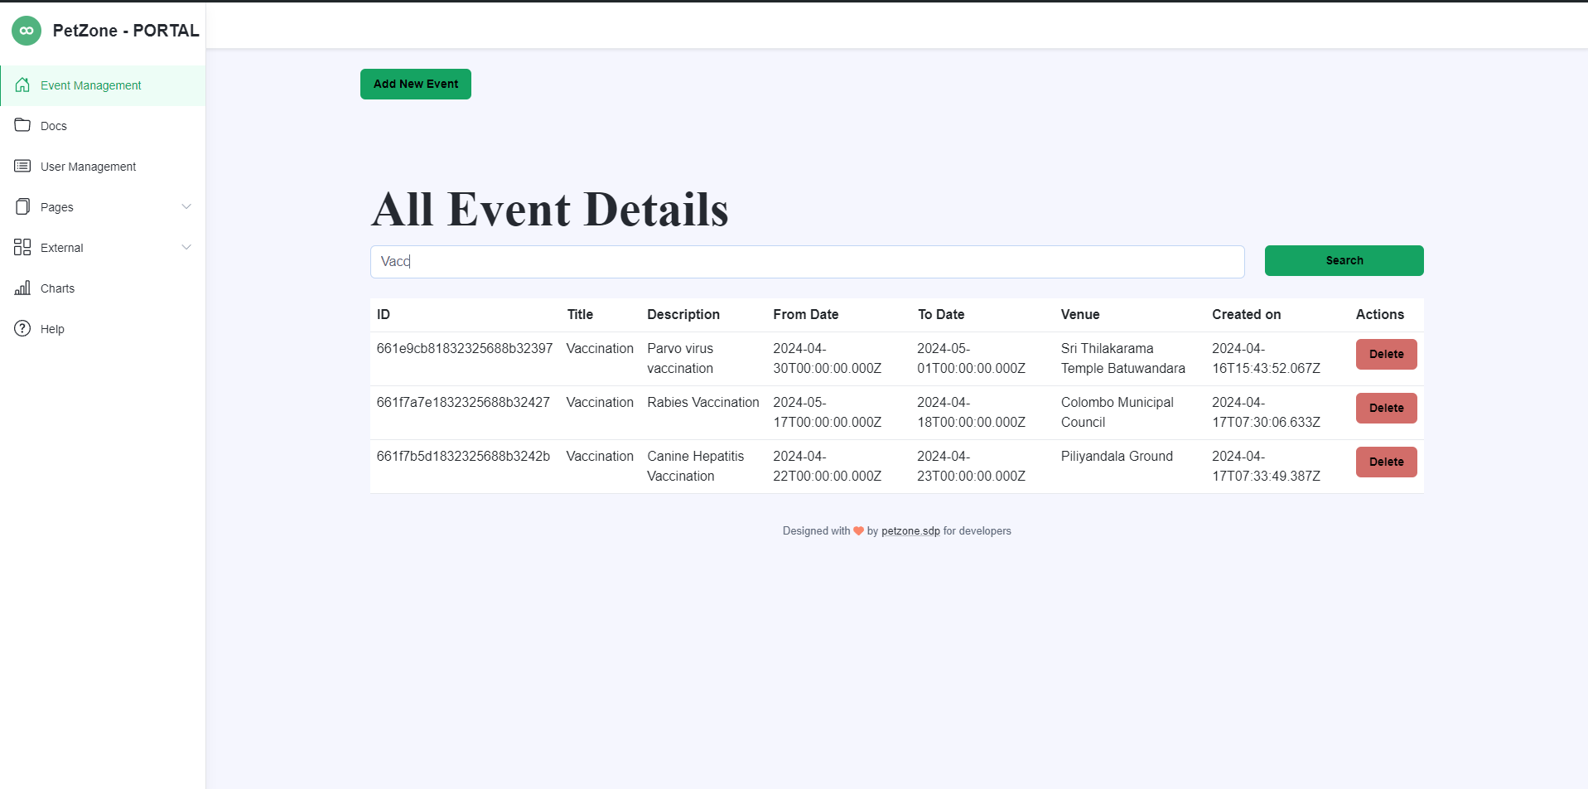

* Add new event.

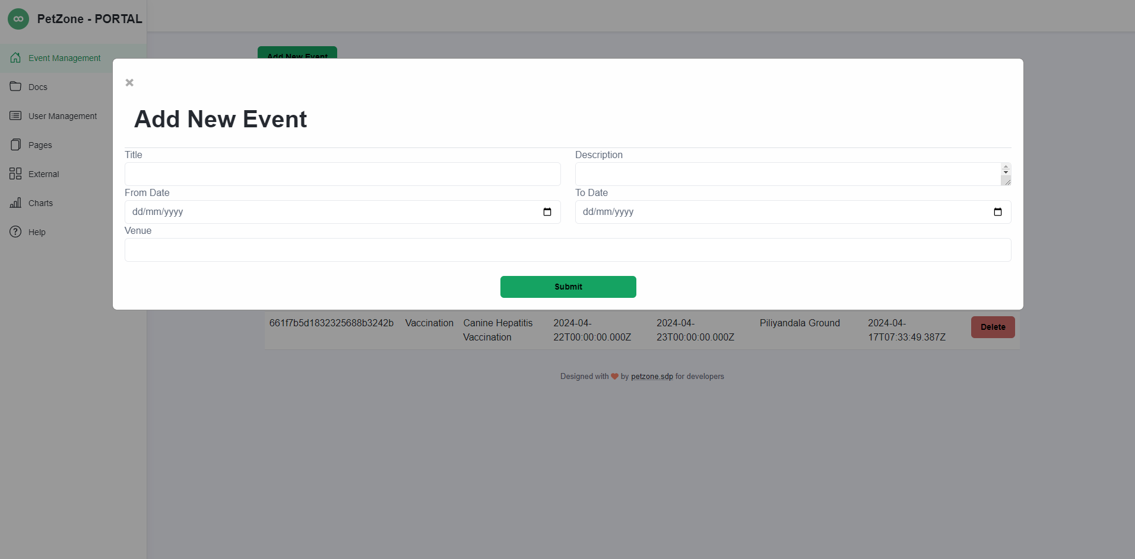

* View volunteer posts from volunteers’ side

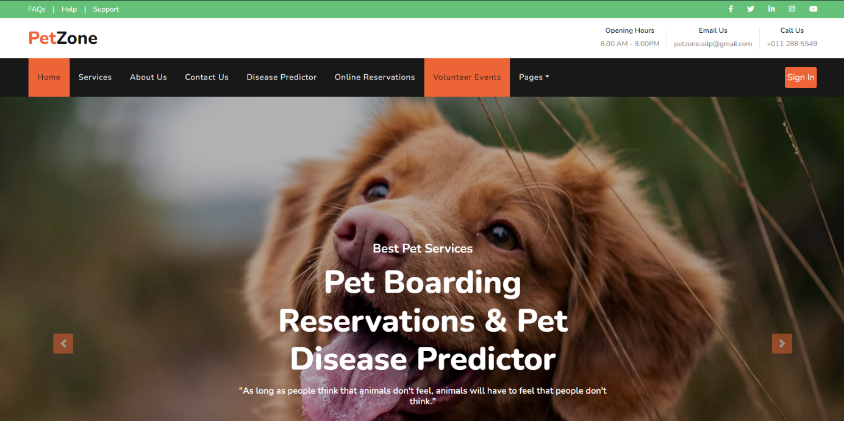

* Volunteer posts

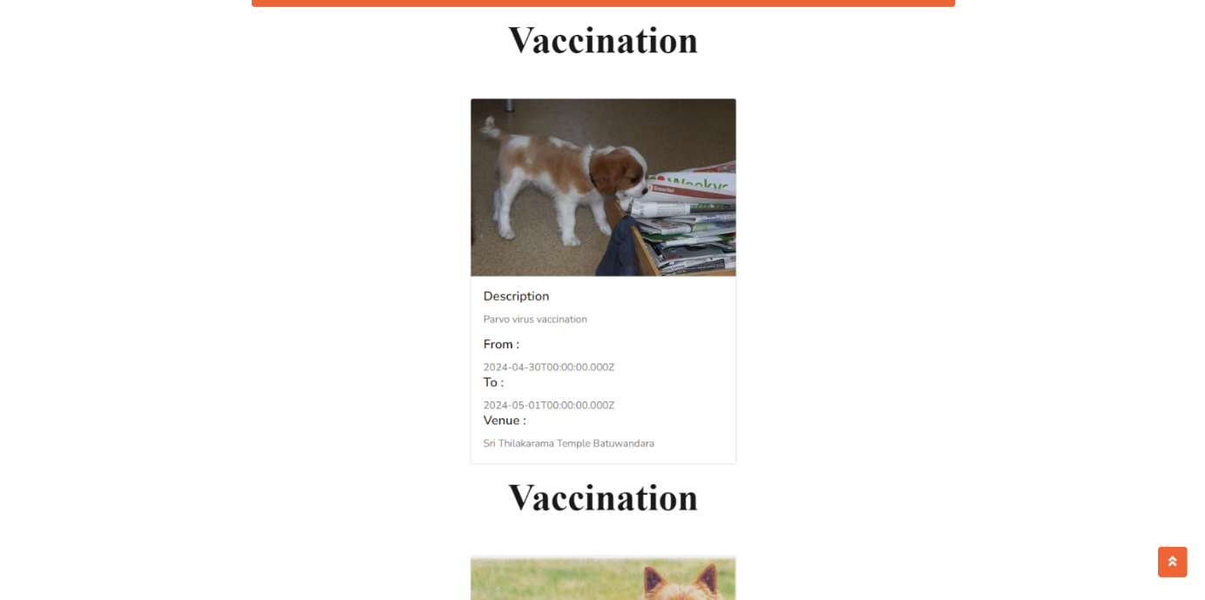

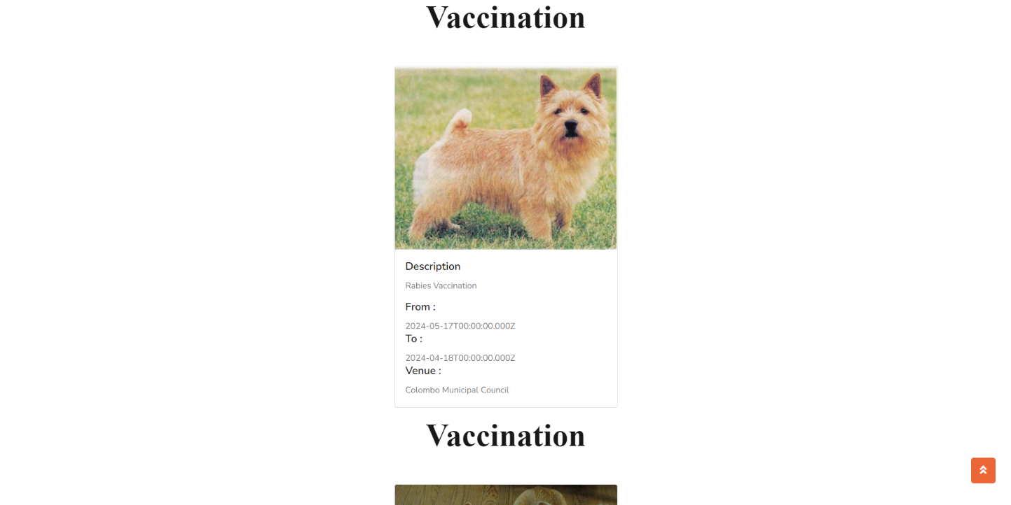

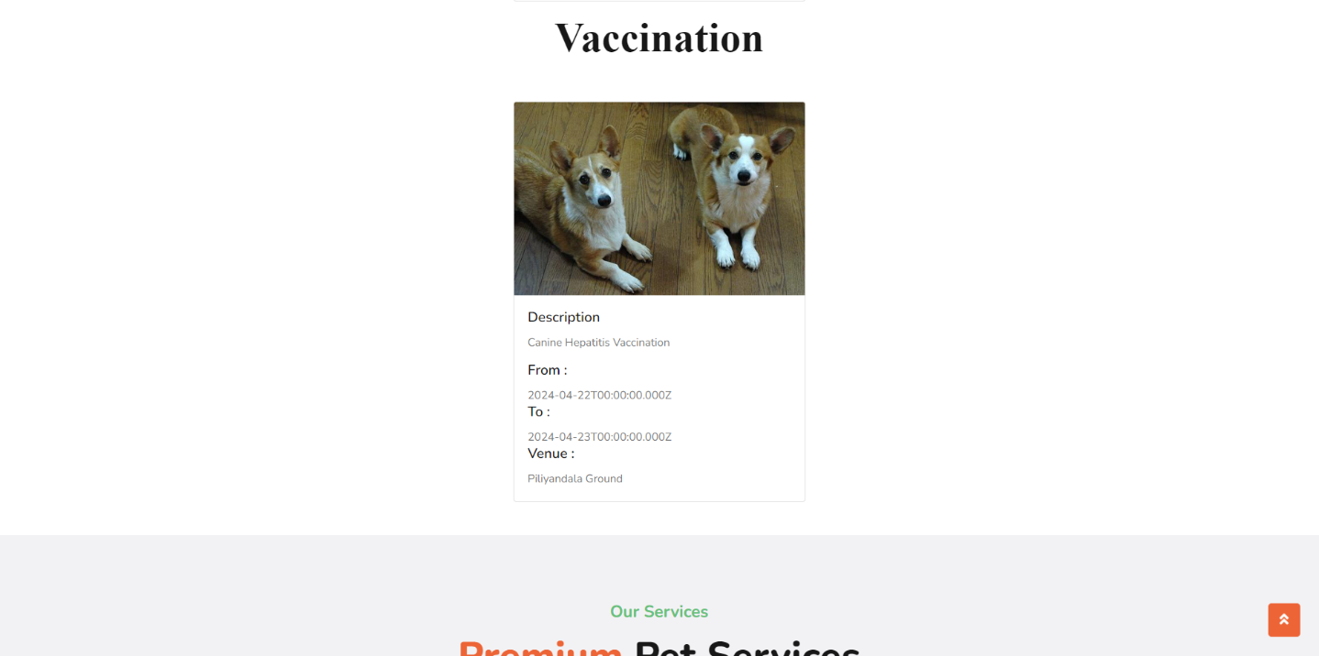

**Code Snippets:**

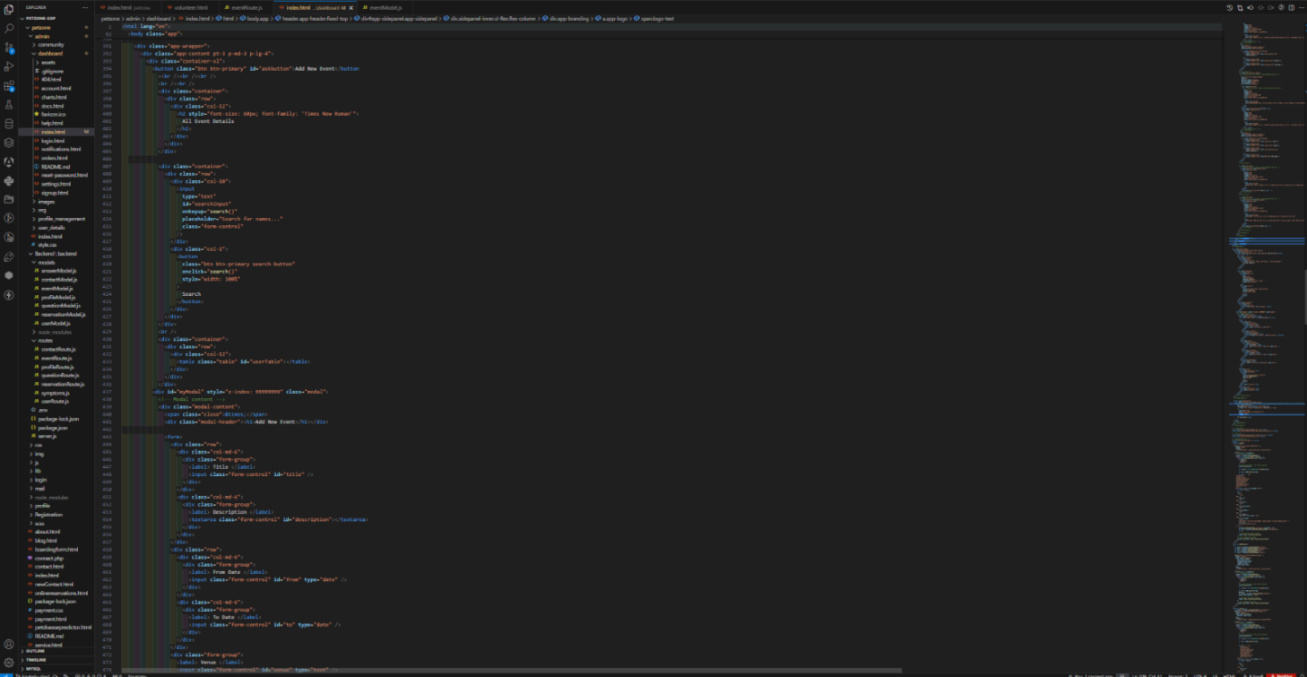

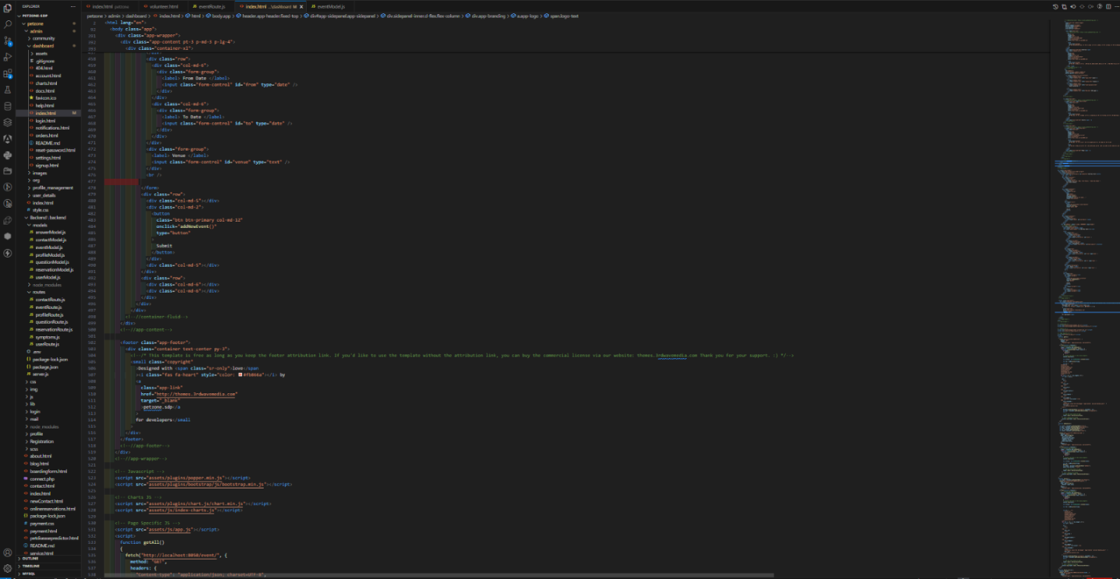

* JavaScript Code

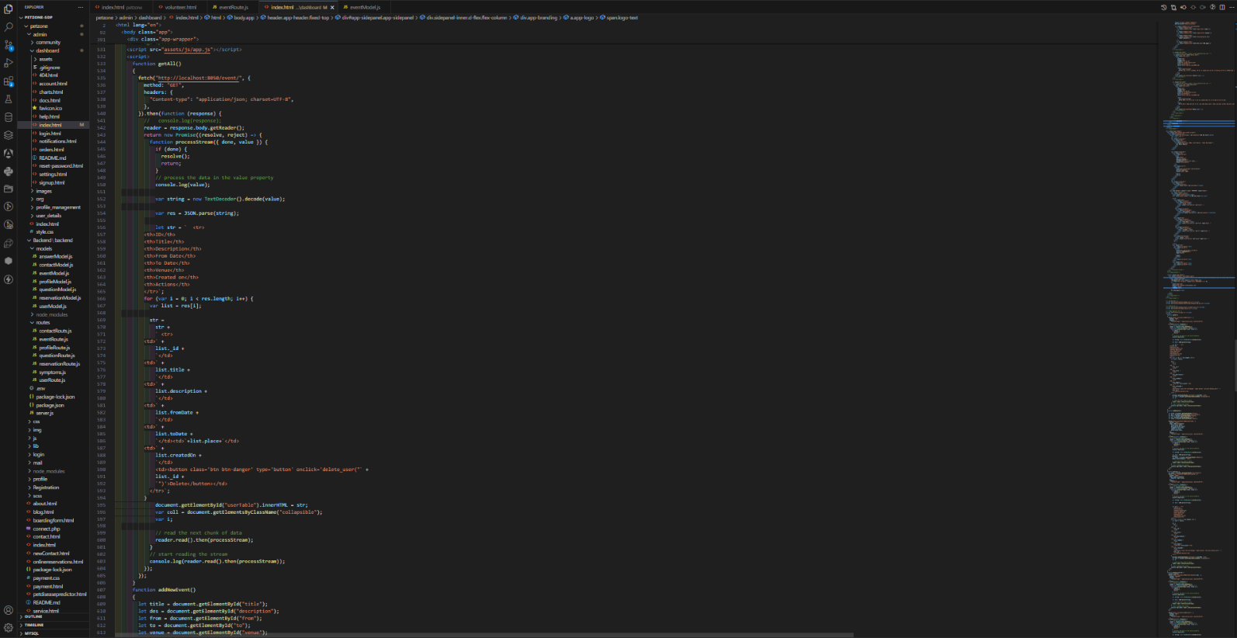

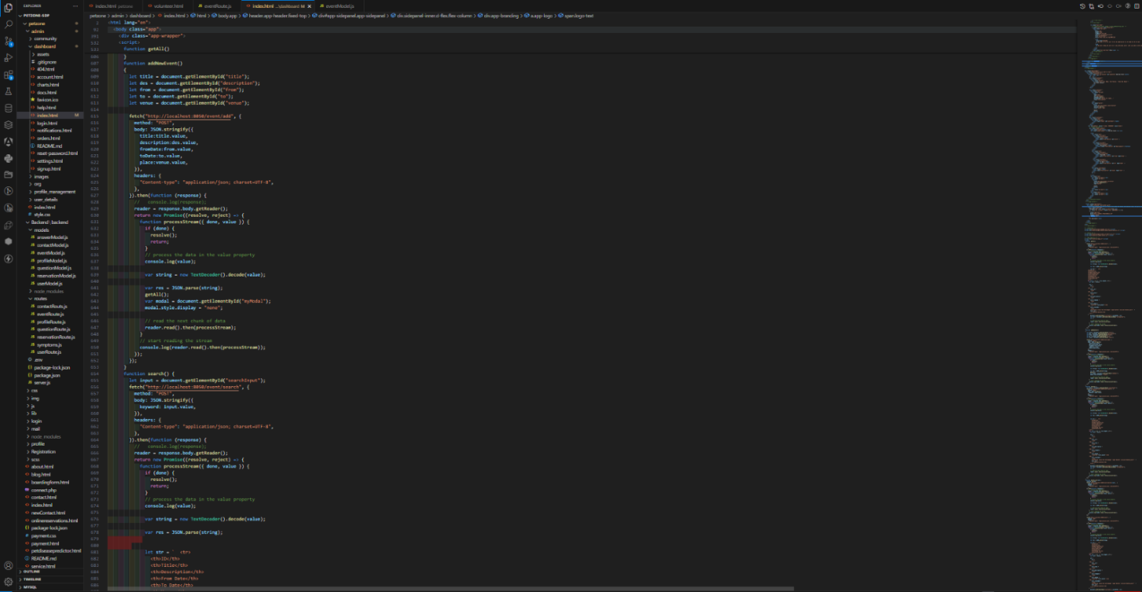

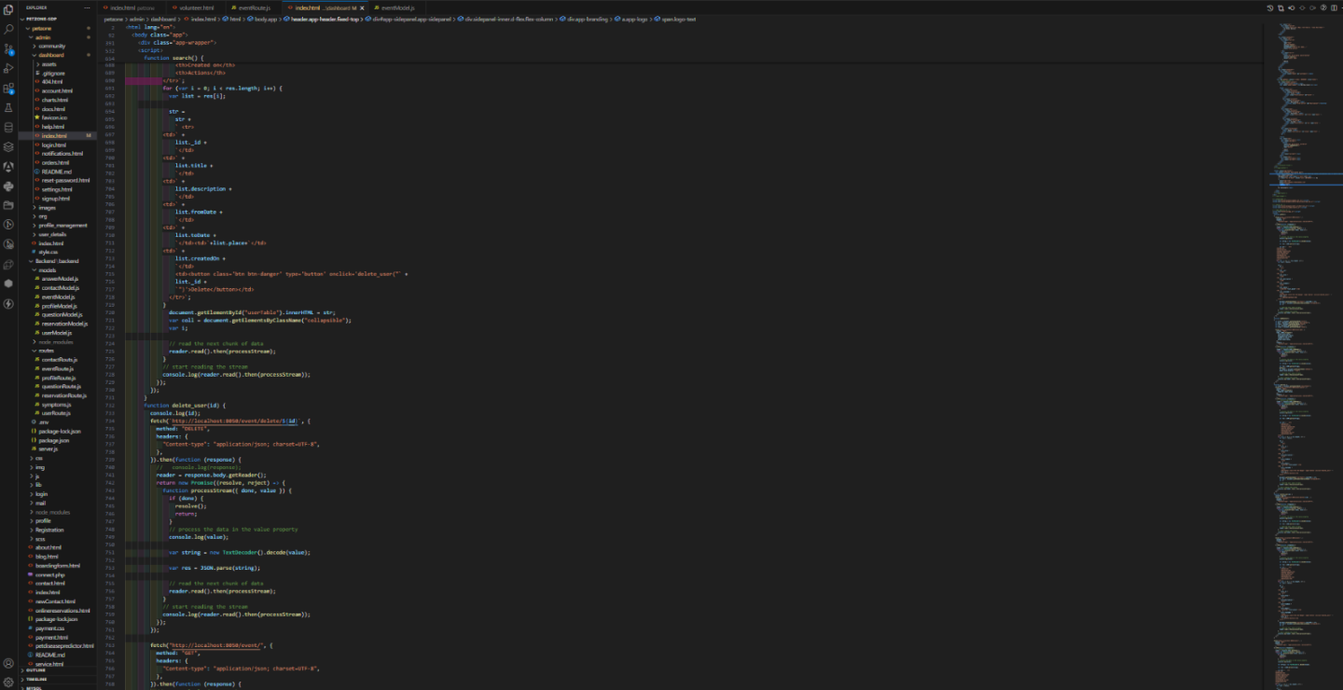

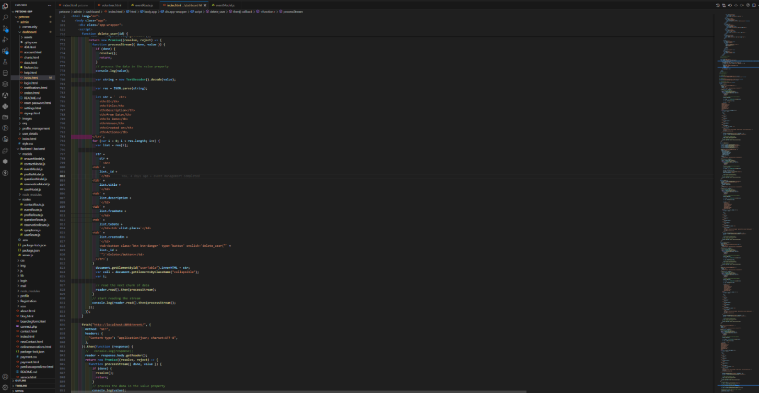

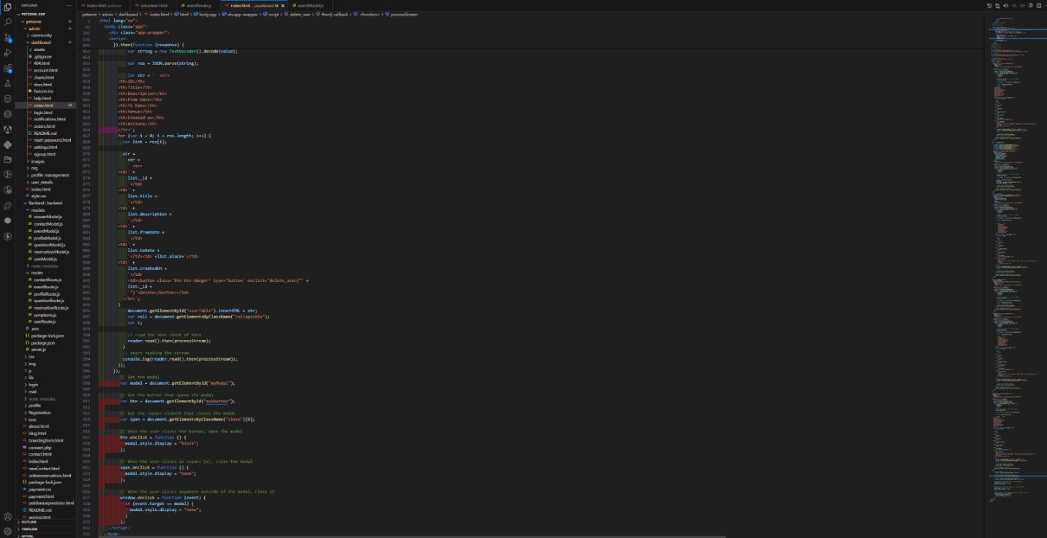

1. Backend Components:

* Express.js Server:

This component serves as the backend server for the application, handling HTTP requests and responses. It defines routes and middleware functions to handle incoming requests from the frontend. Express.js provides a robust framework for building web applications with Node.js.

* API Endpoints:

These endpoints define the communication interface between the frontend and backend. For the admin panel, API endpoints handle actions such as adding new events and searching for existing events. For the volunteer user side, endpoints serve event data to be displayed as posters. These endpoints are implemented using Express.js and interact with the MongoDB database to fetch or modify data.

* MongoDB Database:

MongoDB stores the pet care event data in a structured format. It provides collections to store event details such as title, description, date, and location. MongoDB's flexible schema allows for efficient storage and retrieval of event information, enabling seamless interaction between the backend and frontend components.

**Code Snippets:**

* 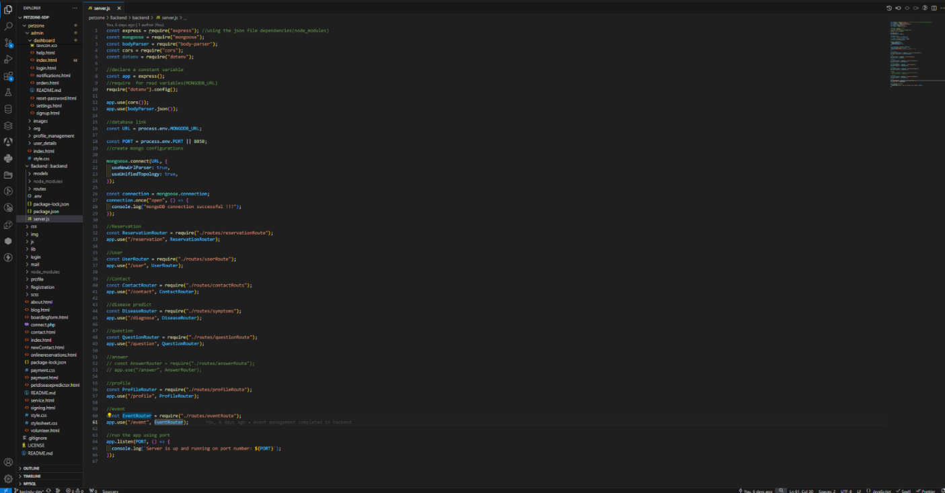ExpressJs Server

* Endpoints

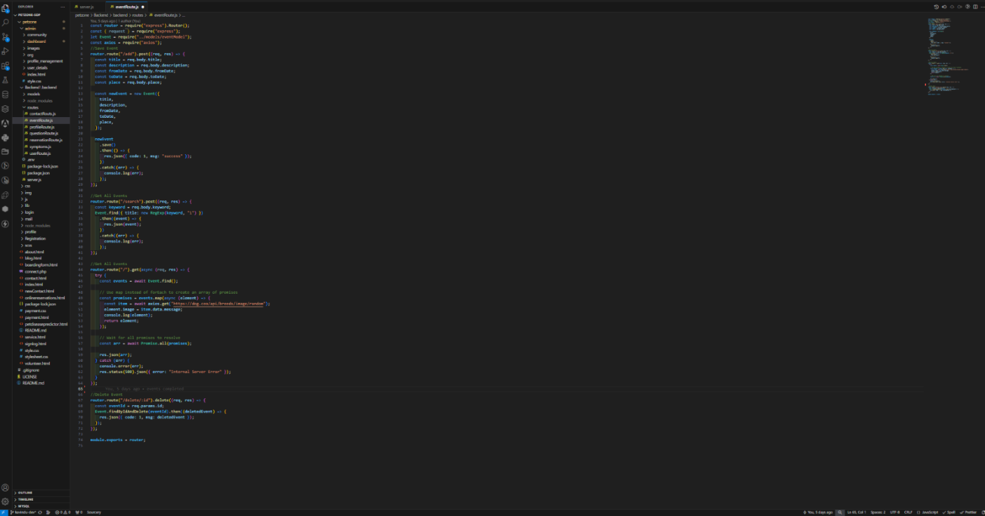

* Model

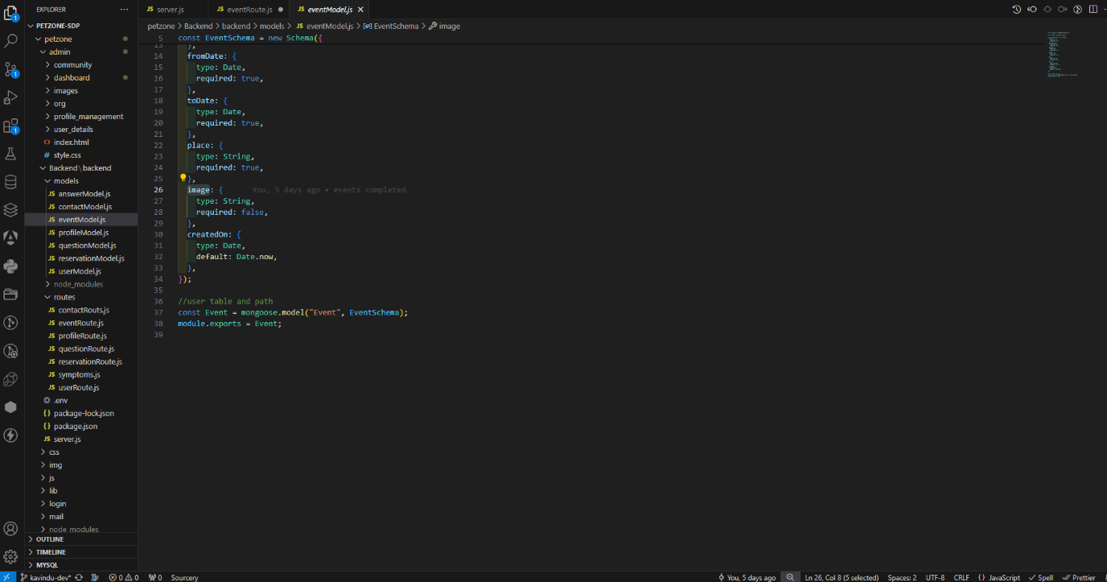

**MongoDB Cloud Database:**

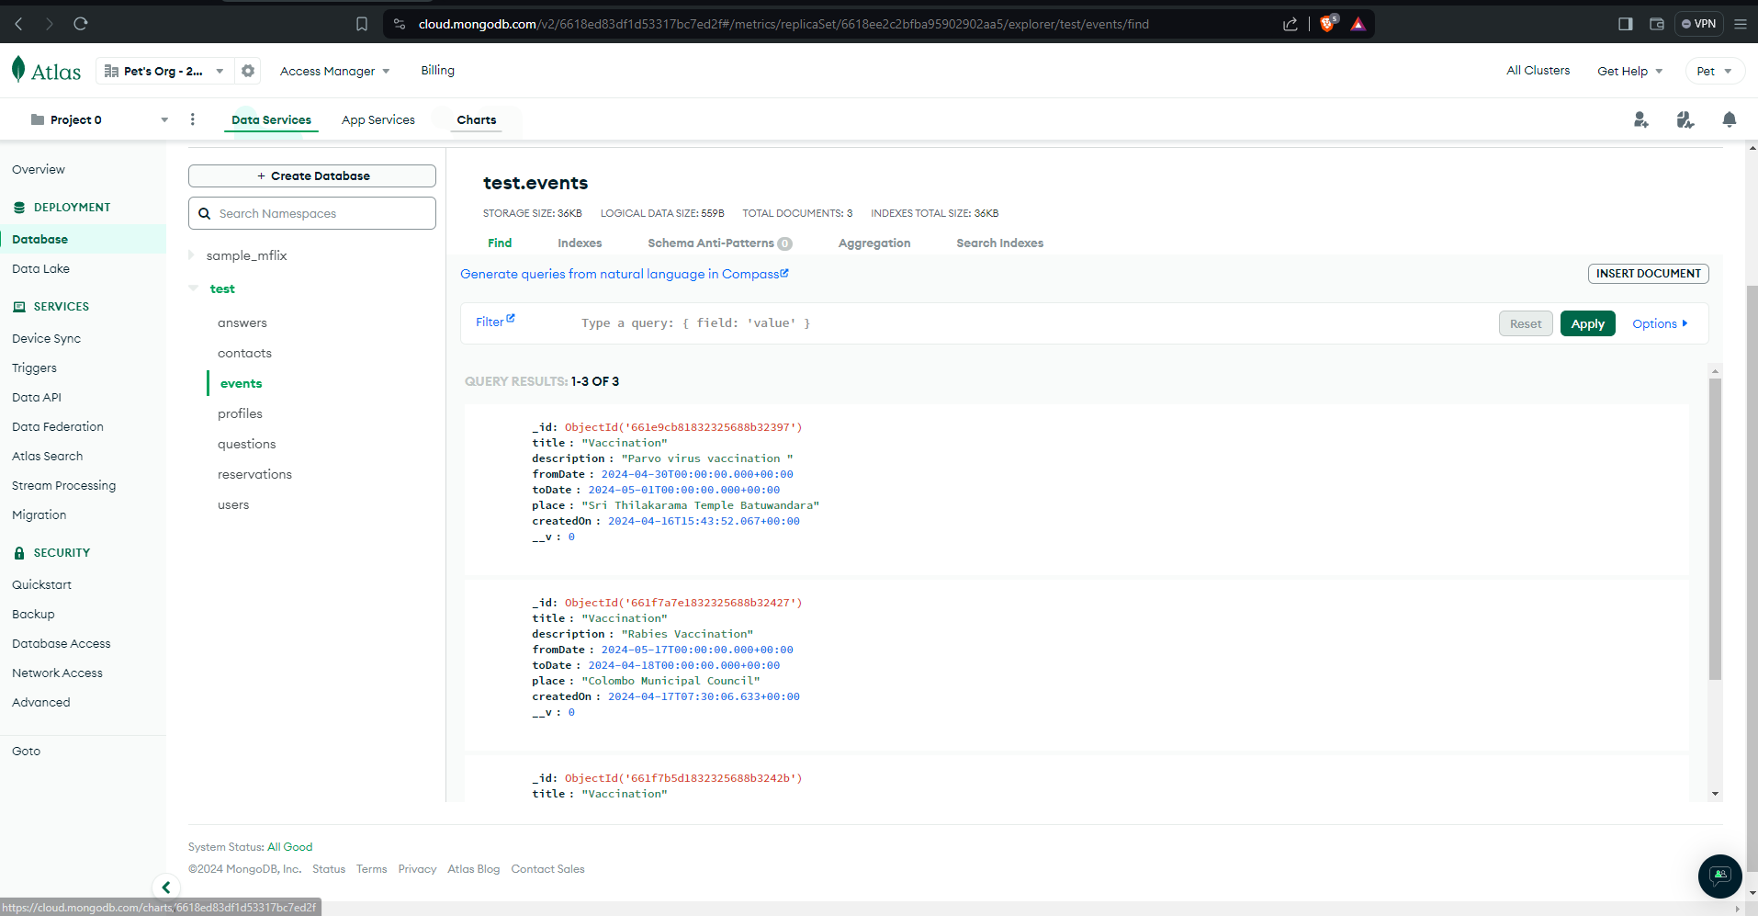

Component level quality assurance

* Test Case 01

|  |  |  |  |  |  |
| --- | --- | --- | --- | --- | --- |
| Project Name: | Pet-Zone Volunteer System – Events | | | Tests Engineer | Kavindu Pathirana |
| Test Date: | 2024-04-17 | | | | |
| Test ID: | 1 | | | | |
| Product Module: | Add New Events | Status: | Pass | | |
| Purpose | To insert new events records |  | | | |
| Pre-Condition | Enter event details such as Title, Description, From Date, To Date, Venue | | | | |
| Steps | Load admin panel and click event management from navigation panel after that click add new button and open the modal component then insert values to input controls then click submit button | | | | |
| Expected Outcome | Add new event details to database | | | | |
| Actual Outcome | Added new event details to database | | | | |
| Pre-Condition | Real-time updated the table after inserting data | | | | |

* Test Case 02

|  |  |  |  |  |  |
| --- | --- | --- | --- | --- | --- |
| Project Name: | Pet-Zone Volunteer System – Events | | | Tests Engineer | Kavindu Pathirana |
| Test Date: | 2024-04-17 | | | | |
| Test ID: | 2 | | | | |
| Product Module: | Search Events | Status: | Pass | | |
| Purpose | To search events records |  | | | |
| Pre-Condition | Enter keyword to search by title | | | | |
| Steps | Load admin panel and click event management from navigation panel after that enter keyword into search input control and click button ‘’Search’ | | | | |
| Expected Outcome | Filter details which searched from database. | | | | |
| Actual Outcome | Update the table with filtered data | | | | |
| Pre-Condition | Real-time updated the table after searching data | | | | |

* Test Case 03

|  |  |  |  |  |  |
| --- | --- | --- | --- | --- | --- |
| Project Name: | Pet-Zone Volunteer System – Events | | | Tests Engineer | Kavindu Pathirana |
| Test Date: | 2024-04-17 | | | | |
| Test ID: | 3 | | | | |
| Product Module: | View Event Posters | Status: | Pass | | |
| Purpose | To view events records as posters |  | | | |
| Pre-Condition | Poster accessible user interface | | | | |
| Steps | Load the volunteer home page and click volunteer events from top navigation bar after that scroll into poster area. | | | | |
| Expected Outcome | View volunteer event posters. | | | | |
| Actual Outcome | View attractive volunteer event posters with images | | | | |
| Pre-Condition | Real-time updated the posters when inserting new events from admin panel dynamically | | | | |

Collaborative tools & Implementation

1. **Version Control System (VCS):**

* Tool: Git

**Implementation:**

Use Git for version control to track changes to the source code, collaborate on code development, and manage code branches effectively. Teams can host their Git repositories on platforms like GitHub, GitLab, or Bitbucket. Each team member can clone the repository, make changes locally, and push them to the remote repository. Git enables collaboration by allowing team members to review each other's code, merge changes, and resolve conflicts efficiently.

1. **Project Management:**

* Tool: Trello

**Implementation:**

Use project management tools like Trello to plan, track, and prioritize tasks and project milestones. Create user stories, tasks, and epics to define project requirements and break down work into manageable units. Assign tasks to team members, set due dates, and track progress in real-time. These tools provide visibility into project status, facilitate communication among team members, and ensure that everyone is aligned with project goals.

1. **Communication and Collaboration:**

* Tool: Google Meet

**Implementation:**

Use chat and collaboration platforms like Google Meet to facilitate real-time communication among team members. Create instant meetings for teams, share updates, ask questions, and collaborate on discussions. These tools offer features such as direct messaging, file sharing, video calls, and integration with other project management and development tools, enhancing team collaboration and productivity.

1. **Code Review:**

* Tool: GitHub Pull Requests, GitHub Merge Requests

**Implementation:**

Implement code review processes using pull requests or merge requests on platforms like GitHub. Before merging code changes into the main codebase, team members can submit pull requests for review by peers. Reviewers can provide feedback, suggest improvements, and ensure code quality and adherence to coding standards. Code review tools facilitate collaboration, knowledge sharing, and continuous improvement within the development team.

1. **Documentation:**

* Tool: OneDrive

**Implementation:**

Use documentation tools like OneDrive to create and maintain project documentation, including requirements, design documents, technical specifications, and user manuals. Collaboratively author and edit documents, track changes, and ensure that documentation is up-to-date and accessible to all team members. Documentation tools promote knowledge sharing, transparency, and alignment across the development team.

Discussion:

1. **Search and Add Events from Admin Panel:**

* The admin panel serves as the hub for event management. Administrators can add new pet care events, specifying details such as event name, date, time, location, and description. The user-friendly interface ensures ease of use and efficient data entry.
* The search functionality allows administrators to search for existing events using various criteria such as event name, date, or location. This helps in quickly locating and managing events within the system.
* These functionalities empower administrators to keep the event catalog up to date and make informed decisions based on available data.

1. **View Volunteer Event Posters:**

* The volunteer user side focuses on presenting event posters to volunteers in a visually appealing and intuitive manner. Volunteers can view upcoming pet care events, gaining insight into event details and deciding which events to participate in.
* The system should ensure that posters are easy to navigate and filter by various criteria, such as event type or location. This allows volunteers to quickly find events that match their interests and availability.
* By providing easy access to event posters, the system encourages volunteer engagement and participation in pet care events.

1. **Quality Assurance Considerations:**

* The system must maintain high quality across all functionalities. This includes ensuring the accuracy of event data, the security of user information, and the responsiveness of the application.
* Testing strategies should include functional testing of the search and add event functionalities, as well as usability testing to ensure volunteers can easily view and interact with event posters.
* Continuous monitoring and feedback collection from users (both administrators and volunteers) can help identify areas for improvement and guide future enhancements.

1. **Challenges and Recommendations:**

* Data Management: Managing a large volume of event data and ensuring its accuracy and integrity can be challenging. Regular data audits and validation processes are recommended.
* User Experience: Maintaining a seamless and intuitive user experience is critical. Continuous feedback from volunteers and administrators should be used to refine the user interface and functionality.
* Scalability and Performance: As the system grows and more events and users are added, scalability and performance should be monitored. Consider optimizing database queries and using caching strategies where appropriate.

Future Implementation

1. **Enhanced Search and Filtering Options:**

* Improve the search functionality by adding more advanced search and filtering options. This could include filtering by event type, pet type, volunteer skills, or specific date ranges.
* Implement natural language processing (NLP) to enable more flexible search queries and to understand user intent better.

1. **Automated Notifications and Reminders:**

* Introduce automated email or push notifications to remind volunteers of upcoming events they have signed up for and inform them of new events that match their interests.
* Allow users to set their notification preferences to receive updates about events in their area.

1. **Online Event Registration and RSVP:**

* Allow volunteers to register or RSVP for events directly through the platform. This can help organizers track attendance and manage resources effectively.
* Introduce a waitlist feature for events that reach full capacity.

1. **Integration with Social Media Platforms:**

* Integrate the system with social media platforms to enable easy sharing of event posters and details. This can help increase event visibility and attract more volunteers.
* Consider adding social login options for easier user authentication and a more streamlined user experience.

1. **Mobile Application Development:**

* Develop a mobile application for the system, providing users with convenient access to search for events, view posters, and manage their participation from their mobile devices.
* Leverage mobile-specific features such as push notifications and geolocation services to enhance the user experience.

1. **Gamification and Volunteer Engagement:**

* Introduce gamification elements such as badges, points, and leaderboards to encourage volunteer participation and engagement.
* Recognize and reward volunteers for their contributions, fostering a sense of community and motivating continued involvement.

1. **Data Analytics and Insights:**

* Implement data analytics tools to gather insights on event participation, volunteer engagement, and the impact of events on pet care initiatives.
* Use these insights to improve future event planning and resource allocation.

1. **Accessibility Improvements:**

* Ensure the system is accessible to all users, including those with disabilities. Implement features such as screen reader support, high-contrast themes, and keyboard navigation.
* Conduct regular accessibility testing and gather feedback from users to identify areas for improvement.

References

* GeeksforGeeks. (15th April 2024). Express.js. Retrieved from <https://www.geeksforgeeks.org/express-js>
* W3Schools. (n.d.). MongoDB Tutorial. Retrieved from <https://www.w3schools.com/mongodb/>